



Continuity of Learning Plan
2020/2021
Our School Vision
Our vision is encapsulated in Article 29 –
‘Your Right to be the best you can be.’
In Morriston Primary School we aim to provide a broad, balanced and rich curriculum. We offer an inclusive environment where pupils are encouraged to be happy, digitally competent, creative, confident and resilient learners. We challenge our pupils to reach their full potential, equipping them with the skills necessary to continue on their journey of life-long learning.

Our School Mission Statement
‘Together Everyone Achieves More.’
Learning and working together as a community, we challenge and support each other, to achieve our goals.

The School aims to:
  - provide pupils with a safe environment and the best possible education and support, promoting their pathway to independence in learning and life skills
  - provide pupils with positive guidance to manage their behaviour through clear expectations, rewards and sanctions
  - achieve high standards of teaching for all pupils throughout the school day; providing an exciting curriculum in a positive and attractive environment
  - keep parents and carers informed of their child’s progress and well-being at school

  - use robust evidence and work closely with governors, staff, parents and pupils in evaluating the school’s performance and planning our strategic direction
  - keep staff informed about school matters; consulting with them about significant changes in school organisation, curriculum and policies

Rationale

The response to COVID-19 has dramatically changed our lives. Both adults and children face very real and pressing challenges to their health and well-being. The risk of infection, the prospect of bereavement and restrictions on leaving home place strains on our physical and mental health and our relationships. Children in particular may struggle with lack of routine, disruption to their learning and isolation from friends.

In this document, Morriston Primary School lays out the plans for pupils to continue their learning in different scenarios:

- In the event of an isolated event, under these circumstances, pupils will stay at home and will be kept informed about school arrangements, and when and if home learning will be implemented.

- Should the school need to be closed for an extended period of time, home learning will be anticipated and information will be shared with the school community to prepare all stakeholders.

- In an unusual case, such as the coronavirus, where a number of students need to be quarantined, it may be necessary to transition to a ‘Blended Learning’ approach, serving pupils both at school and at home.

The decision for the school to transition fully to home learning will be communicated in a number of ways to ensure all stakeholders are fully informed. Information will be shared in the following different ways:

- School website
- In letter
- Class Dojo platform

Parents should review this Continuity of Learning Plan carefully to see how the school will communicate
the details of home learning / blended learning approach. In the paragraphs below explanations will be given
for all the key terminology to ensure continuity of learning for all pupils at Morriston Primary School.

Home Learning

Home Learning can be defined as any prolonged learning outside the school environment. Uniform templates for home learning activities have been designed and created for use across all phases of the school. These templates ensure a uniform approach to home learning activities across the school. Graphics which are already in use via the challenge/mission areas within the classroom environment have been used to ensure a familiar approach to the learners. Templates have been designed with the new curriculum in mind, these include the new Areas of Learning Experience (AoLEs).

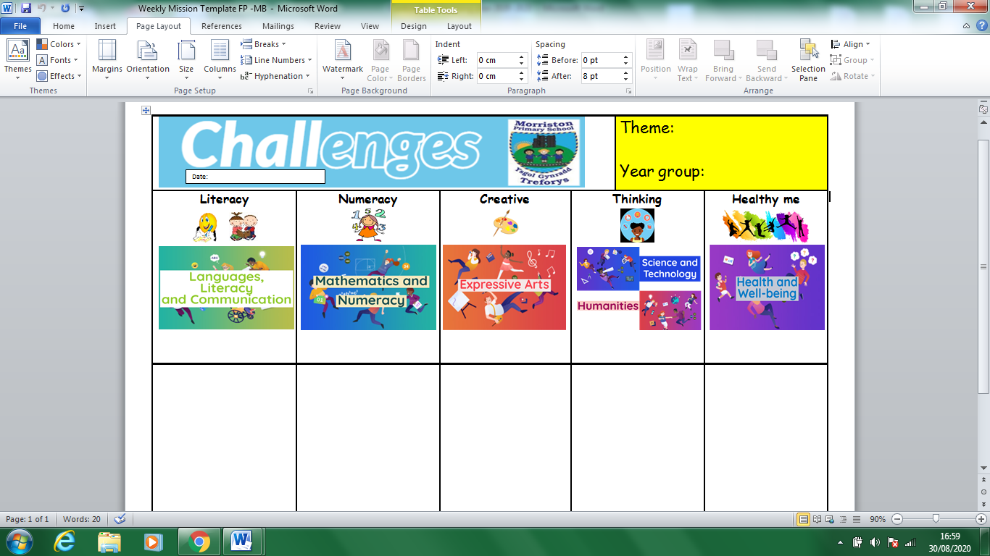

Figure 1 – Foundation Phase Home Learning template

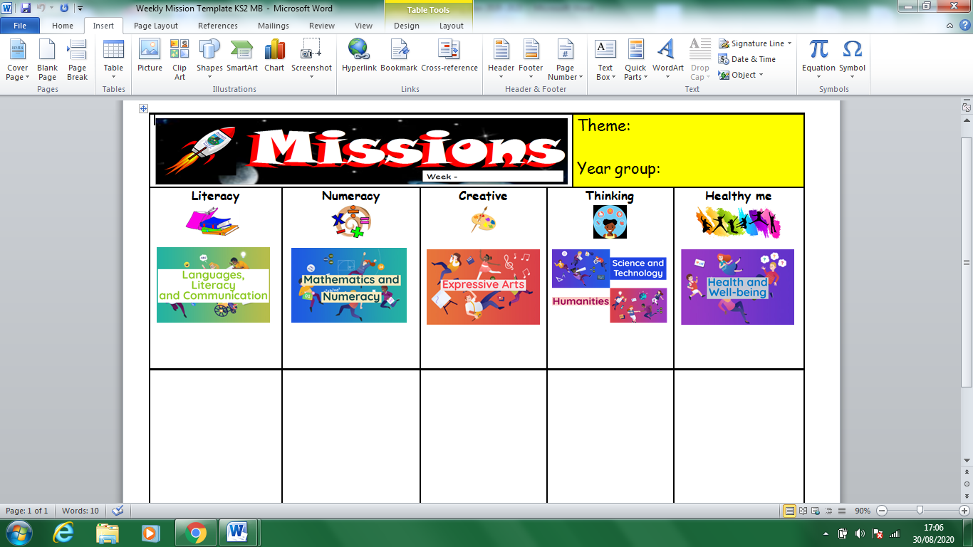

Figure 2 – Key Stage two Home Learning template

In an event of a period of prolonged home learning, practitioners will share a weekly home learning template with learners. These templates will be accessible in a variety of different ways.

Practitioners will upload these templates weekly on their class pages of the school website. Practitioners will also share home learning activities via online platforms such as Microsoft Teams / J2E. Detailed ‘How to’ guide document will be made available to all parents/guardians to ensure leaners understand how to access the template/learning. Classroom practitioners will offer support and assistance to pupils and parents/guardians via a number of methods of commination such as Class Dojo/ email.

Useful examples of recorded lessons can be found at:

- Oak National Academy – https://www.thenational.academy
- Reach Online Learning – https://www.youtube.com/channel/UCiai-MqUoEelQ2FbApQChw/videos
- Swansea Virtual School – https://swanseavirtualschool.org/daily-lessons/
- ERW Dolen Repository – https://thinqi.erw-rhwyd.cymru/Repository

Blended Learning Context and Definition

Up to now, most blended learning approaches have taken place in higher education settings and for work-based training. However, since the COVID-19 pandemic, all schools from nursery to sixth forms and colleges have had to adapt to provide learning materials from a distance, using a mix of digital and paper-pack resources.

“Blended learning is an approach to learning that combines face-to-face and online learning experiences. Ideally, each (online and offline) will complement the other by using its particular strengths.”

Blended-Learning Approaches

A blended learning approach at Morriston Primary School will consist of a range of approaches that can be
broadly categorised as:

- Face-to-face time with pupils
- Online learning
3. Asynchronous learning
i. Resources and activities delivered online (e.g. through Teams, J2E, HWB email etc.)
ii. Recorded lessons
iii. Flipped learning (pupils engage with the material before discussions in class)
4. Synchronous learning
i. Live online pastoral & learning check-in sessions
ii. Live online lessons
5. Hard-copy & physical resources (paper packs & work booklets)

Remote learning can:

- take place more independently at different points in time, based on the learner’s wishes or home circumstances (asynchronous)
- take place with multiple learners and teachers at the same time, usually online (synchronous).

Asynchronous approaches provide greater flexibility and can be easier for parents/carers and learners to manage at home, so should be the main approach considered by schools and settings when organising distance learning.

Synchronous approaches such as live video streaming may be practical and appropriate in certain circumstances particularly in support of learner engagement and well-being. Synchronous or ‘live streaming’ lessons with learners can also be very useful for keeping in contact with learners.

Synchronous / Live Streaming

In an event of synchronous approaches being adopted by the school the governing body, headteacher and staff will have full regard to local safeguarding guidance.

- Any live-streaming should be done on a voluntary basis – staff should not be directed to undertake live-streaming of lessons.
- The school will utilise Microsoft Teams. Microsoft Teams can provide an interactive experience and an opportunity to collaborate and engage in a safe and accessible way.
- The practitioner will utilise a school issued device to ensure the practitioner and learners are appropriately protected and safeguarded.

Before delivering any “live sessions”, practitioners must consider the key considerations to ensure the safeguarding of the learners participating and ensure that the session is managed as well as possible. The graphic below highlights some of these points. Please note, this list is not exhaustive

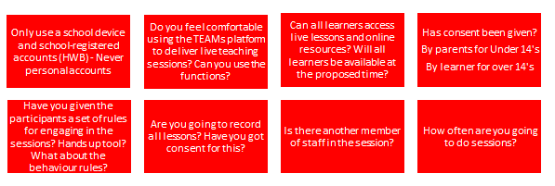

Professional conduct

Any live-streaming should be done on a voluntary basis and education practitioners choosing to live stream should continue to work in the same professional manner as they would in the classroom. Education practitioners should undertake the following.

- Adhere to professional standards of dress when in front of the camera.
- Ensure there are always at least two members of teaching staff online and present at all times during any live-streamed lesson.
- Not have one-to-one live-streaming lessons with learners.
- Be conscious that in an online environment remarks are being heard by a number of learners and could be easily misconstrued.
- Ensure they end the session for all participants, ensuring learners are not left alone and unsupervised in a session the teacher has left.
- Be mindful of the need for confidentiality; especially if you are live-streaming a lesson from a venue where other adults or children are present.

Guidance for Governors

The governing body has responsibility for the approval of all safeguarding policies including the online safety policy, ensuring the effectiveness of the policy within regular reviews.

This will be carried out by the full governing body or sub-committee receiving regular information about online safety incidents and being kept abreast of developments, especially during school closures and blended learning.

Best Practice and 360Safe Cymru recommends that there should be a member of the Governing Body nominated for the role of “Online Safety Governor", which would meet with the online safety co-ordinator regularly and feeding back to the Governing Body.

What should the Governing Body/Online Safety Governor look for?

With the use of distance-learning techniques and the introduction of blended-learning approaches, the role has been extended to include the following considerations:

- Is there now a need for synchronous learning approaches (live sessions) that could not be fulfilled by asynchronous approaches including recorded lessons and interactive resources?
- Have staff had sufficient training on the specific platforms for synchronous teaching (Microsoft Teams)?
- Will all pupils be able to access the sessions without excluding anyone? If pupils are not able to participate in sessions, for example, due to connection difficulties, home-working patterns or personal privacy reasons, schools should provide work or support alternatively so that pupils are not disadvantaged.

Some whole-school safeguarding considerations

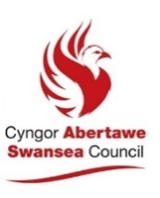
Appendix 1 – Acceptable Use Policy For Live Sessions
Acceptable Use Policy - Live Sessions

Teachers agree to:
- deliver live sessions through Microsoft Teams
- start lessons five to ten minutes before you planned for your lessons to start promptly
- notify the learners of scheduled lessons (through the use of the calendar in Teams) as well as what will be required during that session (documents, presentations etc)
- discuss roles and responsibilities and a short tutorial on the system at the outset of all lessons
- notify the school’s senior management team, learners and parents of any cancelled lessons or changes in arrangements
- ensure that recordings of the session are not made public
- ensure that they keep themselves up to date with all relevant policies and procedures, including online safety, safeguarding and data protection policies
- prevent a one to one situation at the end of an online class by disconnecting all participants from Teams

Learners agree to:
- prepare for the session in plenty of time and ensure you join the session after the session has been started by a member of staff
- access the relevant files for each lesson in advance and have the materials to hand
- ensure your device is powered from the mains and have a good internet connection and that you are not too far from the Wi-Fi router
- choose an appropriate workspace where other family members will not be walking around and disturbing you and explain to your family you are starting a lesson – this should not be in your bedroom
- minimise distractions. Turn off music, tv, phone, Xbox in the background. Don’t impact on the experience of the lesson for other pupils
- ensure you dress appropriately and treat the lesson as you would in school
- show respect for everyone in the online classroom
- positively contribute to the class and not be disruptive at any time. Use the hands up tool to ensure you don’t talk over others
- parents can listen in on lessons, support their pupils but should not ask questions or speak for their child
- any comments or questions should be on the topic being discussed
- any comments or questions which are inappropriate will be removed
- behaviour in an online lesson should be as expected in any lessons and any disruption will be dealt with by the schools' behaviour policy.
- If you disconnect from the call for any reason such as internet or power issues, don’t panic, reset and join again
- not make recordings/images of the class or the teacher
- learners agree not to initiate any live sessions without a teacher present

Learner consent
Consent to record live-stream sessions
Please note that Microsoft Teams lessons may be recorded by the teacher. These recordings are the property of the school and will not be shared with any other body unless there is a safeguarding concern.
Live-stream sessions will be treated in the same way as all other personal data and in accordance with the school's data protection policies and GDPR.
I understand that the Microsoft Teams sessions that I take part in may be recorded.

Learner full name and class …………………………………………………………………………………………………………..
Date …...………………………………………………………………………………………………………
I give consent for live-stream sessions that I participate in to be recorded.
I do not give consent for live-stream sessions that I participate in to be recorded.

Parent/carer consent
Consent to record live-stream sessions
Please note that Microsoft Teams lessons may be recorded by the teacher. These recordings are the property of the school and will not be shared with any other body unless there is a safeguarding concern.
Live-stream sessions will be treated in the same way as all other personal data and in accordance with the school's data protection policies and GDPR.
I understand that the Microsoft Teams sessions that my child may take part in may be recorded.

Parent/carer full name ……………………………………………………………………………………………………………..
Date .…………………………………………………………………………………………………………
I give consent for live-stream sessions that my child participates in to be recorded.
I do not give consent for live-stream sessions that my child participates in to be recorded.

Parent / Carer signature

.................................................................................................................................................

