The Ledged of Branwen
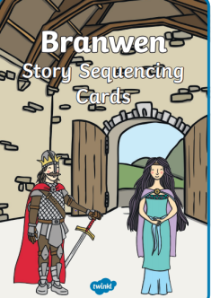
Write the Welsh date and write the heading as you see above.
Answer the questions in FULL sentences:

- Who was the King in Wales?
Bendigeidfran
Brychan
Matholwch

- Why did Matholwch come to see Bendigeidfran?

- Complete the following sentence by writing out the sentence and filling in the missing words. ‘Efnisien cut off the ______________, _______________, and __________________ of Matholwch’s beautiful white horses.

- Explain how Matholwch forgave Efnishen?

- Who was nasty towards Branwen in the kitchens?

- Order these events from 1-5 by writing them out in the correct order.

Bendigeidfran walked to Ireland.
There was a fierce battle.
Branwen and Matholwch got married.
Branwen had to go to work in the kitchens.
Bendigeidfran saw 13 small ships.

- Draw a picture of one of the scenes in the story.

