This term’s class novel is called ‘Phoenix Code’.
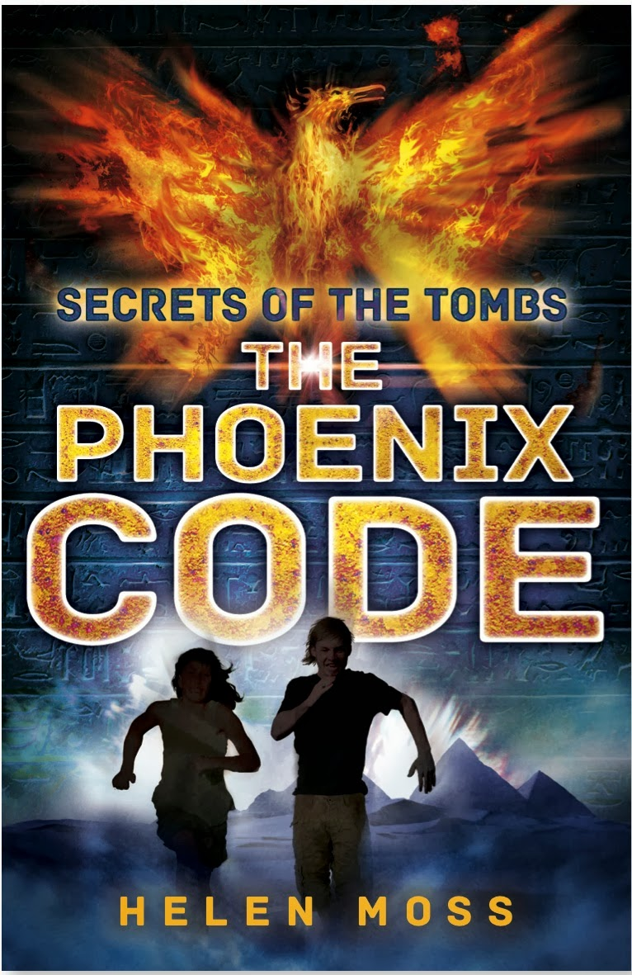

Before we start reading the book, you are going to use some of the reading behaviours.

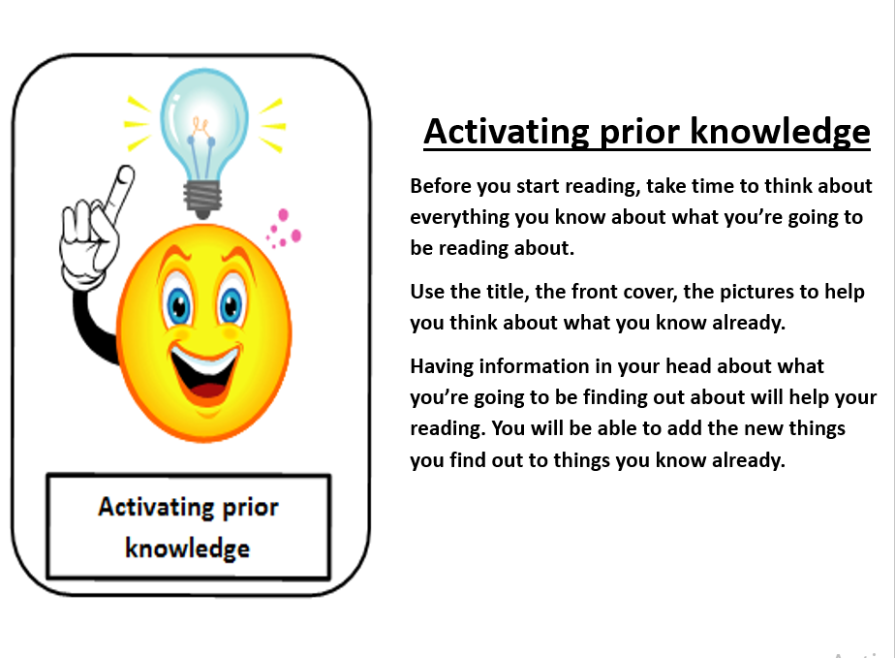

Activate your prior knowledge here:

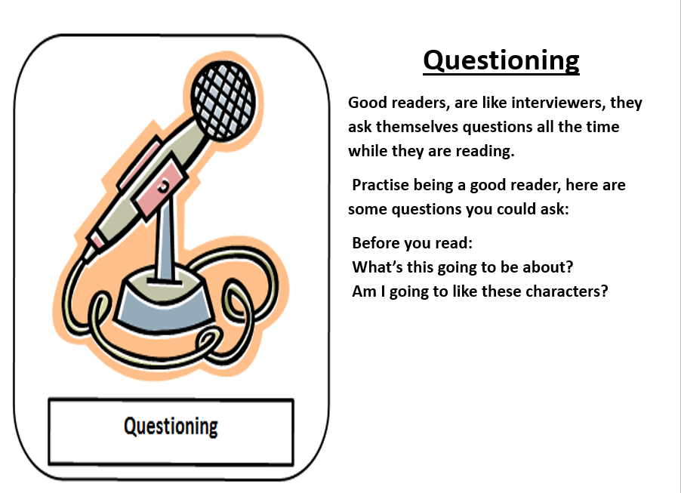

Generate your questions here:

Finally, use your predicting skills to predict what the story is about and what happens during the plot.

