
Templed Gweithgaredd Cymraeg /Welsh Mission Template 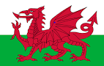

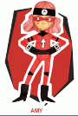
Welsh Language Mission #1:
Read the supporting documents for week 2.
Look at the Year 5/6 and 3/4 Welsh language patterns.
Choose up to 5 sentences that are to include the Welsh thematic words (words linked to your theme). You can, of course, include more than 1 Welsh word in each sentence.
Look at the examples given in the lesson plan and try to extend your sentences to up level your work.

Welsh Language Mission #2:
The Ancient Egyptians used hieroglyohics.
Look at the hieroglyphics word mat included in Focus Task 2 Overview.
Use this word mat to help you create some of the Welsh thematic words that you have learnt this week.
Here is my attempt:


