Additional Learning Needs -  ALN  E: The right to appeal to the  Education Tribunal for Wales  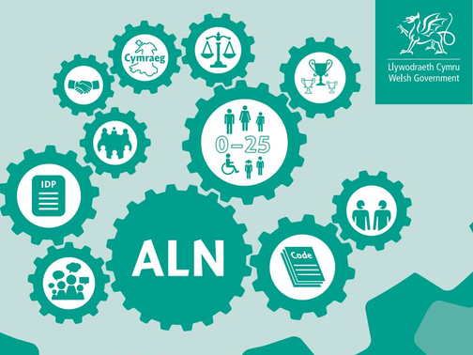  Who can appeal?  An appeal to the Education Tribunal for Wales against certain decisions made by a Welsh Local Authority can be made by :  · A child / young person.  Children and young people can make an appeal by telling the tribunal that they disagree with a decision made about their education.  · A parent.  A parent can make an appeal in regard to decisions made about their child’s ALN.  Case Friend  Children and young people can ask an adult to help them to fill in the appeal application form. If they have someone to help them, the name for this person is a ‘case friend’. The case friend must tell/ inform the tribunal that they are helping. | Early Resolution and disagreement  Early resolution of any concerns or disagreements is best for everyone and can help to avoid stress. Contact the school’s ALNCo who will arrange to meet with you in the hope of resolving any issues early.  If you are still unable to agree about decisions or provisions, Swansea Local Authority have a team of caseworkers who can support and advise you. If you think you will need support from this service speak to your ALNCo or Headteacher.  Alternatively, you can email the caseworker team directly on: caseworker@swansea.gov.uk  Health disagreements  If your concerns or disagreements are to do with a provision provided by Health services, the Designated Education Clinical Lead Officer (DECLO) will work together with the Local Authority to try and find a solution.  Information on the putting things right process can be found at:  www.sbuhb.nhs.wales/files/patient-experience/putting-things-right-information-documents/ | The Education Tribunal  for Wales  The Education Tribunal for Wales is responsible for appeals against decisions about a child or young person and their education. They also deal with discrimination claims of unfair treatment in school to do with a disability.  The Education Tribunal is independent of:  - Government  - Local Authorities  - Schools  - Further Education Institution (FEI’s)  The Tribunal hears and decides appeals and applications in relation to children and young people who have or may have ALN.  Specifically, it hears and decides appeals about the decisions of a Local Authority or FEI in Wales.  The Tribunal's decisions are legally binding.  The Education Tribunal provides advice and guidance on the appeal process and the procedures to be followed on their website:  www.educationtribunal.gov.wales  Thank you for taking the time to read this leaflet.  

