The 4 Core Purposes:
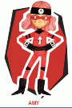
Amy – Ambitious and Capable Learners

LO: To learn some new Welsh words linked to my theme and to re-write them using hieroglyphics

Yr Aifft/Egypt
Pharaohiaid/Pharaohs
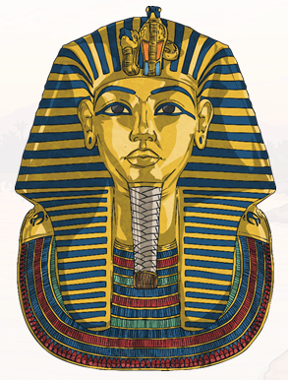
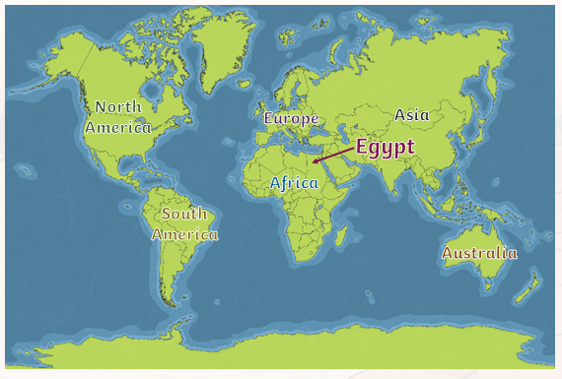

Yr Aifft

The pharaohs and the ancient Egyptians lived in a country called Egypt – in Welsh this is called Yr Aifft. They lived from around 5,000 years ago and sittuated themelves next to the River Nile – Yr Afon Nîl.
For 3,000 years the Egyptians were ruled by pharaohs which are similar to our kings and queens.
Here are some of the words that you may be learning about in the Welsh language – note: some of the words remain exactly the same!

Yr Aifft – Egypt
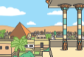
Pharo – Pharo
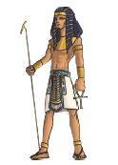
Mymi – Mummy
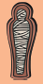
Pyramid – Pyramid
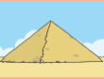

Yr anialwch – the dessert

Arch – Tomb
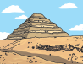
Sphincs
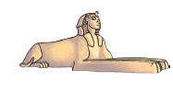
Yr Afon Nîl
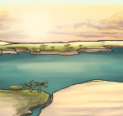
Caethwas – Slave
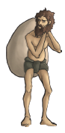
Milwr – Soldier
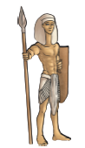

The Egyptians used a special language called hieroglyphics.
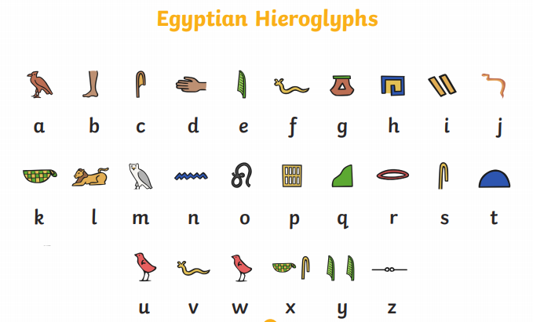

If I was to write my name in Hieroglyphics it would look like this:


