  01/02/2021 |  |  |  | Theme: Pharaohs  Year group: Year 4/5
Literacy     | Numeracy  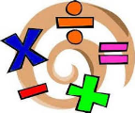   | Creative     | Thinking     |  | Healthy me    
How did the Egyptians build the pyramids?  This half term our writing genre is information texts.  An information text is a piece of non-fiction writing which gives information about a particular thing (for example: Cleopatra, Ancient Egypt, recycling or volcanoes). Information texts are sometimes called non-chronological reports, because they are giving information about something without mentioning the order in which it happened.  This week I would like you to create an information text entitled  How did the Egyptians build the pyramids?  Use the following link to start your research:  Building the pyramids  You will have to conduct more research of your own. This work should be presented in Microsoft Word or by hand.  Important: Use the checklist to ensure you have included all the relevant features of an information text.  Reading  Read chapter two of the Phoenix Code.  J2E Spell Blast  Log into Hwb and access J2E Spell Blast. Continue to practice your spelling patterns.  Ms Davies’s Welsh Missions  Read the instructions on the mission overview carefully as it will help remind you how to write a first person profile.  Choose a character. It can either be Cleopatra or King Tutankhamun  Look at the language patterns and decide which ones you can use to write a first person profile. Remember in order to do this you must pretend that you are King Tut or  Cleopatra and that you are writing about yourself.  Use pictures that I have attached to help you create your profile but you will also need to find a little more information about your chosen character too.  Up level your work by using patterns that you have not used before e.g: Yn fy marn i…...  Use the attached blank word document to write your profile  Turn in your work once you have finished.  If you need any help at all email me or message me on Teams  DaviesL1542@Hwbcymru.net  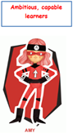 | 2-D Shape and Symmetry  Firstly, I would like to say a BIG well done to those of you attempted/completed the Oak Academy resources last week (Week 4 – based on percentages).  I know some of you found the Fractions/Decimals/ Percentages unit difficult but you used your growth mind-set and carried on.  Use the following Oak Academy lessons based on 2-D shape and Symmetry for each day: Watch the videos, complete the worksheets and quizzes for each day.  Monday : Shape and symmetry: To compare and order angles  Tuesday: Shape and symmetry: To identify right angles  Wednesday: Shape and symmetry: To identify acute and obtuse angles  Thursday: Shape and symmetry: To investigate angles within shapes  Friday: Shape and symmetry: Identify angles within shapes  Share your daily evidence with me via an email BannisterM@hwbcymru.net  MyMaths  Log into MyMaths platform via  https://www.mymaths.co.uk/  You’ve all received new allocations  linked to Angles. Remember to read the lesson materials before completing the quizzes  J2E TT Blast  Log into Hwb and access J2E TT Blast. Continue to practice your times tables. | Egyptian Social Classes and Society  During ancient Egyptian times society was very different to today. People were not equal and people were divided into different groups.  The ancient Egyptian people were grouped in a hierarchical (ranked) system with the Pharaoh at the top and farmers and slaves at the bottom.  I would like you to conduct some research on social classes and society and create your own society pyramid model. Your model can be 2D or 3D this is up to you. Make sure you include pictures/diagrams, labels and plenty of colour.  Finally, I would like you to write a paragraph on each section of your model.  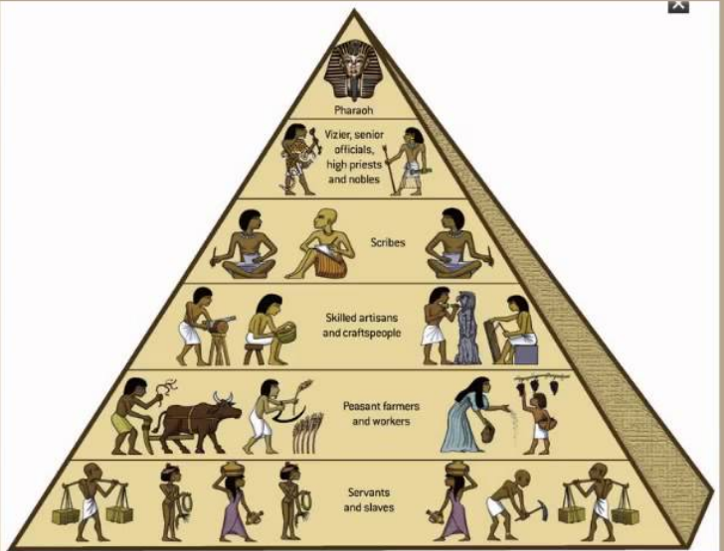  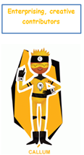  Ms Davies’s Music Missions  Friday February 5th is Dydd Miswig Cymru -Wales/Welsh Music Day  Let us celebrate our Welsh identity and learn a few new Welsh language songs.  Open the editable PowerPoint document on Teams and answer the questions  You will need a QR code reader to listen to the songs or you can type the names of the song and band into a search engine. | Farming in ancient Egypt  Farming is vastly different today compared to farming in ancient Egyptian times.  Create a PowerPoint based on farming in ancient Egypt. Use the following success criteria when building your PowerPoint:  - What did the Egyptians farm?  - Where did the Egyptians farm and why did they use this land?  - When did the Egyptians farm the land?  - What tools/ machinery did the farms use?  Remember to include pictures/ diagrams and text within your presentation.  I have created an assignment on Teams with a blank presentation for you to edit.  Remember to ‘hand in’ your presentation when you are happy.  Egyptian Gods and Goddesses Quiz  Last week you undertook some independent research based on Egyptian God and Goddesses. Using this knowledge use the following video to put your knowledge to the test.  Egyptian gods quiz - YouTube  Listen to the Gods and Goddesses as they describe themselves, can you guess who they are. Note your guess down using the word document within Teams. Were you correct? Self-mark your answers.  Science investigation – Why are trees tall?  I have created an assignment on Teams. Log in and access the information within the PowerPoint presentation this will guide you through the investigation.  Take plenty of pictures and share these we me via email (BannisterM@hwbcymru.net) or ask a parent or a guardians to sent me them via Dojo.  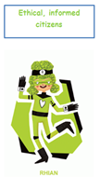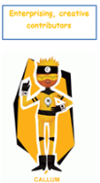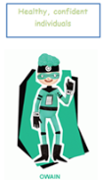 |  | Children’s Mental Health Week 2021  From 1st-7th February 2021, we are taking part in Place2Be’s Children’s Mental Health Week.  This year’s theme is Express  Yourself. Self-expression is a great way to relieve yourself of stress and free your mind.  Self-expression can help you  to reflect on your life, actions, decisions, relationships, beliefs, and thoughts — rather than keep them buried  deep down.  Use the resource ideas to explore the theme. Partake in some of the suggested activities. Take plenty of pictures and share these we me via email (BannisterM@hwbcymru.net) or ask a parent or a guardians to sent me them via Dojo.  Mrs Watts’ PSE:  Mindfulness Challenge Cards  Try some of the mindfulness challenge cards. Use https://flipgrid.com/412cd00a  to respond.  Mrs Watts’ P.E:  Click on the link to take part in a fun game that develops throwing skills:  At home P.E. activities for kids - YouTube  Try playing the game to music. Have fun!  

