First Person Profile – Information to help:

This mission will prepare you to be able to write a third person profile which is one of the Welsh writing tasks for this half term.

Back in September we wrote many first person profiles on Branwen and Llywelyn - can you remember?

In order to write a first person profile you will need to use particular language patterns and you will also need to remember that you must pretend to be your chosen character (you are writing about yourself) therefore writing in the present tense.

These are some of the patterns that you can use:

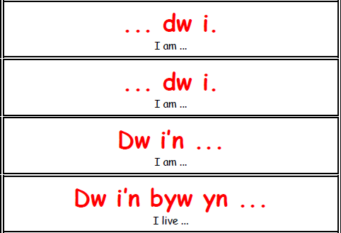
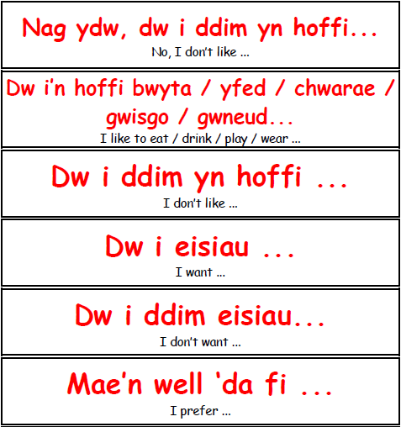
You can use the patterns beginning with ‘Dw i' (I) and some beginning with ‘Mae’ and ending with ‘gyda fi’.
** it may be worth writing down the patterns you can use before you begin writing your profile.
Write your first person profile on the PowerPoint or word document attached to the assignment.

Some useful web pages you may want to try are:
King Tut:
https://kids.nationalgeographic.com/explore/history/king-tut/
http://www.primaryhomeworkhelp.co.uk/tut.html
https://www.historyforkids.net/tutankhamun.html

Cleopatra:
https://kids.kiddle.co/Cleopatra
https://easyscienceforkids.com/cleopatra-facts/
https://kids.britannica.com/kids/article/Cleopatra/352970

But please use some other forms of research if possible.

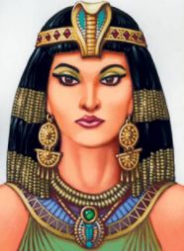

Queen Cleopatra
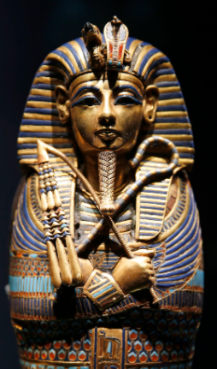
There is no evidence as such to tell us what King Tut looked like ‘in real life’. Therefore, if you choose to write a first person profile on him you can describe the image above.

Here is an example of a first person profile. You can use it to help you:
Sarah dw i. Dw i'n byw yn Abertawe mewn tŷ teras gyda Mam, Dad a fy chwaer Sophie.. Dw i'n mynd i ysgol Gors.Enw fy athrawes ydy Mrs Jones. Dw i'n naw oed. Mae fy mhenblwydd i ar Chwefror dau. Dw i'n hoffi bwyta pitsa. Fy hoff pitsa ydy pitsa pepperoni. Dw i'n hoffi mynd gyda'r teulu i Pizza Hut. Dw i ddim yn hoffi bwyta pys achos dw i ddim yn hoffi llysiau gwyrdd. Ar y teledu, dw i'n hoffi Adventure time achos mae'n gyffrous ond dw i ddim yn hoffi Ben 10 achos mae’n blentynnaidd. Dw i'n dwlu ar wisgo tracsiwt ar y penwythnos ond dw i ddim yn mwynhau gwisgo gwisg ysgol achos mae'n hen ffasiwn. Dw i'n mwynhau mynd i'r sinema gyda ffrindiau. Fy hoff ffilm ydy Turbo. Mae llygaid brown a du gyda fi a gwallt brown. Dw i'n bert. Fy hoff bwnc yn yr ysgol ydy Cymraeg achos dw i'n gallu siarad Cymraeg yn dda ond dw i ddim yn hoffi mathemateg achos mae symiau yn anodd.

If you have time there is a tarsia iaith on the bottom of the page that you can use tot test yourself. Cut it out and fold along the black lines.


