First Person Profile – Information to help:

This mission will prepare you to be able to write a third person profile which is one of the Welsh writing tasks for this half term.

Back in September we wrote many first person profiles on Branwen and Llywelyn - can you remember?

In order to write a first person profile you will need to use particular language patterns and you will also need to remember that you must pretend to be your chosen character (you are writing about yourself) therefore writing in the present tense.

These are some of the patterns that you can use:

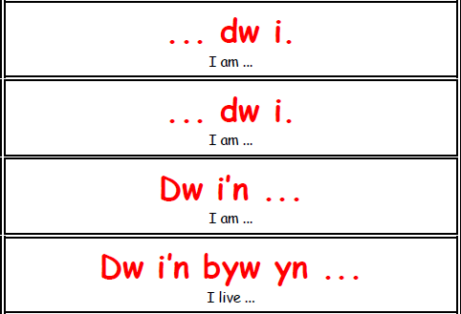
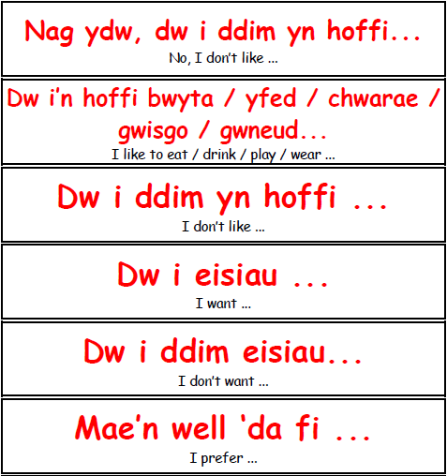
You can use the patterns beginning with ‘Dw i' (I) and some beginning with ‘Mae’ and ending with ‘gyda fi’.
** it may be worth writing down the patterns you can use before you begin writing your profile.
Write your first person profile on the PowerPoint or word document attached to the assignment.

Some useful web pages you may want to try are:
King Tut:
https://kids.nationalgeographic.com/explore/history/king-tut/
http://www.primaryhomeworkhelp.co.uk/tut.html
https://www.historyforkids.net/tutankhamun.html

Cleopatra:
https://kids.kiddle.co/Cleopatra
https://easyscienceforkids.com/cleopatra-facts/
https://kids.britannica.com/kids/article/Cleopatra/352970

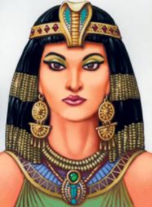

Queen Cleopatra
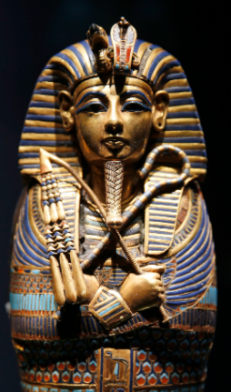
There is no evidence as such to tell us what King Tut looked like ‘in real life’. Therefore, if you choose to write a first person profile on him you can describe the image above.

Example of a Welsh first person profile:
Sarah dw i .
Dw i'n byw yn Abertawe.
Dw i'n mynd i Ysgol Gors.
Dw i'n naw oed.
Dw i'n hoffi bwyta pitsa, byrger a sglodion.
Dw i ddim yn hoffi pys.
Ar y teledu, dw i'n hoffi “Adventure Time”.
Dw i ddim yn hoffi Ben 10.
Dw i'n hoffi gwisgo tracsiwt.
Dw i'n mwynhau mynd i'r sinema. Mae llygaid brown a du gyda fi.
Mae gwallt brown gyda fi.
Dw i'n bert.
Fy hoff bwnc yn yr ysgol ydy Cymraeg.

