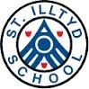
October 2019

Chair of Governors:
Mrs Emma Boucher Headteacher:
Mrs Alison Thomas

Deputy Headteacher:
Mr Matthew Bannister

Senior Management:

Mr Phil Bendle,
Mrs Gemma Harris (ALNCo)

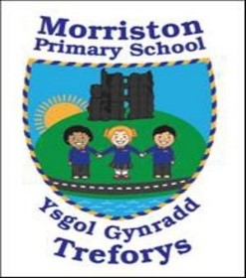
Governor’s Annual Report 2018-19

Welcome by Chair

I am delighted to present the Annual Report to Parents which describes the work, activities and achievements of our school over the last academic year. Morriston Primary School provides an inclusive environment dedicated to helping pupils be the best that they can be, reaching the highest standards they are capable of.

School life continues to be busy, with all staff ensuring
that children are provided with a wide range of experiences and activities throughout the year.

The school welcomes support from parents and the local community, and our pupils continue to benefit from the strong partnerships that have been established through initiatives such as ‘Together Tuesday’ and Family Partnership.

We are also very fortunate to have an active PTA/Parentkind who support the school for numerous events throughout the year. We are always grateful to all those who help in school on a voluntary basis. This contribution enhances the pupils’ experience greatly.

Headteacher’s comments

The annual report is an excellent opportunity to reflect on the past year at Morriston Primary School.
We have continued to develop our Curriculum to ensure we are ready for the implementation of the new curriculum. We are constantly enhancing our curriculum to include opportunities for rich tasks/enterprise and the application of skills across the curriculum.
Staff and pupils continue to work hard to fulfil the school’s mission ‘to be the best we can be.’
I would like to thank everyone involved in the school for their support and for working together as a team to continue to drive the school forward.
Mrs Thomas (Headteacher)

The Governing Body is very proud of the inclusive and supportive school ethos at Morriston Primary and the achievements and progress that have been made over the last year. The Governing Body looks forward to continuing to work with Mrs Thomas and the rest of the staff over the coming year to ensure the school moves from strength to strength.
Inside this issue:
Chair of Governors | 1
School Improvement Plan | 2
Pupil achievements | 2
Environment | 2
Additional Learning Needs | 3
School Curriculum | 3
School Results | 4-7
School Council/Welsh | 7
School Holidays/Inset | 8
Governors | 9
Finance | 10

Mrs Boucher
(Chair of Governors)

Page 2
School Environment

This year our Eco-committee and the school have been successful in attaining the Platinum Plus Eco Schools Award and Beacon School status.

We have also worked hard on other initiatives. We have:

- Continued to develop our school garden and the Foundation Phase yards.

- We have painted a mural of a forest in the school hall for Roger our Rights Respecting Owl.

- We have started to collect used batteries to recycle.

Governors Annual report

Having made good progress over the last year the Governors are now responsible for drawing up (in conjunction with staff) the School Development Plan. The plan identifies the direction the school will take over the next academic year, in delivering the curriculum and raising standards. The plan is regularly monitored and revised to take account of any changes/impact.

The main areas for development in 2019-20 are:
- Priority 1 – Raise stands of Language, Literacy and Communication Skills across the school.
- Priority 2 ​ - Raise standards in Mathematics and Numeracy across the school
- Priority 3​ – Develop teaching from good to excellent in order to meet the requirements of the new curriculum, ensuring all receive challenges that are suitable to their ability
- Priority 4 – ​Improve leadership at all levels
- Priority 5 – Ensure self-evaluation is robust and involves all stakeholders

Pupil achievements/Sporting opportunities/Extra-curricular clubs
During the last year our children have achieved academic and sporting success and we are proud of all of them. These opportunities have provided the children with valuable and worthwhile experiences. We currently run a Netball Club, Football Club, Healthy Schools Club, Eco-club, School Council, Criw Cymraeg, Dance Club, Coding Club, Signing Club, Art and Craft and Reading Club as our extra-curricular school activities.

Staffing September 2019
Nursery | Ms. Davies | Mrs Siberry (am)
OAU | Mrs Lucas | Miss Labbett (Tues-Fri), Mrs Watkins, Miss Halcrow (Mon), Miss. D. Bowen (Wed pm)
Rec/Year 1 | Miss Rees | Mrs Samuel (am), Mrs Foale, Mrs Siberry (pm), Miss Halcrow (Wed & Thurs)
Year 2 | Mrs Moore | Mrs Doherty (Mon-Thurs), Miss Sellere (Fri)
Year 3/4 | Miss White | Mrs Davies (am), Mrs Thomas, Mrs Walters (pm), Mrs Watts (Mon), Miss Sellere (Wed)
Year 4/5 | Mr Bannister  (Deputy Head) | Mrs Lovering, Miss Sellere (Mon & Tues)
Year 5/6 | Mr Bendle | Miss Matthews
STF 1 | Miss Johns | Mrs. A. Williams, Mrs. S. Carmichael (Mon-Wed), Mrs. L. Walters (am), Miss Sellere (Thurs), Mrs Moses (Fri), Miss. D. Bowen (Wed am)
STF 2 | Mrs Harris | Mr Hopkins, Mrs. J. Watts (Tues-Fri), Miss. D. Bowen (Mon pm and Fri all day), Miss. D Halcrow (Tues), Miss Melville



Did you know the school has 2 Specialist Teaching Facilities and an Observation and Assessment Unit for pupils with moderate to severe learning difficulties and autism? The OAU is a short-term placement facility where pupils attend to have further assessment. The staff in these classes have specialist skills in teaching pupils with autism. We are very proud of our Specialist Teaching Facilities which we feel hugely benefit the school and pupils involved.

Page 3

Additional Learning needs
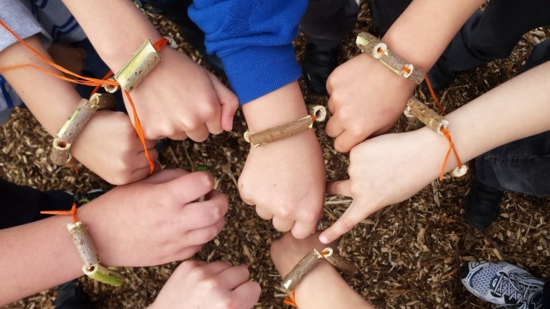
Mrs G. Harris is the school ALNCo (Additional Learning Needs co-ordinator). If you have a concern about your child’s learning or development you should initially speak to their class teacher. The teacher may then suggest a further meeting with the ALNCo should it be deemed necessary. This may lead to additional support or a teaching intervention.
We are proud that we are an inclusive school and allow all pupils to have access to the full curriculum. We have good facilities to include pupils with physical disabilities including disabled toilets.
Our school prospectus is updated every year. Call into the school or look at our website if you would like a copy.

School Commuity links/Parentkind/PTA

Parentkind/PTA contributions

The events put on with the support of the Parentkind/PTA this year have supported your children in the following ways:

-New Chromebooks
-Family Fun Day
-School discos
-Easter presents
-Father Christmas gifts
-Year 6 ‘Leavers gifts’
-Year 6 Leavers ball
Etc.

For more details/information please contact the Parentkind/PTA via the school.

The school works closely to develop and establish strong links with the community of Morriston. The PCSO’s come in regularly to speak to the children and the fire brigade also visit. We have a strong relationship with Libanus Church and we hold services there throughout the year. Our choir sing in local residential homes every Christmas. Morriston Primary PTA/Parentkind is made up of numerous parents, grandparents and volunteers
with an interest in enhancing the school for all pupils. They meet regularly to discuss and arrange a variety of fund raising and non-profit events and activities. Though raising money is a large part of their work everyone agrees the main aim is to help the school give each pupil the fullest experience possible during their time at school.

School organisation/curriculum
The school continues to offer a rich and varied curriculum. Text-types are mapped out across the year and pupils are encouraged to apply their skills across the curriculum through rich tasks and enterprise tasks. This innovative and very successful method of teaching enables pupils to apply their Literacy, Numeracy and DCF skills in a cross- curricular way and to apply the core purposes. We pride ourselves on a holistic approach to teaching, focussing on the all-round development of pupils.

Healthy Schools
We are a healthy school and sell fruit everyday as well as learning about healthy eating as part of the curriculum.

Over the last year we worked hard to attain the Healthy Schools Phase 6 Award. We are now looking forward to working toward the NQA.

Page 4

When interpreting in- formation on National Curriculum results it is important to remember that there are a number of factors that can significantly affect the results year on year. For example each child’s percentage weighting can vary depending on the size of the cohort.

Governors Annual report

School Comparative/Validation 2019 (End of Foundation Phase Outcomes – Pupils

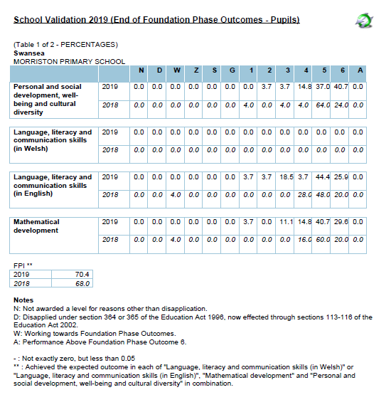
Page 5
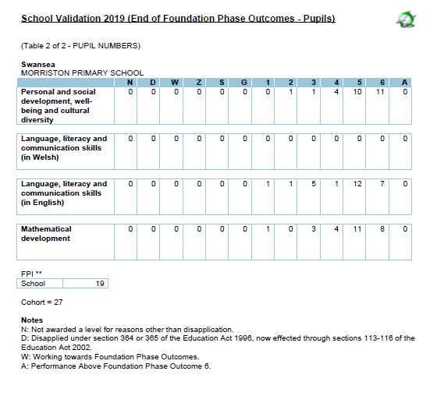

Our results include the results of our pupils who attend the specialist teaching facilities.
.

Remember LO5+ in the Foundation Phase means Outcome 5+. This is the
equivalent of a Level 2 at Key Stage 2.

Page 6
School Comparative/Validation 2019 (KS2 - Pupils)
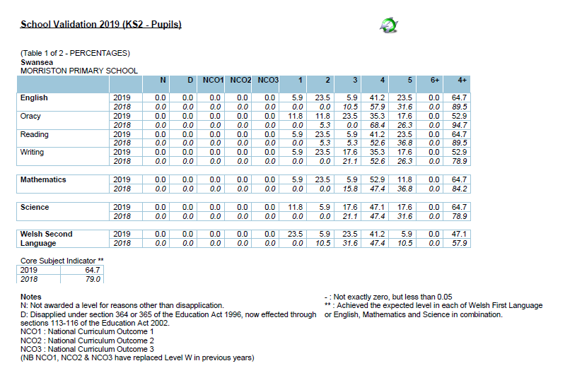

Page 7

School Comparative/Validation 2019 (KS2 - Pupils) 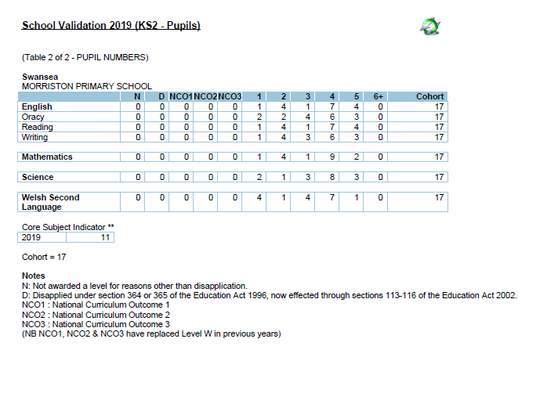
School Council
The School Council are a group of children who represent their classmates in having a pupil voice in school. Throughout the year they hold regular class surveys and meetings to discuss suggestions from their peers. A new initiative they have introduced recently has been a ‘Weekly Walk’ around the school yard.


WELSH

We are an English medium school and we teach Welsh as a second language. Incidental Welsh happens every day and children have focussed lessons based around a topic or our language patterns during the week. We have achieved the Bronze Award for the Siarter Iaith and have started to work towards Silver.

We have 5 sets of toilets through-out the school. These are cleaned every evening!!

Page 8

Morriston Primary School Terms and Holiday Dates
2019-2020 Academic Year

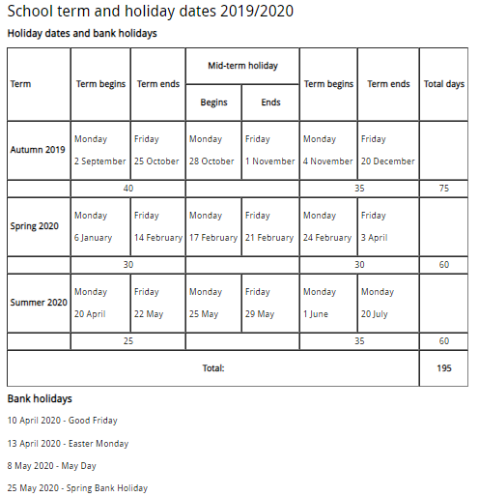

Page 9

When a Parent Governor’s ‘term of office’ comes to an end, the school will send letters home to give all parents the opportunity to apply to become a governor. If more than one parent applies then a ballot is usually held.

Governor roles and responsibilities

There is a high level of expertise within the staff & governors and there is a strong commitment to continued professional development. The governors ensure that the focus for the school is to raise standards of teaching, learning and care of the pupils. Governors are involved with the analysis of school data and setting targets and the School Improvement Plan.
The Governors have specific committees that they are involved with and they also have areas of responsibility that they focus on. This involves them coming into school to monitor their individual area of responsibility. This could involve speaking to the teacher lead for the area or meeting children and discussing their work.
Governors also regularly review school policies to ensure they are up to date and valid. School policies are made available on the school website once reviewed. Governors also receive regular training via the Local Authority. Any questions or queries should be addressed to the Chair of Governors, Mrs Emma Boucher or the Clerk to Governors, Mrs Debbie Gibbs. Both are available for contact through the school.

Meet the Governors

 | Type of Governor | End of Term
Chris Screen | Parent | 5/7/21
Emma Boucher (Chair) | Parent | 14/2/21
Louise Quinn-Flipping | Parent | 14/2/21
Melanie Phillips | Parent | 22/10/22
Hywel Griffiths | Local Authority | 26/7/21
Cllr Andrea Lewis | Local Authority | 22/2/21
Gemma Harris | Teacher | 24/2/20
Cllr Yvonne Jardine | Local Authority | 25/1/21
Kim Bass | Community | 13/5/22
Anthony Beynon | Community | 16/7/23
Clare Beynon | Community | 16/7/23
Mike Hopkins | Non-teaching | 18/9/23
Alison Thomas | Headteacher | /



Our governors receive regular
training opportunities
provided by the Local Authority.

The school’s attendance figure for 2018-2019 places the school in the top 50% of similar schools, in Benchmark Quartile 2 at 93.93%.

Morriston Primary follows the local authority and ERW graduated response. Parents are sent letters about low attendance. If attendance does not improve within 2 weeks, a second letter is sent stating that the EWO will become involved. If after a week, attendance still hasn’t improved, a third letter is sent asking the parents to come to school for a meeting.

2018/2019 | Autumn 2018 | Spring 2019 | Summer 2019
Attendance | 93.5% | 93.2% | 93.5%
Authorised Absence | 4.6% | 5.5% | 2.6%
Unauthorised absence | 1.9% | 1.4% | 3.8%
Overall for the year | 93.93%


- Page 10
FINANCIAL MANAGEMENT REPORTING

The school and governors have a responsibility to ensure there is good financial management practice in the school and that we
provide ‘good value for money’. The information below shows the budget and actual spend for the academic year 2018-19.



