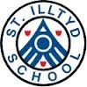
October 2018

Chair of Governors:
Mr Chris Hess Headteacher:
Mrs Alison Thomas

Senior Management:

Mr Phil Bendle (Acting Deputy Head) ,
Mrs Gemma Harris (ALNCo)

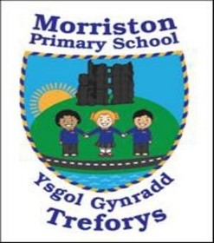
Governor’s Annual Report 2017-18

Welcome by Chair

I am delighted to present the Annual Report to Parents which describes the work, activities and achievements of the school over the last academic year. Morriston Primary school provides an inclusive environment dedicated to helping pupils be the best that they can be, reaching the highest standards they are capable of.

To this end, school life continues to be busy, with all staff ensuring
that children are provided with a wide range of experiences and activities throughout the year.

The school welcomes support from parents and the local community, and our pupils continue to benefit from the strong partnerships that have been established, especially that of the Parent Forum and the newly established ‘Together Tuesday’ initiative.

Headteacher’s comments
We are also very fortunate to have an active PTA/Parentkind who support the school for numerous events throughout the year. We are always grateful to all those who help in school on a voluntary basis. This contribution enhances the pupils’ education greatly.

The annual report is an excellent opportunity to reflect on the past year at Morriston Primary School. Following the Estyn Review Visit in July 2018, the school has been deemed to have made sufficient progress with regards to previous Estyn Recommendations, with significant progress made in developing foundation phase practice, safeguarding procedures and curriculum planning. As a school we are keen to continue to move forward and develop our practice.

Partnership working was a very important feature of our work last year. The 150-year celebrations involved the whole community and resulted in us winning a Welsh Heritage Schools Initiative Award. This project along with our Arts in Action project and Young Reader’s project significantly benefitted the pupils and the school community.
We have continued to develop our Curriculum to ensure we are ready for the implementation of the new curriculum. We are constantly enhancing our curriculum to include opportunities for Rich Tasks and the application of skills across the curriculum.
I would like to thank everyone involved in the school for their support and for working together as a team to continue to drive the school forward.
Mrs Thomas (Headteacher)

The Governing Body is very proud of the inclusive and supportive school ethos at Morriston Primary and the achievements and progress that have been made over the last year. The Governing Body was delighted to appoint Mrs Thomas as Headteacher and will continue to work with her and the staff over the coming year to ensure its continued improvement and development.
Inside this issue:
Chair of Governors | 1
School Improvement Plan | 2
Pupil achievements | 2
Environment | 2
Additional Learning Needs | 3
School Curriculum | 3
School Results | 4-7
School Council/Welsh | 7
School Holidays/Inset | 8
Governors | 9
Finance | 10

Mr Hess (Chair of Governors)

Page 2
School Environment

This year our Eco-committee and the school were successful in attaining the Platinum Eco Schools Award.

- We also worked hard to improve our school environment. We have:

- Painted playground markings on the school yard.

- Installed a summer house as a reading den on the yard.

- Continued to develop our school garden and the Foundation Phase yards.

- Removed a tree that was causing concern and replaced any old fencing on the school bank.
Governors Annual report

Governors are responsible for drawing up (in conjunction with staff) the School
Development Plan/PIAP. The plan identifies the direction the school will take over the next academic year, in delivering the curriculum and raising standards. The plan is regularly monitored and revised to take account of any changes/impact.
The main areas for development in 2018-19 are:
- R1 ​Improve standards of reading and writing
- R2 ​Develop the curriculum to ensure that it meets statutory requirements, promotes the ethos of the Foundation Phase and develops pupils’ literacy and numeracy skills across the curriculum.
- R3​ Share the good practice in teaching across the school to ensure that all pupils receive challenges that are suitable to their ability
- R4 ​Address the safeguarding issues identified during the inspection
- R5 ​Improve the effectiveness of strategic leadership
- R6 ​Ensure that targets in the school improvement plan are specific enough to enable progress to be monitored and evaluated
Pupil achievements/Sporting opportunities/Extra-curricular clubs
During the last year our children have achieved academic and sporting success and we are proud of all of them. We thank the Parentkind/PTA Association who purchased a new school football kit for us and also a parent who organised a dance afterschool club for us. These opportunities have provided the children with valuable and worthwhile experiences. We currently run a netball club, football club, eco-club, school council, Criw Cymraeg, dance club, coding club and craft and construction club as our extra-curricular school activities.

Staffing Sept 2018
Nursery/  Reception | Miss Rees | Mrs Samuel, Mrs Foale
OAU | Mrs Lucas | Miss Labett (Tues-Fri), Mrs Watkins, Miss Halcrow (Mon), Miss. D. Bowen (Wed pm)
Rec/Year 1 | Ms. Davies | Mrs Verallo, Mrs Siberry
Year 2 | Miss Cox | Mrs Doherty (Mon-Thurs), Mrs Thomas, Mrs Moss, Miss Sellere (Fri)
Year 3/4 | Mr Gorvett | Mrs Jones, Mrs Davies (am)
Year 4/5 | Mrs Watts/  Miss White | Mrs Lovering, Miss Sellere (Mon), Mrs Brown (Tues-Fri), Miss Crombie
Year 5/6 | Mr Bendle | Miss Matthews
STF 1 | Miss Johns | Mrs. A. Williams, Mrs. S. Carmichael (Mon-Wed), Mrs. L. Walters (Thurs-Fri), Miss. D. Bowen (Mon pm)
STF 2 | Mrs Harris | Mrs. J. Watts, Mrs. L. Walters (Thurs-Fri), Miss. D. Bowen (Wed am and Fri all day), Miss. Sellere (Tues-Thurs), Mr Hopkins (Thurs and Fri), Miss. D Halcrow (Tues-Fri)



Did you know the school has 2 Specialist Teaching Facilities and an Observation and Assessment Unit for pupils with moderate to severe learning difficulties and autism? The OAU is a short-term placement facility where pupils attend to have further assessment. The staff in these classes have specialist skills in teaching pupils with autism. We are very proud of our Specialist Teaching Facilities which we feel hugely benefit the school and pupils involved.

Page 3

Additional Learning needs
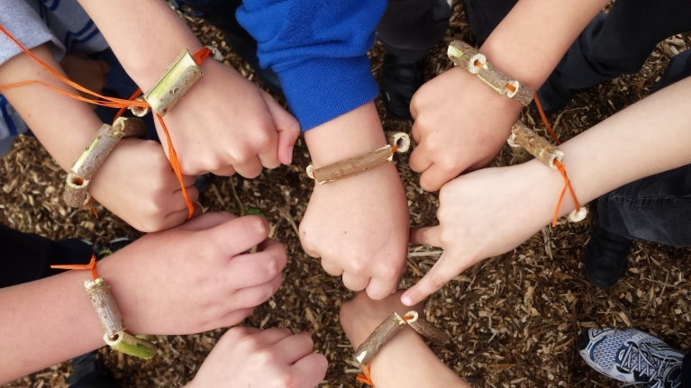
Mrs G. Harris is the school ALNCo (Additional Learning Needs co-ordinator). If you have a concern about your child’s learning or development you should initially speak to their class teacher. The teacher may then suggest a further meeting with the ALNCo should it be deemed necessary. This may lead to additional support or a teaching intervention.
We are proud that we are an inclusive school and allow all pupils to have access to the full curriculum. We have good facilities to include pupils with physical disabilities including disabled toilets.

School Commuity links/Parentkind/PTA

Parentkind/PTA contributions

The events put on with the support of the Parentkind/PTA this year have supported your children in the following ways:

Football kit
School discos
Easter eggs
Father Christmas gifts Year 6 ‘Leavers gifts’
Year 6 Leavers ball
Summer Fayre
Etc.

For more detail please contact the Parentkind/PTA via the school.

The school works closely to develop and establish strong links with the community of Morriston. The police PCSO’s come in regularly to speak to the children and the fire brigade also visit. We have a strong relationship with Libanus Church and we hold services there throughout the year. Our choir sing in local residential homes every Christmas. Morriston Primary PTA/Parentkind is made up of numerous parents, grandparents and volunteers
with a vested interest in enhancing the school for all pupils. They meet regularly to discuss and arrange a variety of fund raising and non-profit events and activities. Though raising money is a large part of their work everyone agrees the main aim is to help the school give each pupil the fullest experience possible during their time at school.

School organisation/curriculum
The school continues to offer the Cornerstones themes. Text-types are mapped out across the year and pupils are encouraged to apply their skills across the curriculum through rich tasks. This innovative and very successful method of teaching enables pupils to apply their Literacy and Numeracy skills in a cross- curricular way and to develop new skills. We pride ourselves on a holistic approach to teaching, focusing on the all-round development of pupils.

We are a healthy school and sell fruit everyday as well as learning about healthy eating as part of the curriculum.
We have 5 sets of toilets through-out the school. These are cleaned every evening!!

Page 4

When interpreting in- formation on National Curriculum results it is important to remember that there are a number of factors that can significantly affect the results year on year. For example each child’s percentage weighting can vary depending on the size of the cohort.

Governors Annual report

School Comparative/Validation 2018 (End of Foundation Phase Outcomes – Pupils

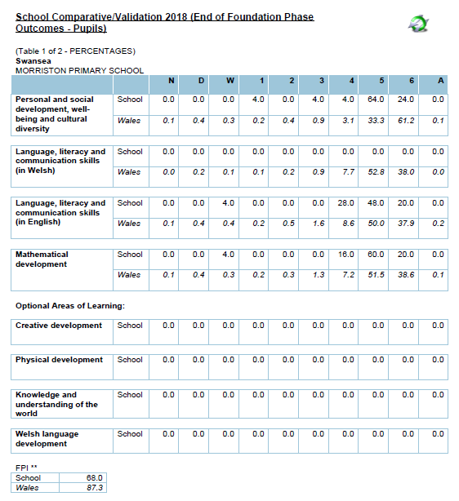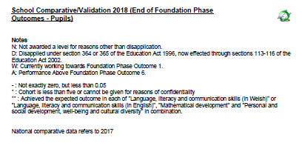
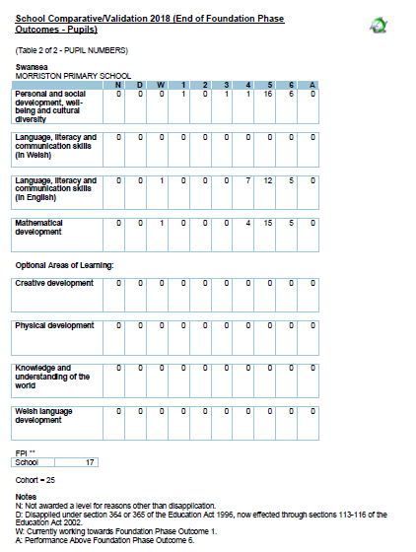
Page 5

Our results include the results of our pupils who attend the specialist teaching facilities.
.

Remember LO5+ in the Foundation Phase means Outcome 5+. This is the
equivalent of a Level 2 at Key Stage 2.

Page 6
School Comparative/Validation 2018 (KS2 - Pupils)
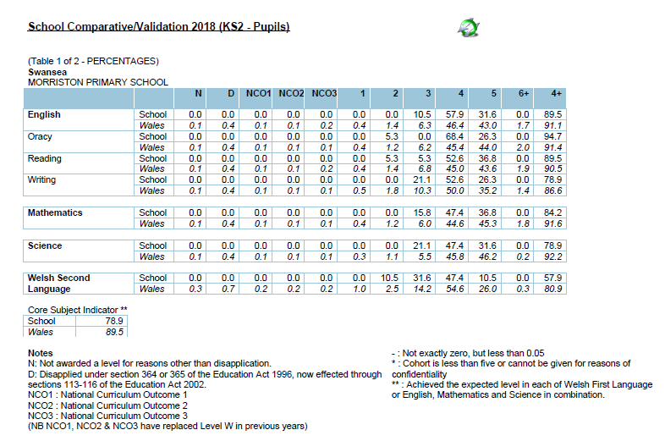

Page 7

School Comparative/Validation 2018 (KS2 - Pupils) 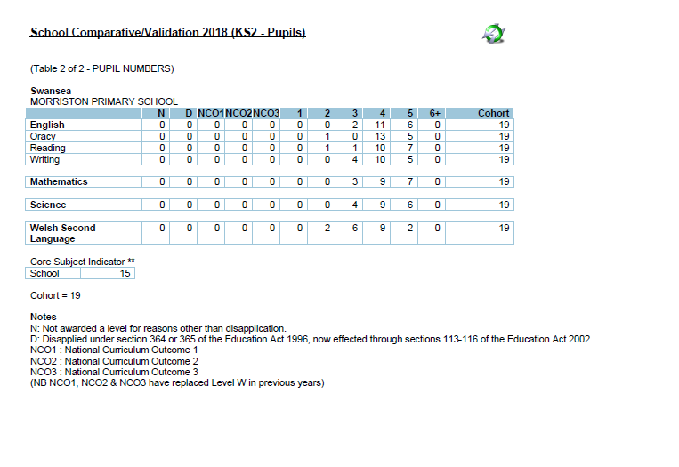


WELSH

We are an English medium school and we teach Welsh as a second language. Incidental welsh happens every day and children have focussed lessons based around a topic or our language patterns during the week. Last year we achieved the Bronze Award for the Siarter Iaith.

School council
The school council are a group of children who represent their classmates in having a pupil voice in school.
Throughout the year they hold regular class surveys and
meetings to discuss suggestions from their peers. These have included looking at play equipment on the yard and at playtime and reviewing pupil opinions on the school curriculum.

Page 8

Morriston Primary School Terms and Holiday Dates
2018-2019 Academic Year

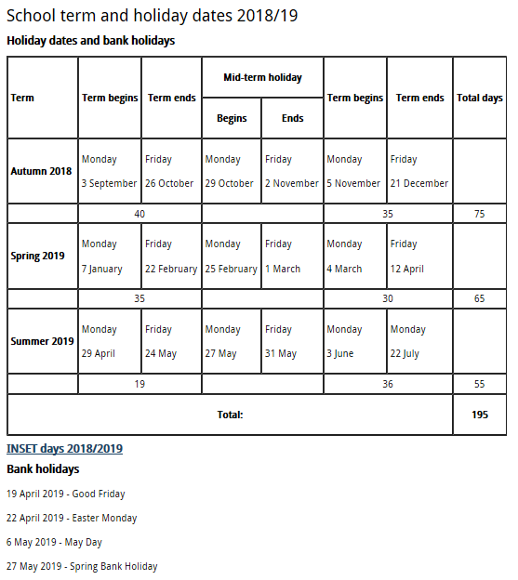

Page 9

When a Parent Governor’s ‘term of office’ comes to an end, the school will send letters home to give all parents the opportunity to apply to become a governor. If more than one parent applies then a ballot is usually held.

Governor roles and responsibilities

There is a high level of expertise within the staff & governors and there is a strong commitment to continued professional development. The governors ensure that the focus for the school is to raise standards of teaching, learning and care of the pupils. Governors are involved with the analysis of school data and setting targets and the School Improvement Plan.
The Governors have specific committees that they are involved with and they also have areas of responsibility that they focus on. This involves them coming into school to monitor their individual area of responsibility. This could involve speaking to the teacher lead for the area or meeting children and discussing their work.
Governors also regularly review school policies to ensure they are up to date and valid. School policies are made available on the school website once reviewed. Governors also receive regular training via the Local Authority. Any questions or queries should be addressed to the Chair of Governors Mr Chris Hess or the Clerk to Governors, Mrs Debbie Gibbs, both available for contact through the school.

Meet the Governors

 | Type of Governor | End of Term
Chris Screen | Parent | 5/7/21
Emma Boucher | Parent | 14/2/21
Louise Quinn-Flipping | Parent | 14/2/21
Cllr Yvonne Jardine | Local Authority | 25/1/21
Hywel Griffiths | Local Authority | 26/7/21
Cllr Andrea Lewis | Local Authority | 22/2/21
Ann Jones | Teaching Assistant | 5/5/19
Gemma Harris | Teacher | 24/2/20
Chris Hess (Chair) | Community | 19/6/20
Rhiannon Harris | Community | 23/9/20
Kim Bass | Community | 13/5/22
Alison Thomas | Headteacher | /



Our governors receive regular
training opportunities provided by the Local Authority.

The school’s attendance figure for 2017-2018 places the school in the top 50% of similar schools, in Benchmark Quartile 2 at 94.0%.
Morriston Primary follows the local authority and ERW graduated response. Parents are sent letters about low attendance. If attendance does not improve within 2 weeks, a second letter is sent stating that the EWO will become involved. If after a week, attendance still hasn’t improved, a third letter is sent asking the parents to come to school for a meeting.

2017/2018 | Autumn 2017 | Spring 2018 | Summer 2018
Attendance | 93.8% | 94.2% | 93.6%
Authorised Absence | 5.2% | 4.2% | 3.8%
Unauthorised absence | 1.1% | 1.5% | 2.7%
Overall for the year | 94.0%


- Page 10
FINANCIAL MANAGEMENT REPORTING

The school and governors have a responsibility to ensure there is good financial management practice in the school and that we
provide ‘good value for money’. The information below shows the budget and actual spend for the academic year 2017-18.



