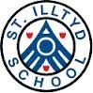
October 2017

Chair of Governors:
Cllr Andrea Lewis Acting Headteacher:
Mrs Alison Thomas

Senior Management:

Mr Phil Bendle (Acting Deputy Head) Mrs Gemma Harris (ALNCo)
Mrs Leanne Moore (Foundation Phase Lead)
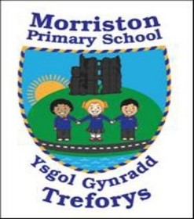
Governor’s Annual Report 2016-17

Welcome by Chair

I am delighted to present the Annual Report to Parents which describes the work, activities and achievements of the school for the last academic year. Morriston Primary school remains an inclusive environment dedicated to helping our pupils be the best that they can be, reaching to the highest standards they are capable of. To
this end, school life continues to be very busy with all staff ensuring
that children experience a wide range of events and activities
throughout the year.

The school welcomes input from parents and the local community, and our pupils continue to benefit from the support received through these strong partnerships, especially that of the Parent Forum.

Acting Headteacher’s comments
We are also very fortunate to have an active PTA, and the range of resources we have in school are greatly enhanced by their hard work and fundraising. We are also always grateful to all those who help in school on a voluntary basis. This contribution enhances the pupils’ education greatly.

The Governing Body is very proud of the inclusive,
challenging and supportive school ethos at Morriston Primary, and will continue to work with Mrs Thomas and the staff to ensure that we contribute to its development.
Inside this issue:
Chair of Governors | 1
School Improvement Plan | 2
Pupil achievements | 2
Environment | 2
Additional Learning Needs | 3
School Curriculum | 3
School Results | 4-6
School Council | 7
Welsh | 7
Governors | 8
Finance | 9

Cllr Lewis
Chair of Governors

After the Estyn visit in March 2017, we were keen to move forward and further enhance
teaching and learning in the school and improve the school environment.
The annual report is an excellent opportunity to reflect on the past year at Morriston Primary School.
Partnership working was a very important feature of our work last year and these relationships significantly benefitted the pupils and the school.
We have been working hard to make changes to our Curriculum to be ready for the changes Professor
Donaldson has recommended. We are constantly enhancing our curriculum to include opportunities for Rich Tasks and the application of skills across the curriculum.
I would like to thank everyone involved in the school for working together as a team.
Mrs Thomas

Page 2
School Environment
This year we have:

Painted inside the building and fitted new carpets in certain areas.

Decorated some of the toilet areas.

We have renovated the garden with the help of Natural Resources Wales and replaced the flooring under the play equipment with astro-turf.

We have also painted murals on the outdoor yards and renovated some of the outdoor furniture and resources,
Governors Annual report

Governors are responsible for drawing up (in conjunction with staff) the School
Improvement Plan/PIAP. The plan identifies the direction the school will take over the next academic year, in delivering the curriculum and raising standards. The plan is regularly monitored and revised to take account of any changes/impact.
The main areas for development in 2017-18 are:
- R1 ​Improve standards of reading and writing
- R2 ​Develop the curriculum to ensure that it meets statutory requirements, promotes the ethos of the Foundation Phase and develops pupils’ literacy and numeracy skills across the curriculum.
- R3​ Share the good practice in teaching across the school to ensure that all pupils receive challenges that are suitable to their ability
- R4 ​Address the safeguarding issues identified during the inspection
- R5 ​Improve the effectiveness of strategic leadership
- R6 ​Ensure that targets in the school improvement plan are specific enough to enable progress to be monitored and evaluated
Pupil achievements/Sporting opportunities/Extra-curricular clubs

During the last year our children have achieved academic and sporting success and we are proud of all of them.
We thank all staff and parents who gave up
their time to provide the children with these opportunities. We run a sports club, art club, eco-club and coding club to name but a few of our after-school activities.

Staffing Sept 2017-18
Nursery/  Reception | Miss Rees | Mrs Samuel, Mrs Siberry (pm), Miss Halcrow (Tues – Fri), Mrs Foale, Mrs Davies, Mrs Bowen (Mon am).
OAU | Mrs Lucas | Miss Labett, Mrs Watkins
Year 1 | Ms. Davies | Mrs Howells, Miss Varello (am), Mrs Siberry (pm)
Year 2 | Mrs Moore | Mrs Doherty, Miss Varello (pm), Miss C. Crombie (Fri all day)
Year 3/4 | Mr Hopkins | Mrs Jones, Miss Sellere, Miss. C. Crombie (Mon and Wed)
Year 4/5 | Mrs Watts | Mrs Lovering
Year 5/6 | Mr Bendle | Miss Matthews
STF 1 | Miss Johns | Mrs. A. Williams, Mrs. S. Carmichael (Mon-Wed), Mrs. L. Walters, Miss. S. Price (Thurs all day), Mrs. H. Moses (Fri all day)
STF 2 | Mrs Harris | Mrs. J. Watts, Mrs. M. Thoma, Miss. D. Bowen (Wed and Fri all day), Miss. C. Crombie (Tues, and Thurs all day), Miss. S. Price (Mon all day, Tues all day), Miss. D Halcrow (Fri pm)



Did you know the school has 2 Specialist Teaching Facilities and an Observation and Assessment Unit for pupils with moderate to severe learning difficulties and autism? The OAU is a short-term placement facility where pupils attend to have further assessment. The staff in these classes have specialist skills in teaching pupils with autism. We are very proud of our Specialist Teaching Facilities which we feel hugely benefit the school and pupils involved.

Page 3

Additional Learning needs
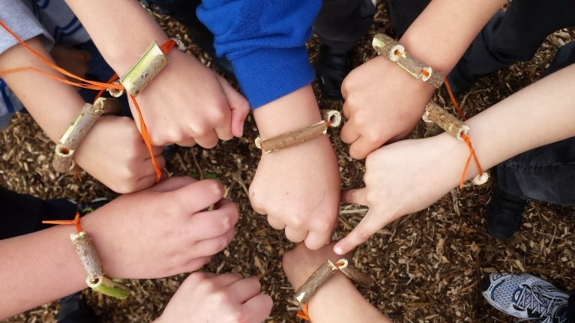
The school has an ALNCo (Additional Learning Needs co-ordinator) which is Mrs G. Harris. If you have a concern about your child’s learning or development you should initially speak to their class teacher. The teacher may then suggest a further meeting with the ALNCo should it be deemed necessary. This may lead to additional support or a teaching intervention.
We are proud that we are an inclusive school and allow all pupils to have access to the full curriculum. We have good facilities to include pupils with physical disabilities including disabled toilets.

PTA contributions

The events put on with the support of the PTA this year have supported your children in the following ways:

Coaches for trips
School discos
Easter eggs
Father Christmas gifts Year 6 ‘Leavers gifts’
Year 6 Leavers ball
Summer Fayre
Football kit
Etc.

For more detail please contact the PTA via the school.

The school works closely to

School Com m u n i t y
l i n ks / P TA

develop and establish strong links with the community of Morriston. The police PSO’s come in regularly to speak to the children and the fire brigade visit. We have a strong relationship with Libanus Church and we hold services there throughout the year. Our choir sing in local Residential Homes every Christmas. Morriston Primary PTA is made up of numerous parents, grandparents and volunteers with a
vested interest in enhancing the school for all pupils. We meet regularly to discuss and arrange a variety of fund raising and non- profit events and activities. Though raising money is a large part of our work we all agree our aim is to help the school give each pupil the fullest experience possible during their time at School.

School organisation/curriculum
The school continues to offer the Cornerstones themes. Text-types are
mapped out across the year and pupils are encouraged to apply their skills
across the curriculum through rich tasks. This innovative and very successful
method of teaching enables pupils to apply their Literacy and Numeracy skills
in a cross- curricular way and to develop new skills. We pride ourselves on a
holistic apprpach to teaching, focusing on the all-round development of pupils.

We are a healthy school and sell fruit everyday as well as learning about healthy eating as part of the curriculum.
We have 5 sets of toilets through- out the school. These are cleaned every evening!!

Page 4

Governors Annual report

School Comparative/Validation 2017 (End of Foundation Phase Outcomes – Pupils
weighting can vary depending on the size of the cohort.
percentage
each
example,
For child’s
When interpreting in- formation on National Curriculum results it is important to remember that there are a number of factors that can significantly affect the results year on year.
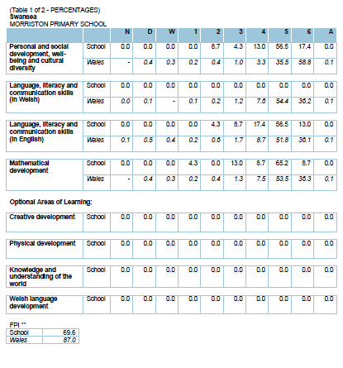
Page 5
Our results are compared against a ‘family’; that is a group of schools in a similar socio
-economic situation to ourselves.
.
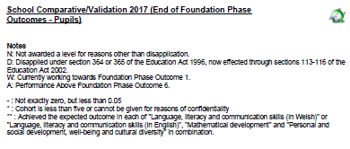

Remember LO5+ in the Foundation Phase means Outcome 5+. This is the
equivalent of a Level 2 at Key Stage 2.

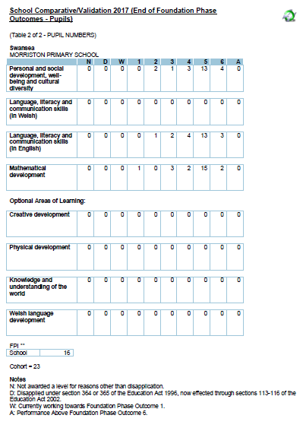

Page 6

School Comparative/Validation 2017 (KS2 - Pupils)
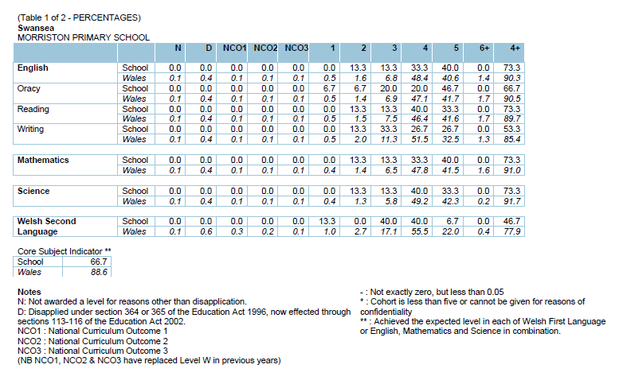
School Comparative/Validation 2017 (KS2 - Pupils) 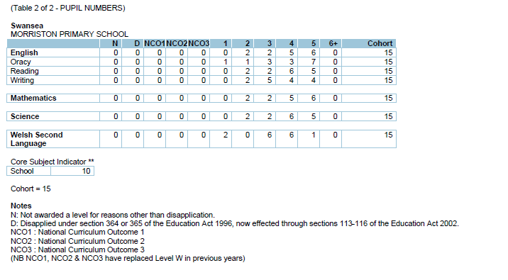

Page 7


WELSH

We are an English medium school and we teach Welsh as a second language. Incidental welsh happens every day and children have focussed lessons based around a topic or our language patterns during the week.

School council
The school council are a group of children who represent their classmates in
having a pupil voice in school.

Throughout the year they hold regular class surveys and meet- ings to discuss
suggestions from their peers. These have includ- ed looking at play equipment
on the yard and at playtime and reviewing pupil opinions on the school
curriculum.

Morriston Primary School Terms and Holiday Dates
2017-2018 Academic Year
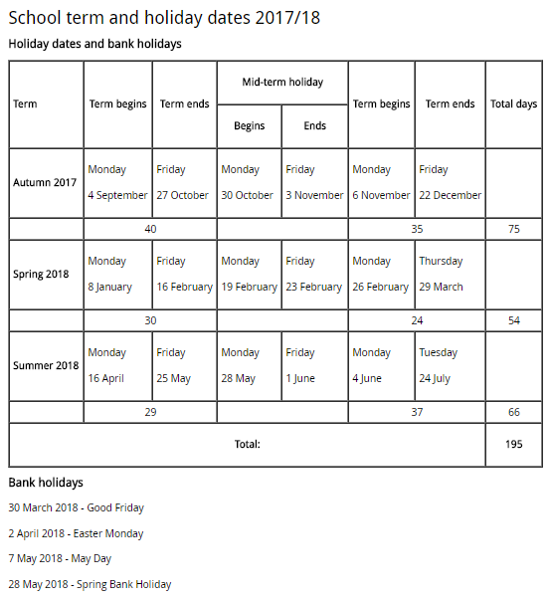

Page 8

When a Parent Governor’s ‘term of office’ comes to an end, the school will send letters home to give all parents the opportunity to apply to become a governor. If more than one parent applies then a ballot is usually held.

Governor roles and responsibilities

We have a high level of expertise within the staff & governors and we are committed to continued professional development. The governors ensure that the focus for the school is to raise standards of teaching, learning and care of the pupils. Governors are involved with the analysis of school data and setting the School Improvement Plan,
The Governors have specific committee’s that they are involved with and they also have areas of responsibility that they focus on. This involves them coming into school to monitor their individual area of responsibility. This could involve speaking to the teacher lead for the area or meeting children and discussing their work.
Governors also regularly review school policies to ensure they are up to date and valid. We intend to include our policies on our website once reviewed. Governors also receive regular training via the Local Authority. Any questions or queries should be addressed to the Chair of Governors Cllr Andrea Lewis or the Clerk to Governors, Mrs Debbie Gibbs.

Meet the Governors

 | Type of Governor
Chris Screen | Parent
Emma Boucher | Parent
Louise Quinn-Flipping | Parent
Cllr Yvonne Jardine | Local Authority
Steven Griffiths | Local Authority
Cllr Andrea Lewis | Local Authority
Ann Jones | Teaching Assistant
Gemma Harris | Teacher
Chris Hess | Community
Rhiannon Harris | Community
Julie O’Connor | Community
Alison Thomas | Acting Headteacher



Our governors receive regular
training opportunities provided by the Local Authority.

The school’s attendance figure for 2016-2017 places the school in the top 25% of similar schools, in Benchmark Quartile 1.
Morriston Primary follows the local authority and ERW graduated response. Parents are sent letters about low attendance. If attendance does not improve within 2 weeks, a second letter is sent stating that the EWO will become involved. If after a week, attendance still hasn’t improved, a third letter is sent asking the parents to come to school for a meeting.

2013/2014 | 2014/2015 | 2015/2016 | 2016/2017
93.5%  Quartile 3 | 94.6%  Quartile 1 | 94.7%  Quartile 1 | 94.8%  Quartile 1


- Page 9
FINANCIAL MANAGEMENT REPORTING

The school and governors have a responsibility to ensure there is good financial management practice in the school and that we
provide ‘good value for money’. The information below shows the budget and actual spend for the academic year 2016-17.



