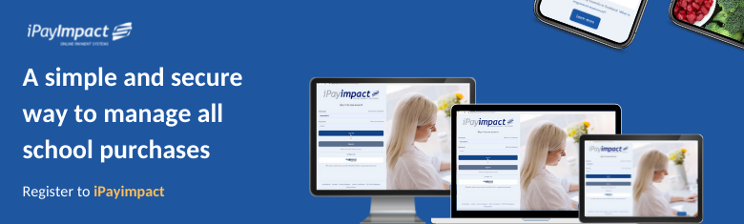

Trusted cashless payments for parents!
A simple and secure way for parents and guardians to pay for all school purchases, iPayimpact removes the need for pupils to bring cash and cheques into school, making school purchases completely cashless.

iPayimpact can be used to purchase school dinners, trips, events, tickets, and school shop, either through desktop, tablet, or a mobile phone, enabling you to review payments, purchase history and current balance anytime, anywhere.

Manage all school purchases
iPayimpact offers a simple and secure way for parents and guardians to pay for all school purchases.

Individual online user accounts provide parents with a single view over all their children’s activities, including clubs, trips, and meals account, with the ability to top-up anytime and view their entire transaction history and live cashless balance.

Secure online payments
All payments made through iPayimpact are covered under the Financial Conduct Authority (FCA) to provide parents with the highest level of payment protection.

Set-up automated payments
You no longer need to rush to look for cash or remember to top-up your child’s account on a Sunday night. With iPayimpact, you can set up automated payments daily, weekly, or monthly to ensure your child’s account always has adequate funds.

What’s more, you can also check your live cashless balance anytime, anywhere with iPayimpact.

Let’s get started

Register your account

Visit www.ipayimpact.co.uk and click ‘Register’.

Create an account
Once you have received your letter containing the Child Account Ref for your child/ren, you can register to iPayimpact by following these instructions:

- Go to www.ipayimpact.co.uk and click ‘Register’
- Enter the Child Account Ref – as provided by your school
- Enter your username and password – this is what you will use to login into your account
- Enter a valid email address and confirm
- Answer the maths test – to prove you are a human!
- Agree to the terms and conditions, and click ‘Register’
- You will receive an email with an activation link – click on the link or copy and paste the link into your browser. This will activate your account

Once activated, you can log into iPayimpact and start managing your school purchases!
What if I need help registering?
Further information can be online: www.ipayimpact.co.uk/IPI/FAQ, where you will be able to view a range of helpful articles to get you up and running in no time.

Kind regards,

<<Your school>>

