  08/02/2021 |  |  |  | Theme: Pharaohs  Year group: Year 4/5
Literacy     | Numeracy  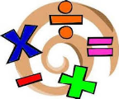   | Creative     | Thinking     |  | Healthy me    
Howard Carter – Biography.  This week I would like you to create a biography on Howard Carter.  A biography is a text about someone’s life. A biography is usually written both to inform and to entertain. This means it is a mix of factual information and creative writing. The audience is usually made up of people who are interested in the person being written about.  Conduct some independent research based on Howard Cater.  Ensure you gather information on the following:  - Year / location where he was born  - Family  - His early life and education  - His occupation (job)  - Why he became famous?  - What he will be remember for?  - Later life  - Year he died  Important: Use the checklist to ensure you have included all the relevant features of a biography.  This work should be presented in Microsoft Word or by hand.  J2E Spell Blast  Log into Hwb and access J2E Spell Blast. Continue to practice your spelling patterns.  We’re sailing down the Nile  Listen and enjoy the story ‘We’re sailing down the Nile’ read by Heather Williams from Morriston Library.  https://we.tl/t-o9DZvoljGs  Reading  Read chapter three of the Phoenix Code. If you find the text difficult, partake in some shared reading with your family.  Ms Davies’s Welsh Missions  You are going to adapt (change) your first person profile from last week into a 3rd person profile.  Look at the examples in the information to help you and try to see the differences between the two profiles. Use the information that you researched last week about either King Tut or  Cleopatra and create your 3rd person profile on one of these two historical characters.  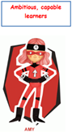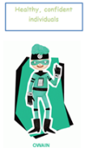 | Reading, interpreting and comparing graphs  Use the following Oak Academy lessons based on reading, interpreting and comparing graphs for each day: Watch the videos, complete the worksheets and quizzes for each day.  Monday : Reading, interpreting and comparing pictograms  Tuesday: Construct pictograms  Wednesday: Read, interpret and compare bar charts  Thursday: Constructing bar charts  Friday: Read and interpret time graphs  Share your daily evidence with me via an email BannisterM@hwbcymru.net  MyMaths  Log into MyMaths platform via  https://www.mymaths.co.uk/  You’ve all received new allocations  linked to pictograms and bar charts. Remember to read the lesson materials before completing the quizzes  J2E TT Blast  Log into Hwb and access J2E TT Blast. Continue to practice your times tables. | Egyptian Masks  In ancient Egypt, masks were used for two purposes: as death masks and as ritual masks.  This week I would like you to design and create your own mask.  Conduct your own research in masks and how and why these were used during this time. Think about the colours that were used.  Remember to share evidence of your mask with me via Dojo / email (BannisterM@hwbcymru.ent)  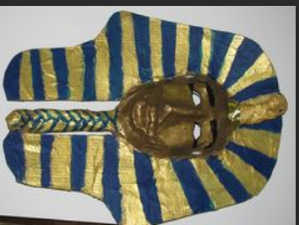  Ms Davies’ Music Mission  Copy and paste the following YouTube link into your search engine:  Lean on Me - YouTube  Listen to the song - it may help if find a quiet space to listen and it also may help if close your eyes too.  Answer the questions on the accompanying sheet which has been prepared for you.  If you have any questions please email me on DaviesL1542@Hwbcymru.net  or message me on teams  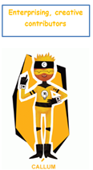 | Environmental oracy task  Listen to the following speech by Greta Thunberg.  https://youtu.be/KAJsdgTPJpU  Your task is to create a speech that inspires listeners to save the planet.  Think about what is important to you and what can be changed to help save our planet. Think about the following:  - Recycling  - Reducing waste  - Reducing emissions  - Saving habitats and eco systems for living things.  Firstly plan your speech and then record via the following Flipgrid:  https://flipgrid.com/813358b6  Africa  Egypt is in the continent of Africa. The continents are the planet’s large, continuous landmasses.  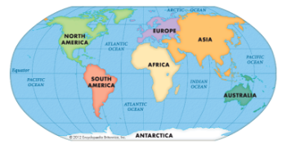  Africa is the most interesting and diverse (different) continents on earth.  It is the home for the most incredible variety of people, animals, climates and specular places.  Conduct your own research and complete the map of Africa. Remember to label each country and colour your map in. Consider the colour of your map. You may also want to include a key for your map.  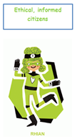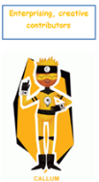 |  | Safer Internet Day  On Tuesday 9th February 2021, we will celebrate the 18th edition of Safer Internet Day with actions taking place right across the globe. With a theme once again of "Together for a better internet".    I would like you to design an Adobe Spark post displaying 10 pieces of advice on how to stay safe online.  Remember your post must be bright and colourful and share important internet safety messages. Once you have finished your graphic share with me Via email (BannisterM@hwbcymru.net)  

