MIRACLES AND JESUS
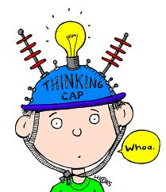
What is a miracle?
The word miracle can have 3 meanings:
- it can mean something that fills us with wonder
- it can mean an unlikely event
- it can mean something that is scientifically
impossible.

Miracles and Jesus

The Bible tells stories about the miracles that Jesus did.
It does this to show Christians how special Jesus was and that he had the power to do these kinds of things.

In fact, the
Resurrection was
the biggest miracle as it showed the
power of God over death. Christians
believe that these miracles happened as
part of their faith.

The Feeding of the Five Thousand
(The story about this miracle is told in all of the four gospels in the New Testament).
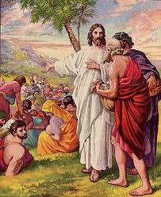
Jesus had been teaching all day to a large group of people – there were about 5,000 of them. He noticed it was getting late and asked his disciples where they could find food for the crowd.

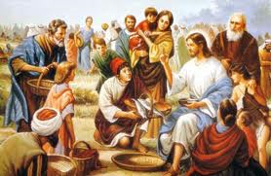
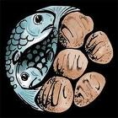
One of his disciples, Philip, said that it would cost about 8 months wages to feed that many people. The disciples found a young boy in the crowd who had a packed lunch with him – there were five loaves and two fish. The boy wanted to share his food with Jesus and the other people there. The disciples brought this to Jesus, but they did not believe everybody could be fed.
Jesus said a prayer and started to break apart the bread and fish. His disciples handed it round the crowd. There was more than enough for everyone – in fact, there were 12 baskets of leftover food.
Activity 1 – Sharing
Would you share your things?
What would you find easy to share, and what would be difficult to share?

Why?
How did it make you feel when you did share?

