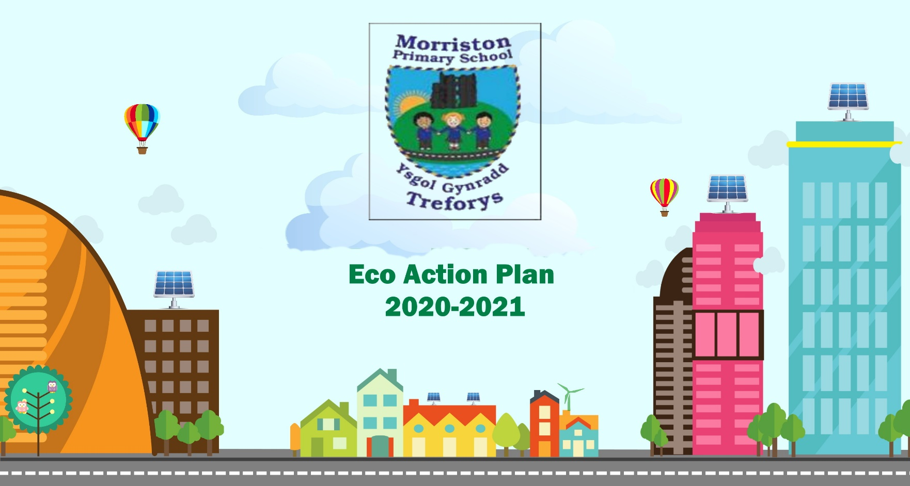
Eco Action Plan
2025-2026
DATE: Autumn Term 2025





Action plan | Date to begin | Outcome/Findings and action to be taken | Achieved/Not Achieved
Term 1 Carry out environmental review, give a copy to each class in the school to complete.  Make a powerpoint for each strand to collect evidence.  Form an action plan based on the findings of the review and decide what areas to focus on.  Draw a plan of the school yard and decide where the improvements should be made.  To design and create a new Eco Logo. | September 2025 | Review and evaluate the Environmental Review and form the Action Plan.  School Grounds with a link to Biodiveristy to form the Action Plan  Create a power point for each of the Eco Strands to begin to collect evidence from each class.



