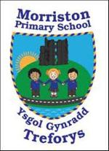
Year 4/5 – Summer term topic – ‘Scream Machine’
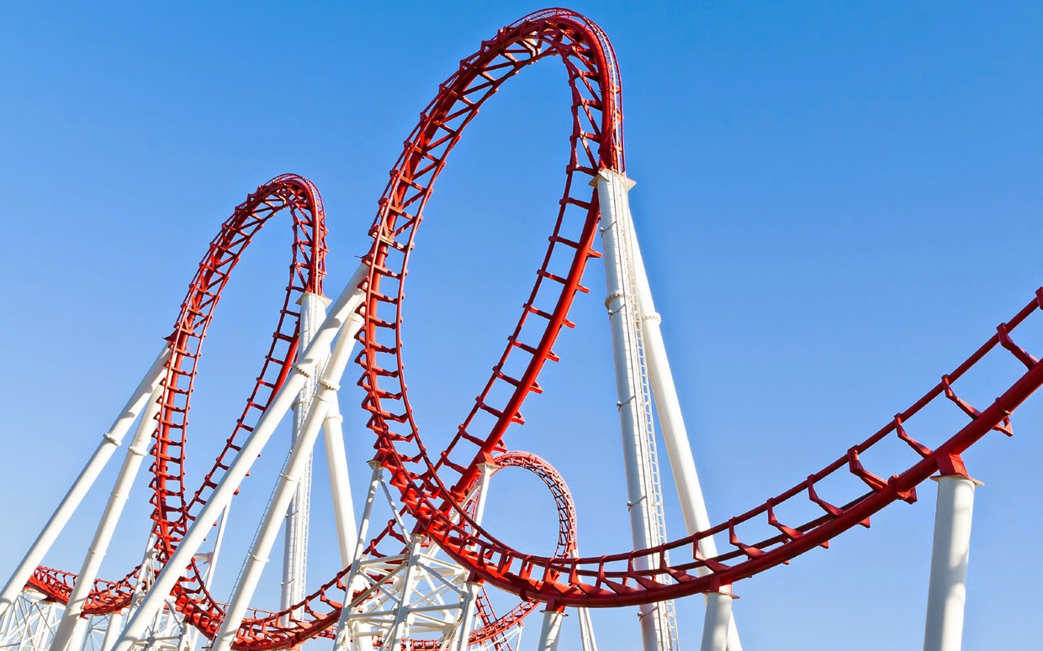

Our topic this term is entitled ‘Scream Machine’. The topic has a Science and Technology focus relating to theme parks and roller coasters.

Roll up, roll up! Year 4/5 this term are going to experience the unique sounds, sights and smells of the fair. We will learn about the science behind roller coasters and write poems that are shaped as a loop the loop. Testing, testing! Pupils will complete some mini investigations on cam mechanisms, pendulums and pulleys finding out about the forces at work at a theme park.

Pupils will also design their own theme park and death defying new drop rides! Don't forget to scream if you want to go faster!

Please take some time to discuss/work with your child to discuss possible learning / questions they would like to find out during the ‘Scream Machine’ topic. These ideas will aid future planning during the Summer Term.
Possible learning / questions to explore
Thanking you in anticipation,
Mr Bannister & Year 4/5 staff

