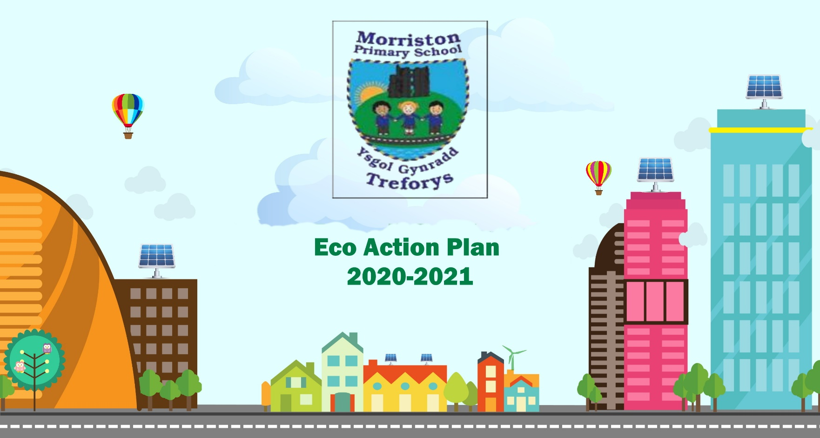
DATE: Spring Term 2026
Eco Action Plan
2025-2026

Action plan | Date to begin | Outcome/Findings and action to be taken | Achieved/Not Achieved
Term 2  Work on our ‘Big Project’ based on our findings during the Environmental Review.  Continue to work on planning what needs to be done to the schhol garden/grounds.  Involve the upper phase children in supporting with preparing the green house by clearning out.  Work on mini projects that will fit with the Eco Strands  Ie. Battery Recycling, Bird Watch, energy workshop, Dwr Cymru Workshop | September 2025 ongoing | School Grounds with a link to Biodiveristy to form the Action Plan  Create a power point for each of the Eco Strands to begin to collect evidence from each class.






