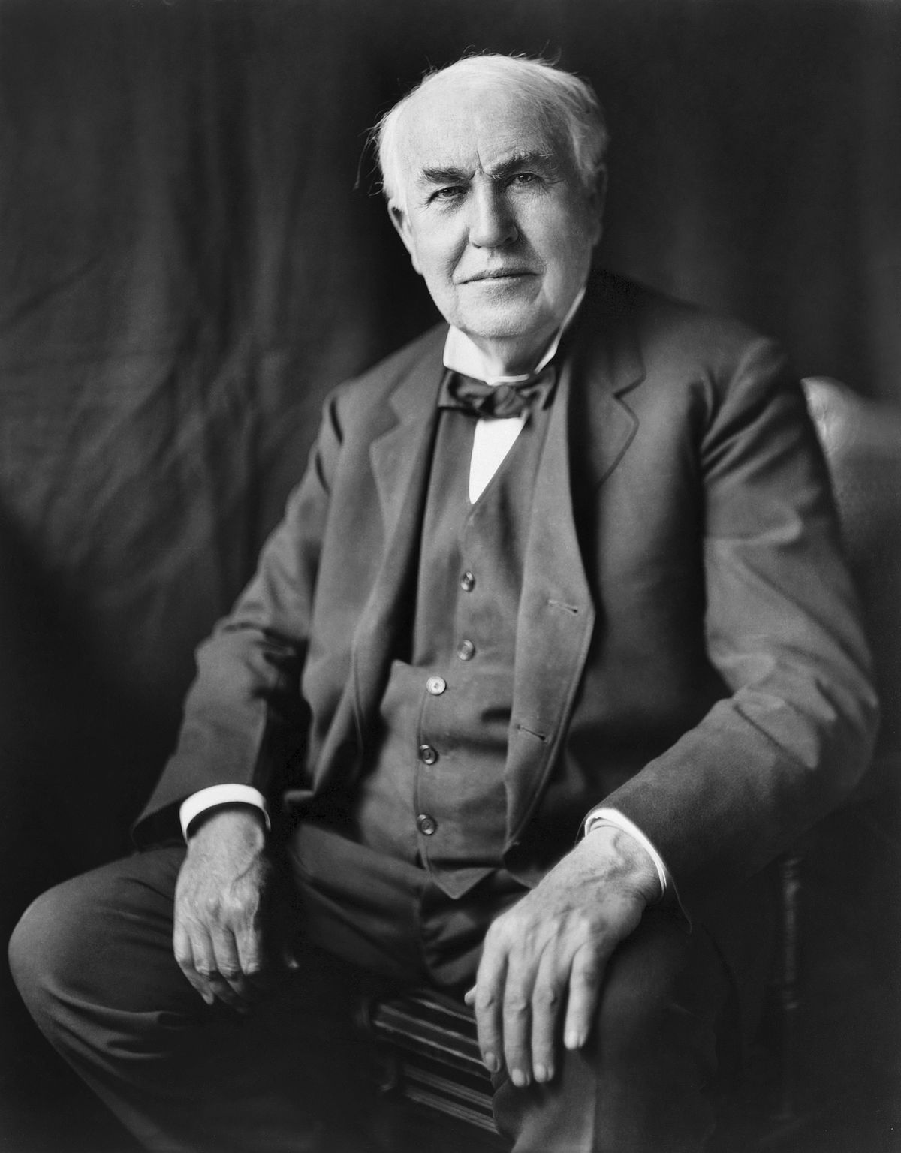
Thomas Edison - Anticipation Guide
Statement | True | False | Evidence / correct information
Thomas Edison was born on the 11th February 1847 and died on 18th October 1931. He was 84 when he died.

Thomas was born in Canada.
Due to his mother being a teacher and illness from a young age Thomas didn’t attend school. He was home schooled by his mother.
Thomas’ first job was working on a train.
At 19 years old, Thomas got a new job. He worked at night so that he could do his experiments.

Thomas’ first invention was his most famous, the lightbulb. Edison created a lightbulb that would stay lit using electricity for 13 ½ hours!
At 29 years old, Thomas moved to Washington to start a new job.
Thomas Edison died in 1931 from problems with diabetes. He was 84 years old.
In 1877, he demonstrated this amazing invention to a group of people in Menlo Park. He then became known as the ‘Wizard of Menlo Park’.

