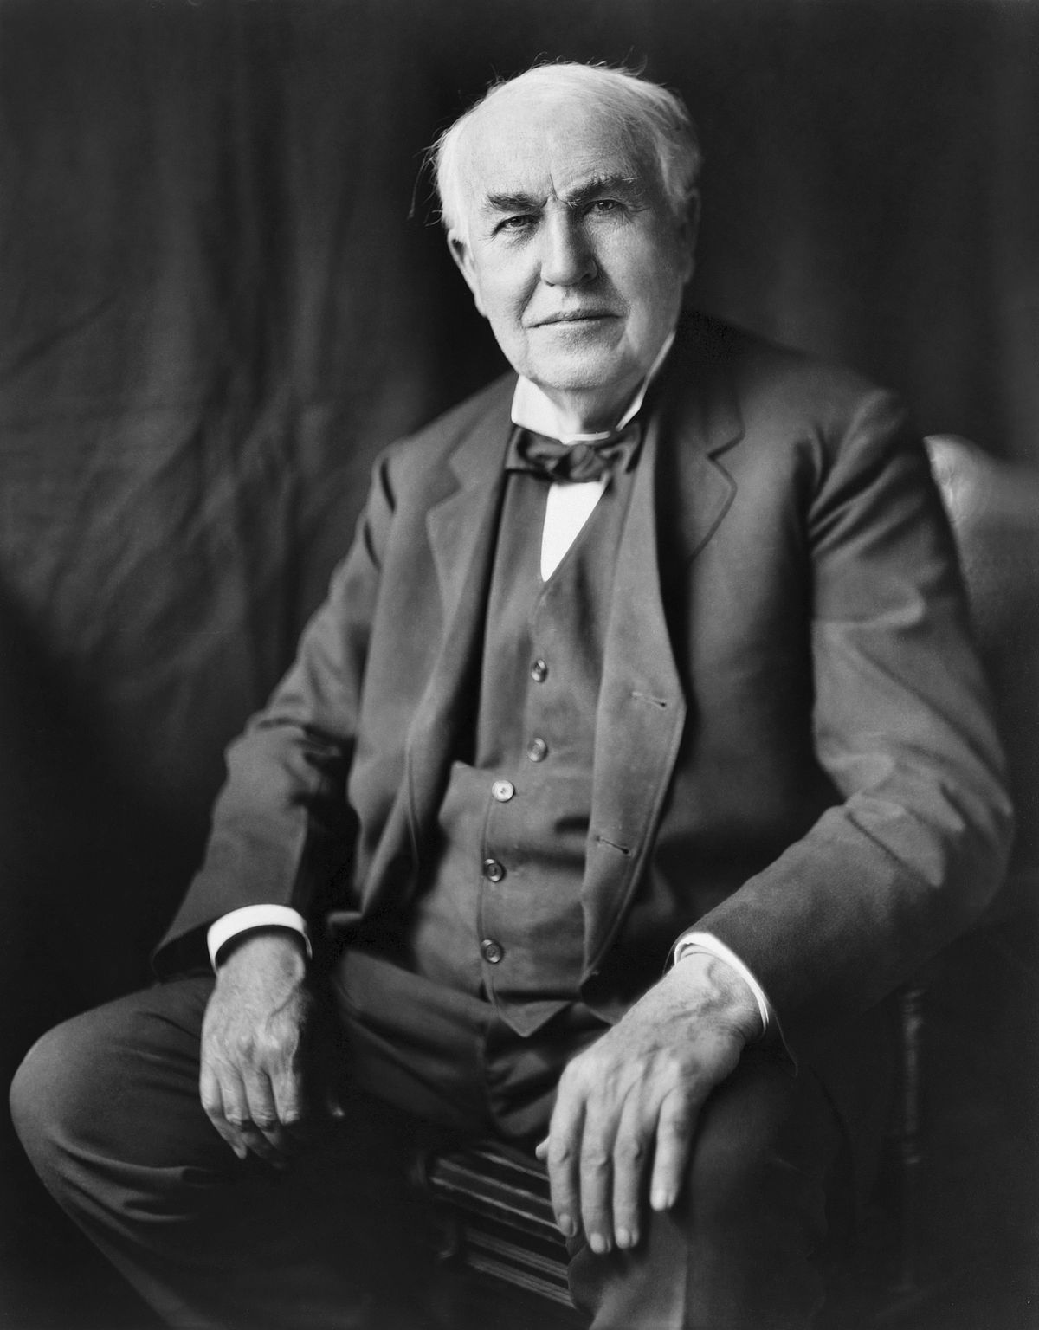
Thomas Edison - Anticipation Guide
Statement | True | False | Evidence / correct information
Thomas Edison was born in Ohio, America. He was the seventh child of Samuel and Nancy Edison.
As a child, he had hearing
problems from the illness diabetes
His father was a head teacher, so Thomas did not go to school but was taught at home.
As a teenager, tickets on trains. Quickly, he became quite a good businessman.
At 19 years old, Thomas moved to Kentucky to start a new job. He chose to work at night so that he could carry on with his experiments.
The electric lightbulb was Thomas’ first invention. This was completed in 1877
Thomas wanted to invent a light that did not need oils or gas to be lit. After some tests and changes, Edison created a lightbulb that would stay lit using electricity for 13 ½ hours!
Thomas Edison died in 1931 from problems with diabetes. He was 84 years old.

