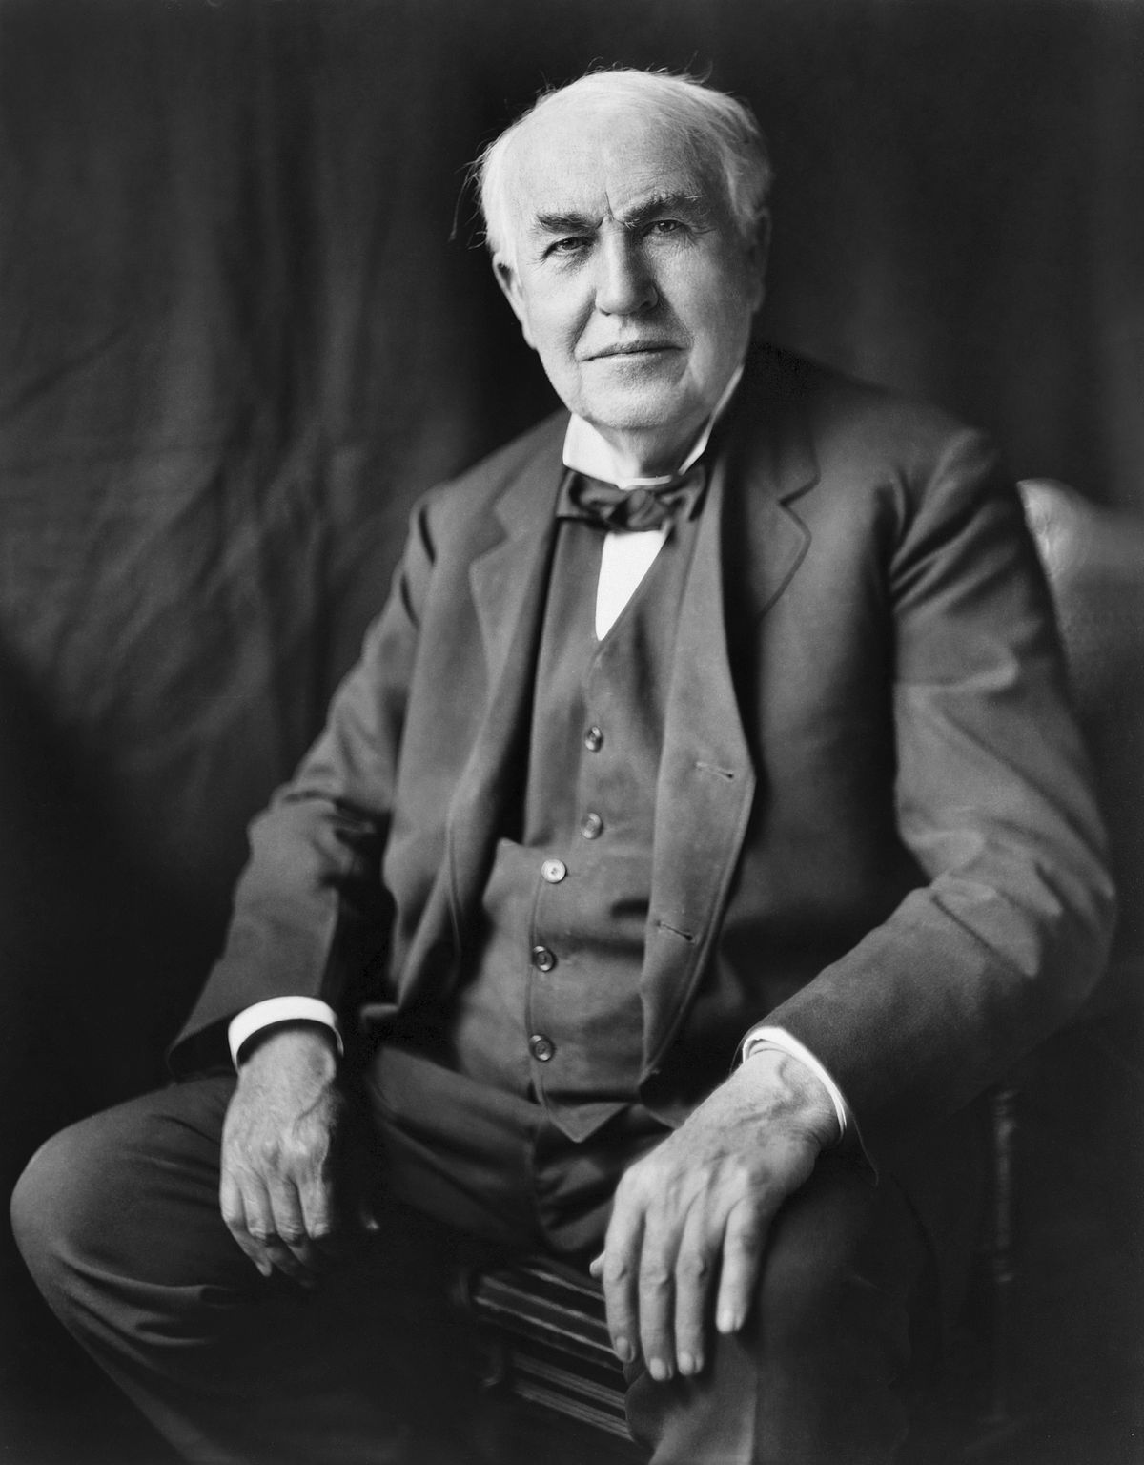
Thomas Edison
Born: 11th February, 1847
Died: 18th October, 1931 aged 84
Childhood
Thomas Edison was born in Ohio, America. He was the seventh child of Samuel and Nancy Edison. As a child, he had hearing problems from the illness scarlet fever. His mother was a teacher, so he did not go to school but was taught at home.
As a teenager, he sold sweets and newspapers on trains. Quickly, he became quite a good businessman, and with four assistants started selling newspapers on the streets.
Getting a Job
He got his first job by accident when he saved a 3 year-old boy from being hit by a train. The boy’s father was so grateful that he gave Thomas a job as a telegraph operator.
A telegraph operator: a person who operates a telephone switchboard.
At 19 years old, Thomas moved to Kentucky to start a new job. He chose to work at night so that he could carry on with his experiments. Unfortunately, he spilt sulphuric acid on the floor and it dripped through the wooden floor boards onto the desk of his boss below. Thomas Edison lost his job!
First Invention
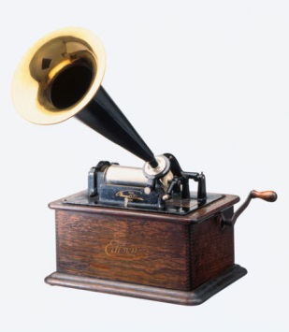
Thomas Edison’s first invention was completed in 1877 – the phonograph. This was a machine that could record and replay sound. The sound was played through a large horn. Suddenly, Thomas Edison became very famous.

The Electric Lightbulb
Thomas wanted to invent a light that did not need oils or gas to be lit. After some tests and changes, Edison created a lightbulb that would stay lit using electricity for 13 ½ hours!

In 1879, he demonstrated this amazing invention to a group of people in Menlo Park. He then became known as the ‘Wizard of Menlo Park’.
An Amazing Man
Thomas Edison was a very careful worker, who went on to become one of the most famous inventors in history. He always thought carefully about all the different things that could go wrong in his projects and how to put them right. He managed to encourage very important people to support his inventions and put money into them, so that he had the time to work on them properly.
His Legacy
Thomas Edison died in 1931 from problems with diabetes. He was 84 years old. Almost everyone in the world has used at least one of his inventions: the electric lightbulb. We are still using them today, almost 100 years later!

