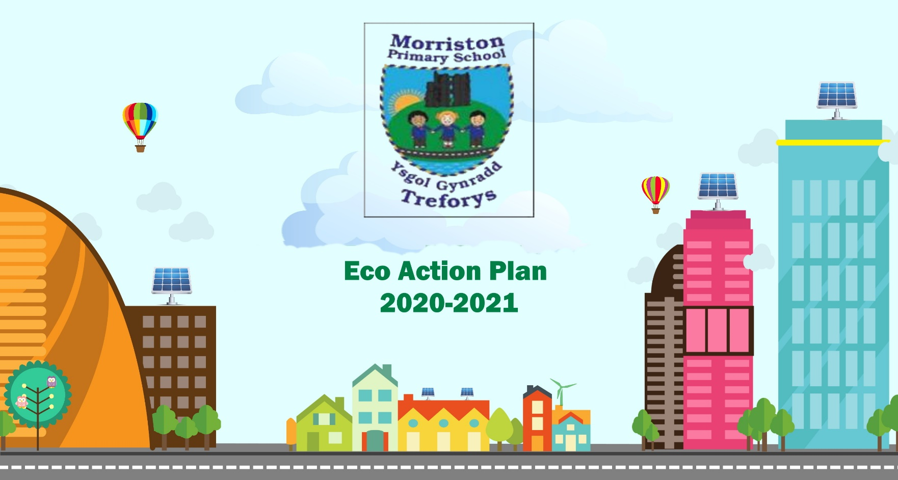
DATE: Summer Term 2026
Eco Action Plan
2025-2026

Action plan | Date to begin | Outcome/Findings and action to be taken | Achieved/Not Achieved
Term 3  Work on our ‘Big Project’ based on our findings during the Environmental Review.  Continue to work on planning what needs to be done to the schhol garden/grounds.  Work on mini projects that will fit with the Eco Strands  Ie. Battery Recycling, Grow your own Potatoes, No Mow May etc. | September 2025 ongoing | School Grounds with a link to Biodiveristy to form the Action Plan  Create a power point for each of the Eco Strands to begin to collect evidence from each class.








