  3 |  |  |  | Theme: The light bulb  Year group: Year 4/5
Literacy     | Numeracy     | Creative     | Thinking     |  | Healthy me    
Proposed Swansea Valley Wind farm development  Read the scenario and supporting evidence regarding the proposed Swansea Valley wind farm development.  Once you have read and understood the text, your task is to use the information about the proposed wind farm project to give your views about the development.  Are your for or against the proposed project? Your opinion must be supported by evidence why the project should/should not go ahead.  Welsh – Ar y penwythnos  Use the ‘Es i’ word mat to build a recount about your weekend. You can make up details (I’m not going to check what you did!).  My Rising Stars  Login to the My Raising Stars website using your username and your password.  You will see I have allocated you a book to read with linked comprehension to complete. | Numeracy  Login into your MyMaths and access the Time and Timetables lesson and homework that have been set for this week.  Time tables booster pack  Remember I have allocated you times tables booster packs for revision in addition to your set lesson/homework. | Art & Design - My Silhouette Drawing  You are nearing the end of your journey in Year 4/5 but you have another exciting journey ahead of next academic year.  Create a silhouette drawing of yourself and fill it with images that represent you as a person (you could include drawings of your hobbies, pets and things that are important to you.) You may want to research some silhouette pictures before you make a start on yours just for inspiration  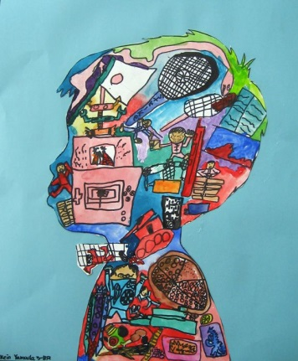 | Science – Global Warming  Watch the following video based on Global Warming  https://youtu.be/7ZnvFkiZmDM  A carbon footprint is a measure of the impact our activities have on the environment. It calculates the greenhouse gases we are expected to produce in all our activities and measures them in units of carbon dioxide (CO2)  Use the template provided to create your own ideas how to reduce your carbon footprint  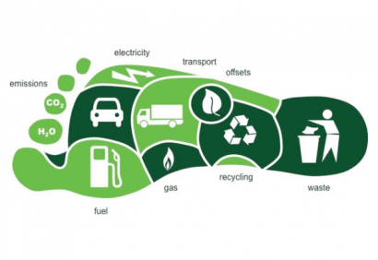  Geography – Four figure grid references  Use the following link to learn about four figure grid references.  https://www.youtube.com/watch?v=c0du8v4EE_Y  Use your new grid referencing skills to complete the questions.  ICT  Login to Flipgrid and create a response on how you could reduce your carbon footprint.  https://flipgrid.com/800fd3f7 |  | Transition - ‘Five Top Tips’  Create a ‘Five Top Tips ‘poster for our current Year 3/4 children which will help them to be successful in Year 4/5.  Think of things that have helped you to achieve and succeed in Year 4/5. Your poster needs to be bright, clear and eye-catching and can be presented in a format of your choice (e.g. by hand or on the computer.)  P.E  Balance - Follow the following lesson  https://www.youtube.com/watch?v=zcgTZp40w-Q

