What I already know. | What I want to find out. | What I have learnt.

This term’s topic is ‘Allotment’. This topic is all about growing things and the lifecycle of crops and plants. During the topic we will learn about different crops and how these are produced in farms across the world.
Write all the things you already know about allotments, plants, fruits, vegetables, crops and farming in the 1st column. In the middle column list the different questions you would like to find out during this topic. Leave the final column empty, we will complete this when the topic is coming to an end.
Allotment

Numeracy / Health and Well being

Over a week keep a food diary; note all the different fruit and vegetables you eat and drink, use a tally chart to keep a record. Once the week is over, convert your tally chart into a bar graph (if you feel confident use Hwb tools e.g excel or J2E to create your bar graph). What fruit and vegetables do you eat the most/least of?
Expressive Arts

Go out in your garden/ outdoor space and sketch a flower or a plant. When you have finished your sketch, use a range of media to add colour. Different media could include:
- Crayons
- Colouring pencils
- Paints
- Felt tip pens
- Chalks

Science and Technology

Earth Day is celebrated on Wednesday 22nd April. Billions of people all over the world celebrate the world and encourage more understanding about the environment and climate change.
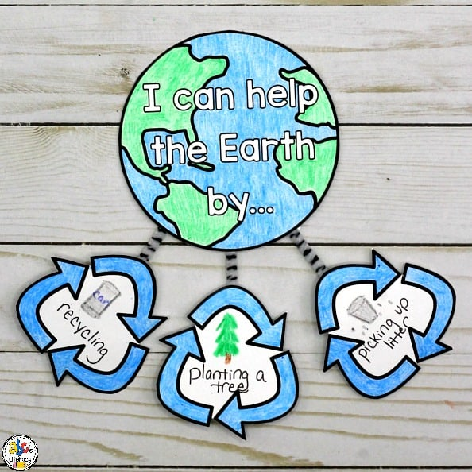
Create a poster on what three actions you could do to help the earth and environment.
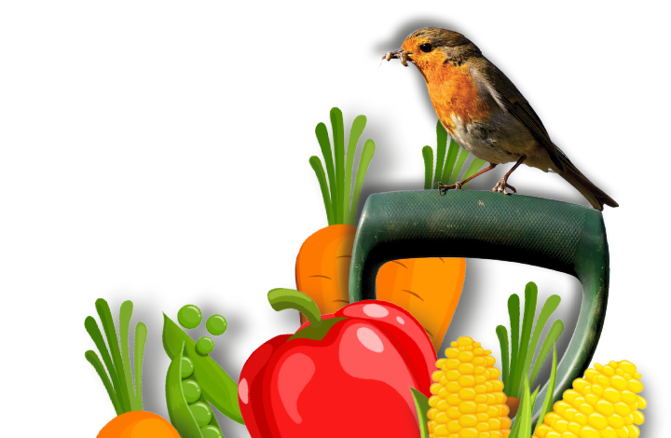
Allotment

Humanities

Research the history of allotments. Why were allotments first created? Who used allotments? What did they use allotments for? What were allotments used for during World War II?
Languages, Literacy and Communication

Create an acrostic poem about Earth Day. Remember an acrostic poem is a poem where certain letters in each line spell out a word or phrase. Typically, the first letters of each line are used to spell the message. When you have created your poem email or send me a copy via Class Dojo

