Health & Wellbeing
The human body needs a balanced diet to work properly. Good health involves drinking enough water and eating the right amount of foods from the different food groups: Find out some more information about the following groups:
- Carbohydrates
- Proteins
- Fats
- Fibre
- Vitamins and Minerals

Languages, Literacy and Communication
Write a story starter about a mysterious plant (perhaps it may be a dangerous plant?!). Consider the following:
- Setting
- Characters
- Plot
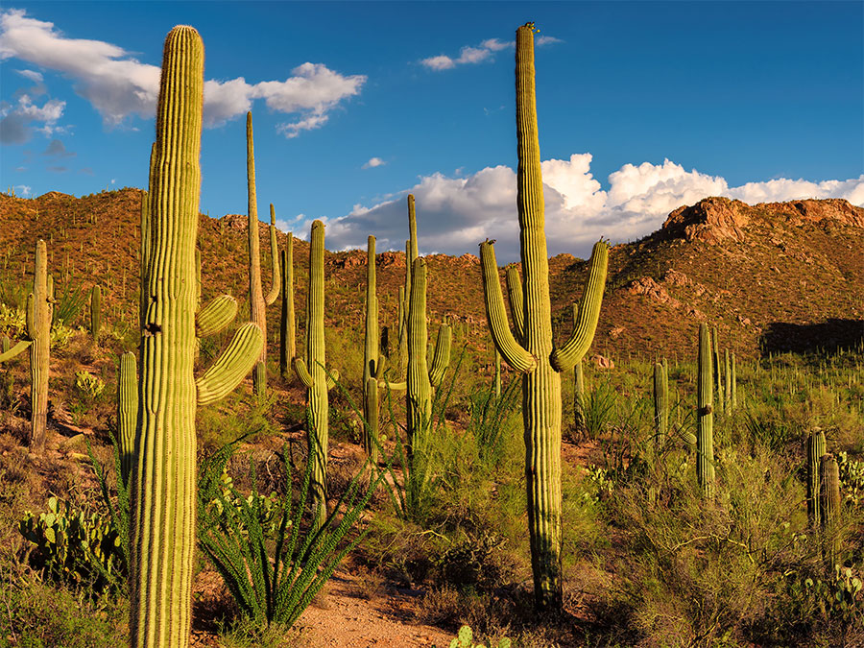

Expressive Arts
Make some observational drawings (drawing what you see) of different plants, fruits, vegetables and seeds using a range of resources.
Keep a sketch book which has a range of different observational drawings.
There are some good videos online which teach observational drawing techniques.

Humanities
Learn about the different types of farming in the UK. It is up to you how you choose to display your findings. You may want to create one of the following:
- Information poster
- PowerPoint via Hwb
- Information text
Mathematics and Numeracy
Design an allotment that can provide something to be harvested each month of the year using the information on the following page. Remember to include a shed in your design for storage of the essentials – tools, seeds, compost and a wheelbarrow.
Remember to use a ruler and pencil when designing your allotment.
Make sure you label your design.

Week 6 – Home Learning Activities

Science & Technology
Keep an observational diary of a plant that you may have in your garden or outdoor space. What changes do you notice? What conditions does your plant need to grow?

Carrots  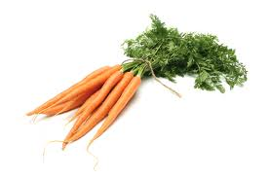  All year | Brussel sprouts  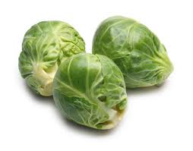  August to December | Courgettes  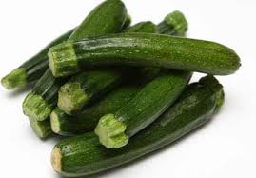  July to October | Leeks  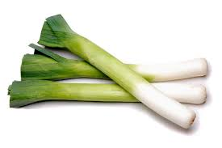  August to January | Lettuce  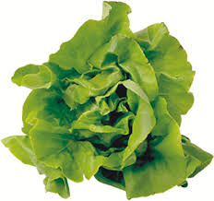  June to October
Onion  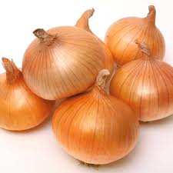  July to September | Potatoes  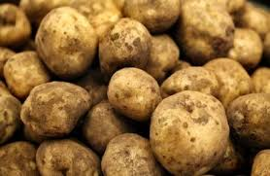  June to October | Peas  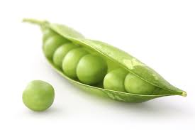  June to October | Pumpkins 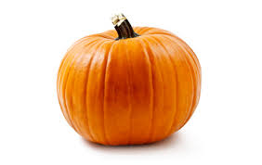  September to November | Turnip  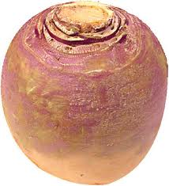  March to December
Tomatoes  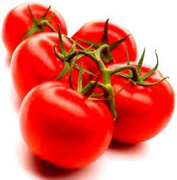  August to October | Raspberries 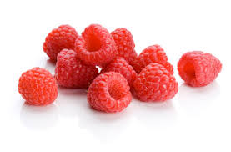  June to October | Strawberries 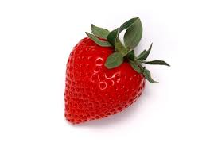  July to August | Apples 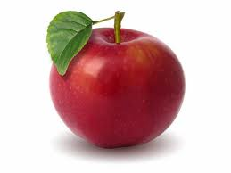  August to November | Pears  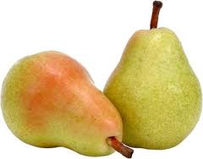  August to November
Cabbage 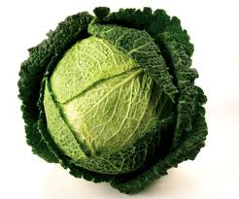  July to April | Cauliflower  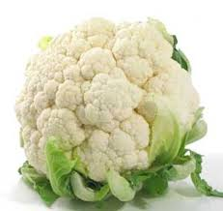  March to June | Cauliflower  September to December | Garlic  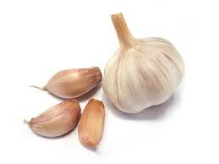  June to August | Rhubarb  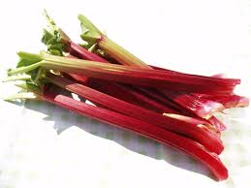  April to July

