Expressive Arts
Vincent van Gogh is one of the world’s most famous artists. Van Gogh is famous for many different paintings, one being Sunflowers.

If you havent seen this painting before, use the internet or other media to familarise yourself with it, then create your own painting of ‘Sunflowers’

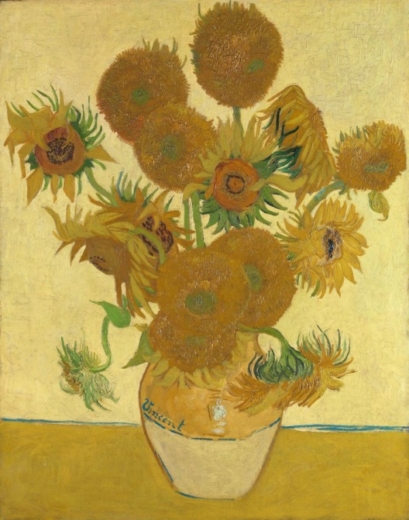
Humanities
Vincent van Gogh was from Holland. Create a fact file about Holland and Vincent van Gogh. It is up to you what you include in your fact file but here are some ideas:
- Where/when he was born
- Where/when he died
- Holland is in what continent
- Language spoken in Holland
- Currency

Languages, Literacy and Communication
Using the Pobble resource ‘The Sunflower’ read the short passage and answer the questions in each of the following sections:
- Question Time
- Sentence Challenge
- Sick Sentences
- Perfect Picture

Week 8 – Allotment / Sunflowers

Science & Technology
Plants have many different parts. Each part plays an important role in keeping the planet healthy. Find out the functions of each of the following:
- Roots
- Stem
- Leaves
- Flower
Mathematics and Numeracy
Sunflower Line Chart (Please see page below). Some data has been collected on the growth of a sunflower.
The height of the sunflower was measured every two days.
Answer questions 1-4.
Health & Well-being
Go and sit down in your garden/outdoor space. Close your eyes for 2 minutes. After the 2 minutes is up, note all the different things you heard.
Divide your list into man-made and natural. What did you hear the most? What does this tell you about the area you live in?



