Expressive Arts
Georgia O’Keeffe is a well known artist for her close up and detailed paintings of flowers.

Use your garden/outdoor space and make detailed drawings /painting of plants and flowers.Use a magnifying glass if you have one or look closely to study the patterns on the petals and leaves as well as the veins and tiny hairs.

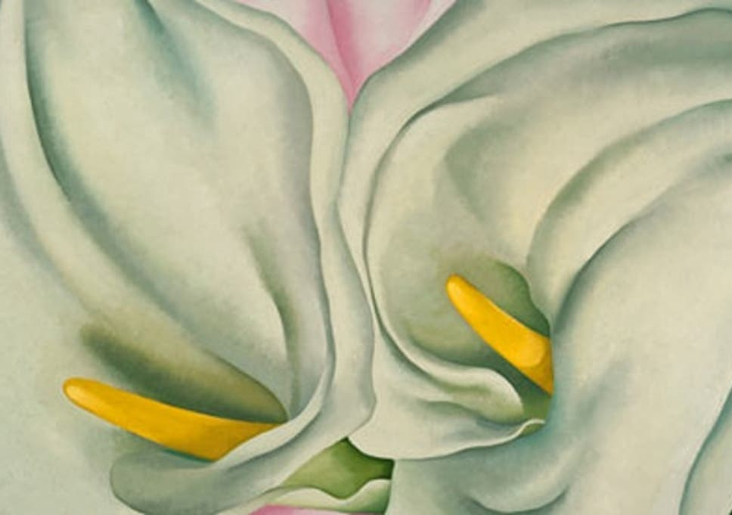
Humanities
Choose five fruits and vegetables of your own choice. Find out country of origin of each. Display your finding on a World Map.
Extension:
Explain what growing conditions are needed for each fruit or vegetable. Could the fruit and vegetables you have chosen all be grown in Wales? If not, why not?
Languages, Literacy and Communication
Read the poem ‘Grandad’s Garden’ by Melaine Water (on Page 2).
After reading the poem several times uses your visualisation skills to draw what you think Grandad’s Garden would look like. Remember to colour your visualisation in.

Week 9 – Allotment

Science & Technology
Watch the following video about pollination and how it works https://www.youtube.com/watch?v=j-S5ui9Us7U

As you are watching make notes of the important details and key vocabulary. You may have to watch the video a couple of times to ensure you’ve got all the details. Once you are happy with your notes. Make a poster to explain the process of the pollination.

Mathematics and Numeracy
Mr Smith has an allotment and he plants and harvests different vegatables at different times of the year. The chart (on page 3) shows the dates of planting and harvsting.
Calculate the length of growing time and complete the table .Don’t include the first date but count the last date. Use the caldendar to help you. The first one has been done as an example.
Health & Well-being
Mental Health Week this year starts today (Monday 18th May) and this year’s theme is ‘Kindness’.
Throughout this week carry out acts of kindness around your house with your loved ones. Keep a ‘Kindness diary’ noting acts of kindness each day and who this helped - your parent/guardian/ sibling?

Grandad’s Garden
In the corner of his garden, there's a patch he used to keep
All to himself, to allow nature to creep
There are no trimmed edges
or prim, proper hedges
He left his earth still and alone
Allowed the forces of nature to roam
He said that you don't always have to be tidy and neat
Just watch the beauty of opportunity grow at your feet
He said just watch the earth produce its own glory
And I watched...and held on to his story
My grandad was right
Add water and light
Behold the sight
There are poppies and flowering weeds
Buttercups and oat coloured reeds
Daisies gingerly lift their heads
Dandelions roar from muddy beds
Purple thistles and strange grasses
Colours that alight and ignite masses
Dark ferns and heathers
Dandelion clock feathers
Birds foot trefoil, a four leafed clover
My grandad's story is not over
He may have gone, I may have cried
But the beauty he predicted never died.
By Melaine Waters


