Welsh / Curriculum Cymreig
After the half term Ms Davies would normally be starting a new Welsh/ Expressive Arts topic with us. This topic is ‘The Beach’
On Page 2 of this document there are some topic words I would like you to start practicing saying and writing. Ms Davies has kindly included a QR code of her saying these topic words correctly. How many did you pronounce correctly?

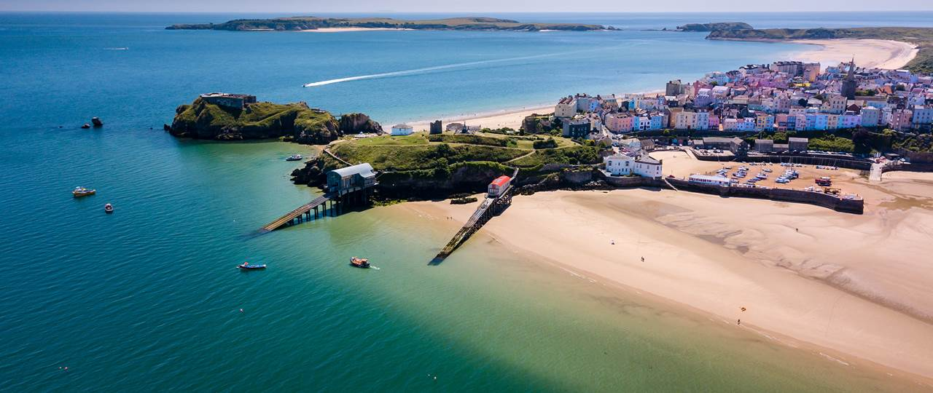

Pupil Comments – for end of Year Reports.
Work with your parents/guardians to write a paragraph which will be included in your end of year report.
Use the following questions to help you build your paragraph:
- Your Name:
- My Best Friend:
- My Funniest Moment:
- My Favourite Moment:
- I am Especially Proud of:
- My Next Steps (One Target):

Once you are happy with your paragraph either email it to me via BannisterM@hwbcymru.net or ask your parent/guardian to send me a picture of your paragraph on Class Dojo.

Week 10 – Half Term Homework


Welsh words and pronunciations with English meanings:


Barcud - kite
Môr – sea
Hufen Iâ – ice cream
Cerrig – stones
Goleudy - lighthouse
Cregyn - shells
Cwch – boat
Haul – sun
Bwced - bucket
Tywod - sand
Tonnau – waves
castell tywod – sand castle
Picnic – picnic
Het haul – sun hat

