Expressive Arts
Using the collection of leaves (See Science and Technology Task) use a plain piece of cloth (e.g old bed sheet) and place the leaf underneath and use a rock to bash the cloth to create a print of the leaf.

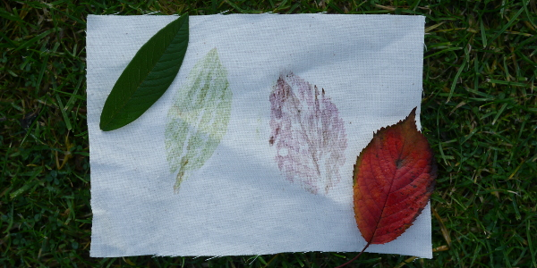

Humanities
Use the map on page two to describe how farming changes throughout the United Kingdom.
Extension
Answer the questions below:
- What type of farming is the most popular in Ireland?
- What type of farming is the least popular throughout the United Kingdom?
- What is the main type of farming where we live?
Languages, Literacy and Communication
Using the Pobble resource ‘The Woods’ read the short passage and answer the questions in each of the following sections:
- Question Time
- Sentence Challenge
- Sick Sentences
- Perfect Picture

Week 11 – Allotment

Science & Technology
Make a collection of different leaves from your outdoor space.
Use a leaf classification key to research and identify the name of the tree the leaf comes from.
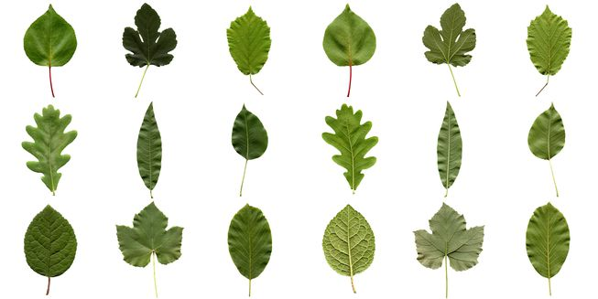
Mathematics and Numeracy
Use the following link: https://www.thenational.academy/online-classroom/year-4/maths#subjects
Follow the schedule of lessons throughout the week. Each lesson follows the same format.
- Introductory Quiz
- Video
- Worksheet
- Exit Quiz
Health & Well-being
During Lockdown, thousands of people have been enjoying “PE with Joe” Everyday he completes a warm-up, short 30 second exercises and stretches. Can you write your own workout? Send me a copy of your plan or even a video of you/your family completing it!



