Science & Technology
Friend or Foe?
Some wildlife are friends of gardens and allotments others can be damaging (foes). Research which wildlife are friends/foes of garden and allotment areas.
E.g – Slug – Foe – The garden slug is a pest in the garden eating leaves, stems and bulbs of different plants. Slugs will even burrow underground to attack root crops like carrots and potatoes.
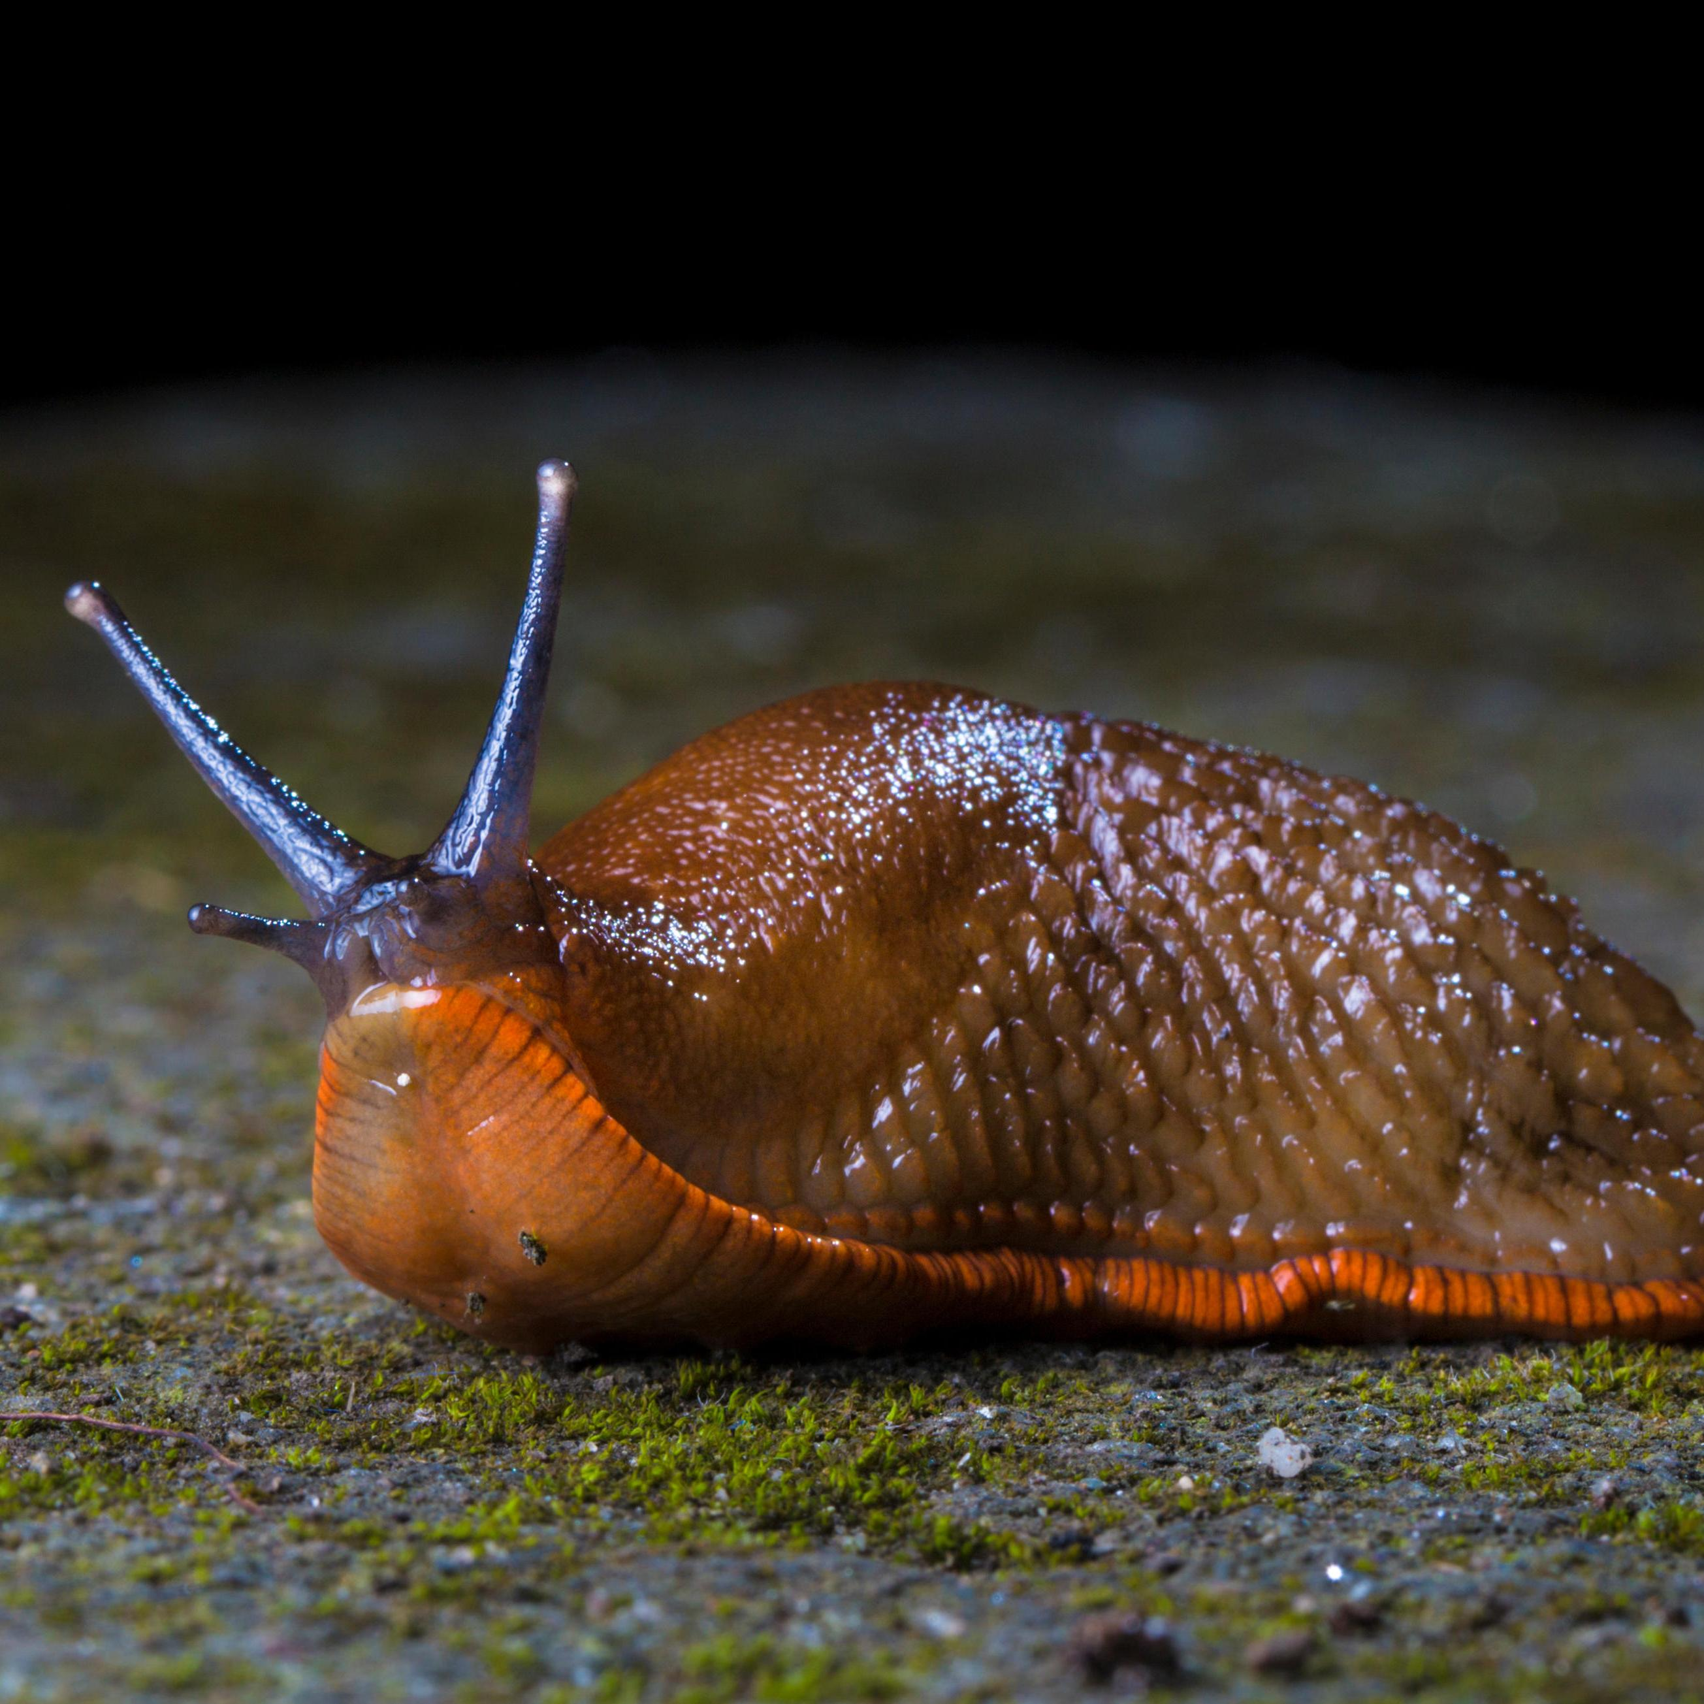

Humanities
Research the history of a famous health care worker/scientist e.g Marie Curie, Florence Nightingale, Aneurin Bevan. Complete a presentation based on your choice.

Include the following information:
- Personal life
- Work life – career – inventions / achievements
- Their legacy

Languages, Literacy and Communication
Read the information on the lifecycle of a Sunflower. Once you have read the text a couple of times answer the questions.
Remember to write in full sentences and make sure your answers makes sense.

Week 12 – Allotment

Expressive Arts
Create a picture of an insect (butterfly etc) with items that can be found in your outdoor space (leaves, twigs, petals etc).

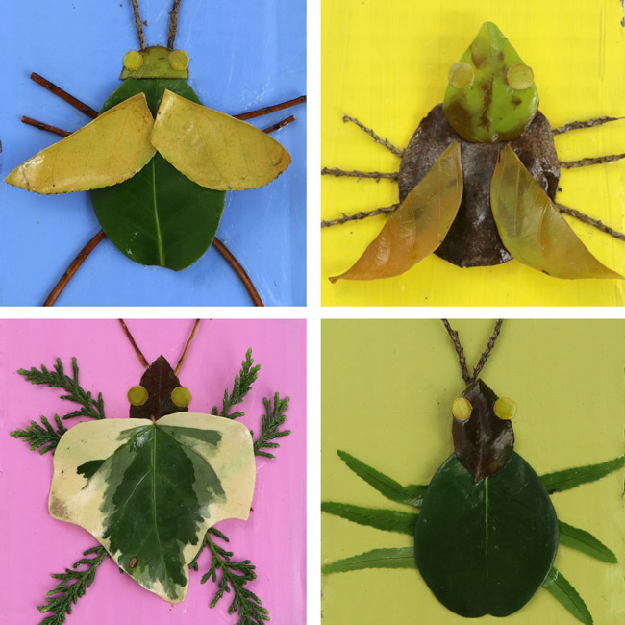

Mathematics and Numeracy
Co-ordinates are a set of values that show an exact position. On graphs it is usually a pair of numbers: the first number shows the distance along, and the second number shows the distance up or down.

‘‘Remember, always go along the cloakroom before you go up the stairs!’’
On the co-ordinates worksheet plot the co-ordinates and name the shape you have made.
Health & Well-being
Write about a time when you were tasked to do something difficult and you got through it. Think about how you felt before the task/ activity and how you overcame the challenge. Think about how you felt after completing the task. How could you use this experience in the future?

