Literacy Challenge  Write a recipe for something that might go into Mr Grinling's lunch.  Spelling  Complete a page from the Phase 3 tricky words booklet. (Find on HWB, Class page on website)  Word level  Complete the sentences – First 100 high frequency words activity booklet. (Page 3 and 4)  (Find on HWB, Class page on website)    This Photo by Unknown Author is licensed under CC BY-SA-NC | Numeracy Challenge  Mr Grinling needs to find out the daily temperature to keep warm in the lighthouse but his thermometer has broken. Record the Daily temperature for Mr Grinling this week.  Play games on the following websites, particularly working in number skills such as place value, addition and subtraction, time, Fractions, multiplication, division.  www.topmarks.co.uk ,  www.snappymaths.com  https://www.bbc.co.uk/bitesize/subjects/z826n39   | Reading Challenge  Read through the power point on ‘Lighthouses’.  https://www.twinkl.co.uk/resource/t-tp-6412-all-about-lighthouses-powerpoint  Read a book of your choice every day for 15 minutes.    This Photo by Unknown Author is licensed under CC BY-NC-ND
ICT Challenge  Research information on the ‘Mumbles Lighthouse’. Use JIT5 Mix to create a leaflet on the lighthouse.   | Creative Challenge  Mr Grinling has decided to renovate his lighthouse as it is very old. Design and make a lighthouse model for Mr Grinling.    This Photo by Unknown Author is licensed under CC BY-SA | Welsh Challenge  Mr Grinling would like to invite you to his Lighthouse for a picnic.  Write a postcard to Mr Grinling in Welsh. Tell him who you are, where you live and what food you like and don’t like.    This Photo by Unknown Author is licensed under CC BY-SA
PSD Challenge  Choose 5 of Mr Grinlings Healthy Snacks. Ask your family which snacks they like best. Record the results using a tally chart.  Complete an activity from this amazing Food website.  https://www.foodafactoflife.org.uk/    This Photo by Unknown Author is licensed under CC BY-NC | P.E. Challenge:  Join in with Joe Wicks PE 30 min a day via YouTube live every morning at 9am (Mon-Fri).  Watch videos of sea creatures and how they move. Move around like the sea creatures. Can your family guess what sea creature you are.   | Science Challenge  What material would be best for Mr Grinlings lunchbox?  Find and collect 5-10 different materials around your home. (e.g. foil, paper, card etc). Make a materials board labelling all your materials.
Year 1-2 Home Learning Planning Mrs Moore
Week Beginning: 27-4-2020

Daily Tasks

- Daily reading of school reading book. (15 mins)

- Welsh sentence patterns. (10 mins)

- Times tables 2, 5, 10. (10 mins) – Lovely songs on you tube that we use in school.

- Joe Wicks daily home led indoor exercise workouts via you tube channel The Body Coach TV (9am he is live but his videos will also be available after this time)

- If you have access to a garden make sure you have at least 1 hr of outdoor play every day whenever possible football, throwing and catching, hide and seek, den building...

- Sum dog Challenges. (Passwords sent Via Class dojo) (15minutes)

- Just keep moving as much as you can daily dancing to your favourite songs in your bedroom or living room.

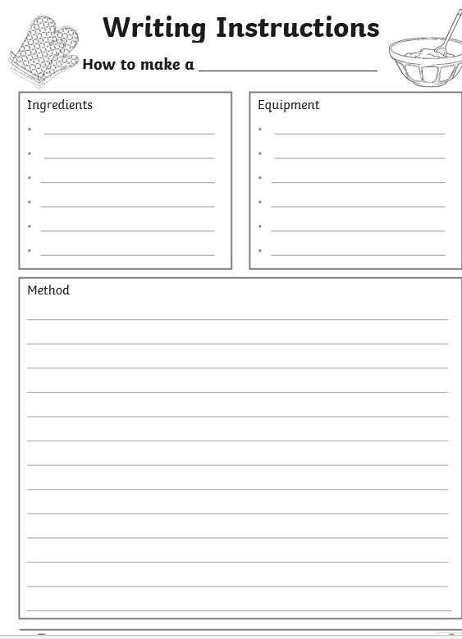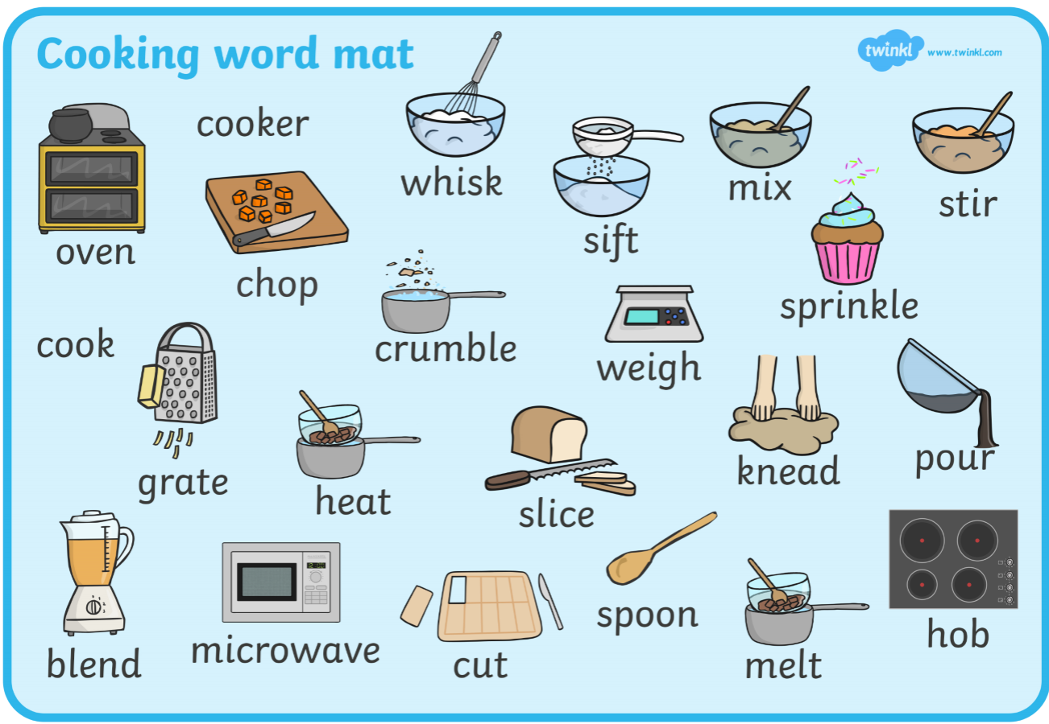

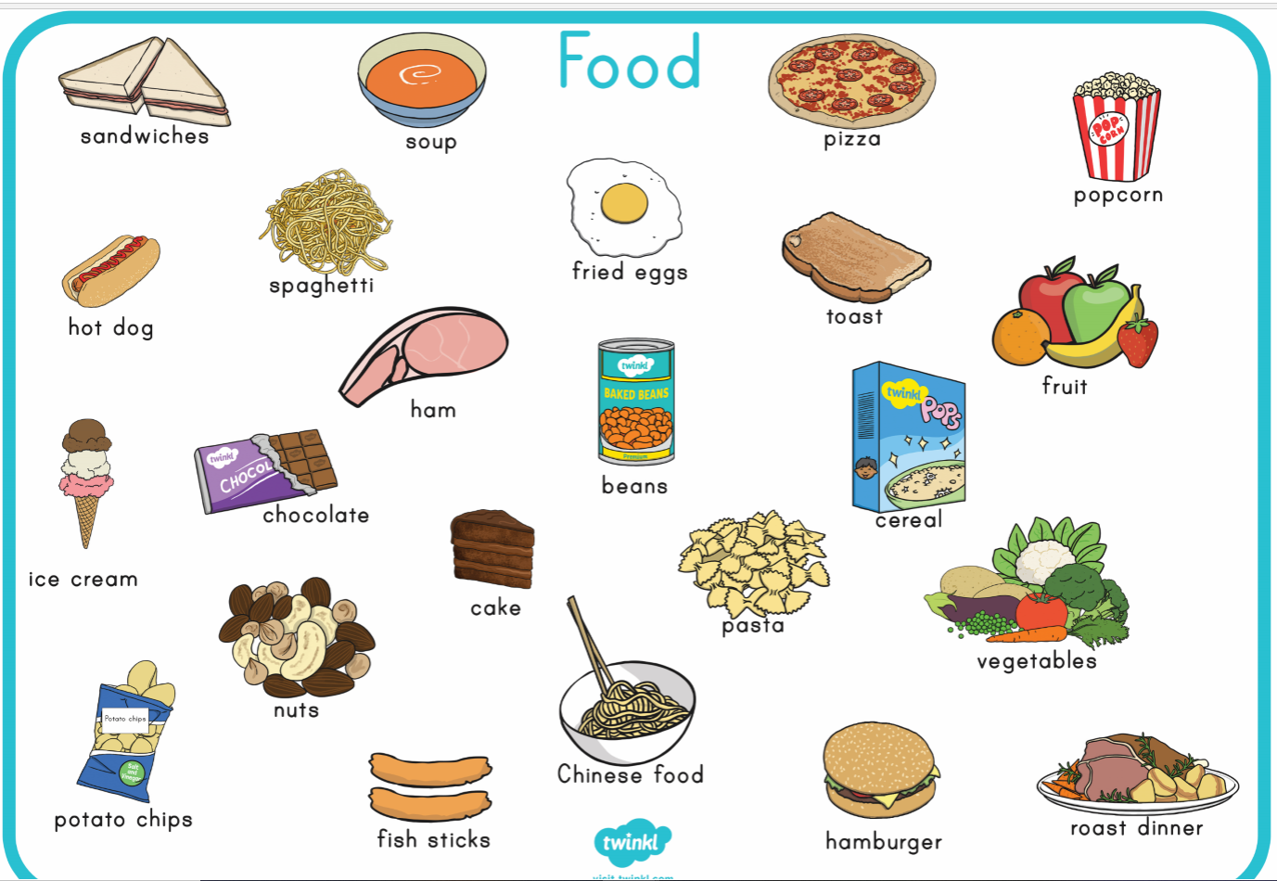

Day | Time | Weather | Temperature

What did you find out? Add words or draw pictures to make an information Board.

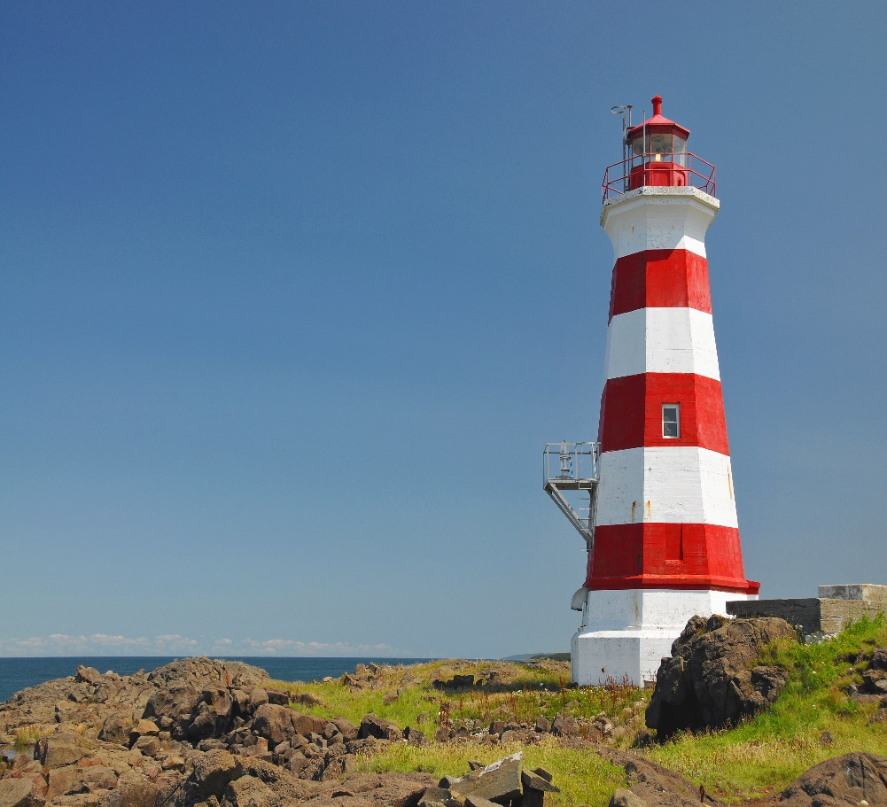

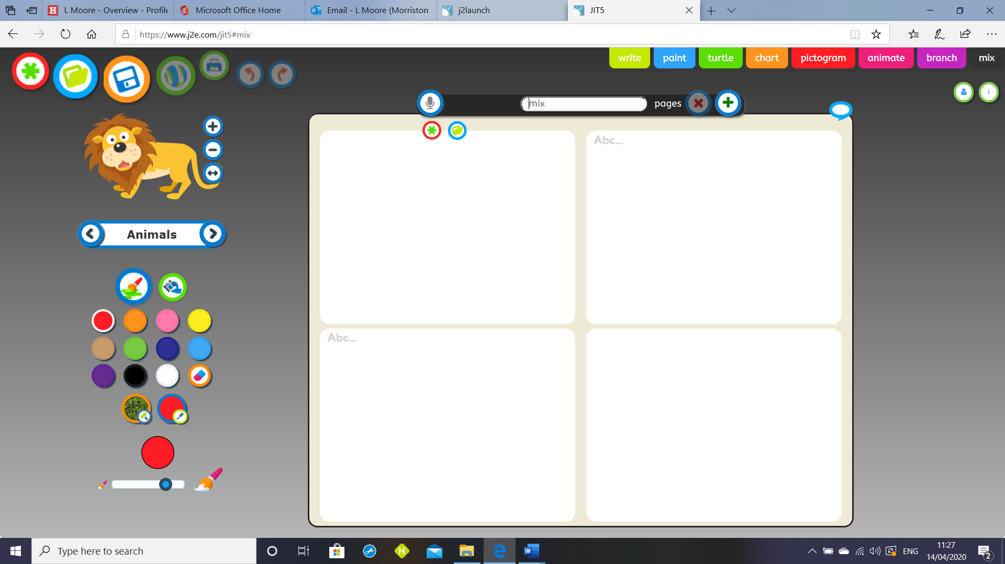

My Lighthouse Design 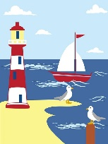

Label your design with measurements and what materials you are going to use.

Write a postcard to Mr Grinling in Welsh.
Use the sentence patterns below to help you.

………………….. ydw i. I am …………………….
Dw i’n …………………. I am …………………… (Feelings)
Dw i’n byw yn ……….. I live in ……………….
Dw i’n hoffi …………… I like …………………..
Dw i ddim yn hoffi …… I don’t Like …………..
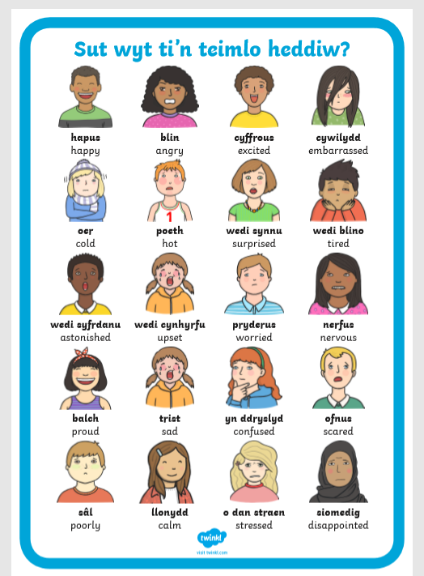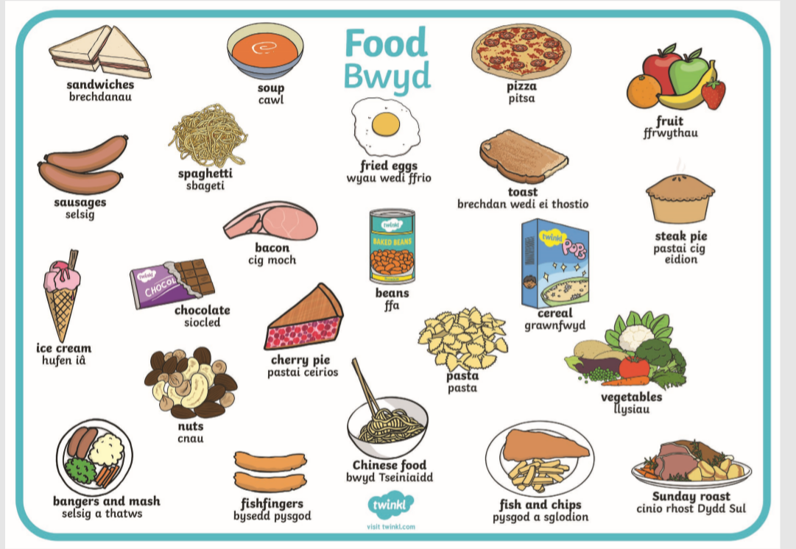
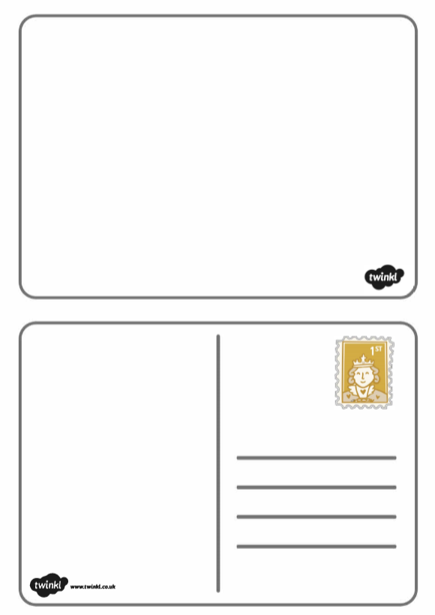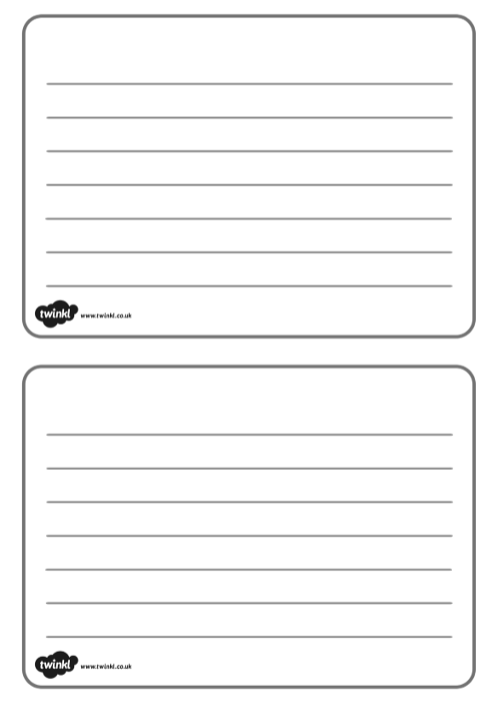
Tally Chart – Our Favourite Snacks.

Snack |  |  |  |  |  | Total
Tally

Welsh Sentence Patterns
I am sad.
I am tired.
I am miserable.
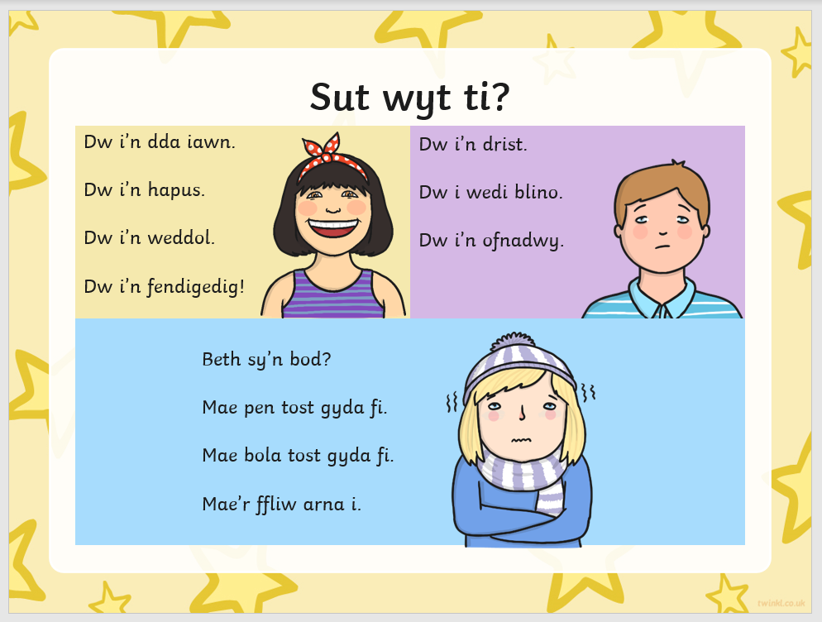
What is the matter?
I have a bad head.
I have a bad tummy.
I have got flu.
I am very good.
I am happy.
I am fair.
I am great.

