  Date: 13/07/2020 |  |  |  | Theme: The Lightbulb/Who lives in a rockpool  Year group: STF1
Literacy      This Photo by Unknown Author is licensed under CC BY-NC-ND   | Numeracy     | Creative     | Thinking     |  | Healthy me    
The sound of the week is b.  We enjoy these two videos in class for the sound of the week - https://www.youtube.com/watch?v=W5D3ySh7s2c and https://www.youtube.com/watch?v=RZwzZ7rMv08 Level 1 - Please can your child either practise identifying/saying/signing and forming this letter.  Level 2 – As we are now learning a new topic, I thought it would be nice if your child could start to make a topic dictionary so each time we look at a new sound please can they think of beach themed words for it and write them down. It would be lovely if they could have a blank notebook so each letter has a page. For example this week is u so they could list – beachball, bbq and barnacle.  If practising forming the letter you can do it in fun ways – writing in/with rice/icing sugar/glitter/string/a collage with bits of paper etc for multi-sensory fun! Also Ruth Miskin is doing daily RWI sound sessions live on youtube each day – https://m.youtube.com/channel/UCo7fbLgY2oA_cFCIg9GdxtQ Read Write Inc have now announced that their resources are free! To recap learnt sounds so far – m, a, s, d, t, i, n, p, g, o, c, k and u to practise forming this week’s sound (b) please follow – https://home.oxfordowl.co.uk/reading/reading-schemes-oxford-levels/read-write-inc-phonics-guide/ scroll down and click on speed sounds practice sheets.  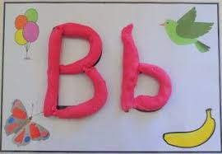  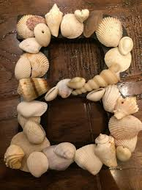 | Level 1 – The number of the week is 4 this week (if your child is confident identifying/writing/saying/signing you can move on to 9 or recap other numbers 1-5 that they need more support with). We enjoy reading the story of one -https://resources.hwb.wales.gov.uk/VTC/story_of_4/eng/Introduction/default.htm  and completing the activities. Please practise recognising the number/saying/signing/writing and linking to objects eg show four buttons/shells/sticks and write the number next to it. You can also enjoy multisensory activities to write 4. Please also recap basic 2d shapes using songs and mat below.  Level 2 – Please spend the final week recapping the 2d shape names and shape properties we have looked at the last two weeks. If you have filled out the online consent form for your child to access Mymaths I have sent your child’s log in details over dojo and you can follow this link for shape activities -https://app.mymaths.co.uk/3284-lesson/introducing-2d-shapes  Here are the songs that we enjoy in class - https://www.youtube.com/watch?v=pfRuLS-Vnjs and https://www.youtube.com/watch?v=WTeqUejf3D0. To help recap names please use the shape mat below -  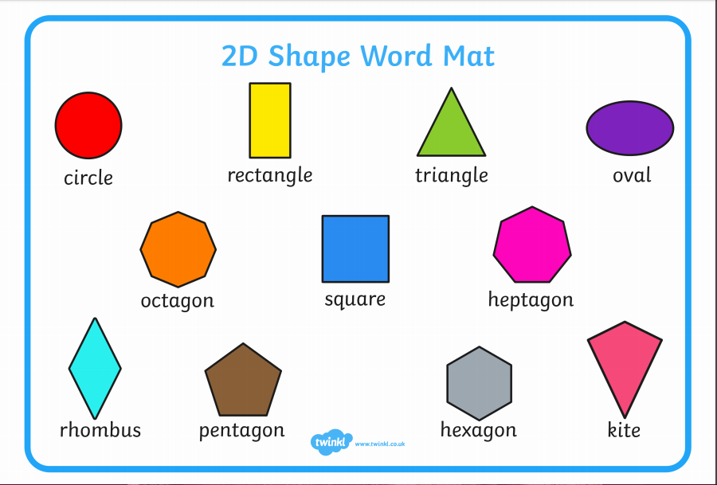  (Enlarged below. I can print out if you would like to collect from school or you could draw out).  If you have access to a printer there is a lovely 2d shape beach themed picture pack here. We used the boat and fish pictures in check in sessions and plan to do the crab this week. I can print out if needed - https://www.twinkl.co.uk/resource/beach-themed-2d-shapes-activity-pack-t-n-2546888  You will also find a wealth of resources to help with 2d shape on topmarks - http://www.primaryresources.co.uk/maths/mathsE3.htm  If your child is confident with 2d shapes please feel free to recap learnt skills over lockdown – adding/subtracting, more than/less than, doubles/halves of numbers, odd/even numbers and estimation. | Please see Science and Technology column first.  As we are learning about the jellyfish this week please help your child make a jellyfish craft. I love the ones below! –  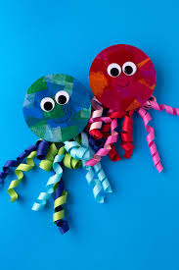  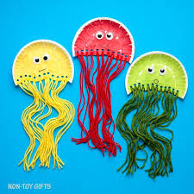  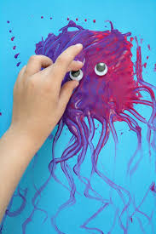  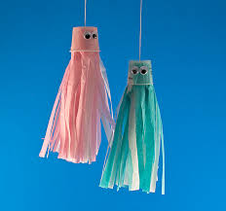  Enlarged below. | Over the past term we have researched a range of sea creatures linked to our topic ‘who lives in a rock pool.’ We then merged our topic with the ‘Lightbulb’ topic for a whole school theme. For our final week I would like you to show your child this picture –  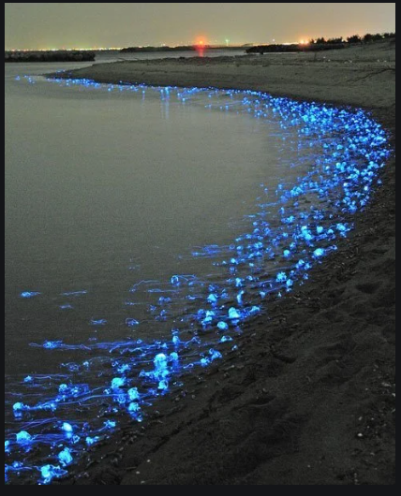  What do you think is causing the sea to light up at the edge?  Is it anything that holds a lightbulb?  Is it a sea creature?  After they have guessed please show them this picture –  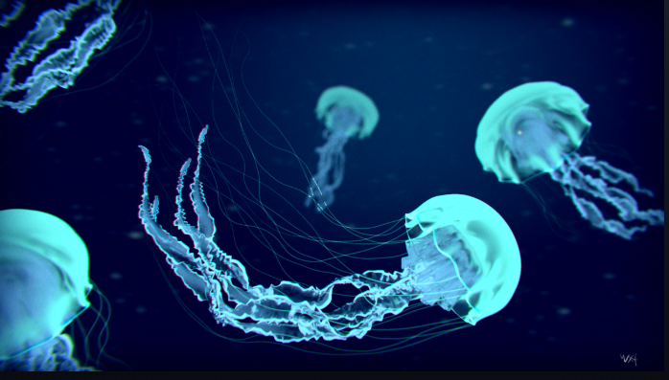  Do they know the name of the sea creature?  Do Jellyfish have lightbulbs inside them?  Please use the final week to research the jellyfish and add to the book of fact files -  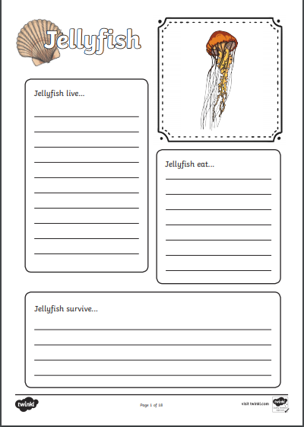  https://www.coolkidfacts.com/jellyfish-facts/  https://www.sciencekids.co.nz/sciencefacts/animals/jellyfish.html  https://www.youtube.com/watch?v=u9Q9knJlhww |  | I hope you are still joining me (virtually) for Joe Wicks at 9am Monday, Wednesdays and Saturdays or search for his 5 – 8 minute movers (created for children).  If you would like to try something different we enjoy Cosmic Kids yoga in class found on Youtube.  Also, remember you can always ask your child to move like the sea creatures we have been learning about!

