Literacy Challenge  Watch videos of a lighthouse during a stormy night. (You Tube) Write a diary account about their feelings on a stormy night in Mr Grinlings Lighthouse.  Spelling  Phase 4 Find and write activity.(Find on HWB, Class page on website)  Word level  Phase 4 match captions to pictures. .  (Find on H/  /WB, Class page on website)   ….  This Photo by Unknown Author is licensed under CC BY-SA-NC | Numeracy Challenge  Complete the Maths measurement booklet Year 1 and Year 2 separate booklets.  Capacity activity.  Play games on the following websites, particularly working in number skills such as place value, addition and subtraction, time, Fractions, multiplication, division.  www.topmarks.co.uk ,  www.snappymaths.com  https://www.bbc.co.uk/bitesize/subjects/z826n39   | Reading Challenge  Read the information Power Point on Grace Darling.  https://www.twinkl.co.uk/resource/t-t-12913-grace-darling-information-powerpoint  Read a book of your choice every day for 15 minutes.  Reading comprehension activity:  Year 1 – The Zoo Vet - https://www.twinkl.co.uk/resource/year-1-the-zoo-vet-differentiated-reading-comprehension-activity-t-or-1155  Year 2 – Rhonald the Rhino. https://www.twinkl.co.uk/resource/t-l-52265-year-2-ronald-the-rhino-differentiated-reading-comprehension-activity    This Photo by Unknown Author is licensed under CC BY-NC-ND
ICT Challenge  Use JIT5 2 animate to create an animation of a lighthouse/boat on the sea during a stormy night.   | Creative Challenge  Look at an artist work of coastal areas. Use J2E to create a painting of a coastal area in Swansea to send to Mr Grinling.    This Photo by Unknown Author is licensed under CC BY-SA | Welsh Challenge  Design some different outfits that Mr Grinling can wear in the winter and the summer label in Welsh.    This Photo by Unknown Author is licensed under CC BY-SA
PSD Challenge  Create a stay Safe time capsule.  https://www.twinkl.co.uk/resource/junior-school-time-capsule-activity-roi-tpcs-83  Complete an activity from this amazing Food website.  https://www.foodafactoflife.org.uk/    This Photo by Unknown Author is licensed under CC BY-NC | P.E. Challenge:  Join in with Joe Wicks PE 30 min a day via YouTube live every morning at 9am (Mon-Fri).  Create your own Yoga session using the Yoga pose cards  https://www.twinkl.co.uk/resource/us-a-183-yoga-movement-cards.   | KUOTW Challenge  Complete the Grace Darling Time line.  https://www.twinkl.co.uk/resource/grace-darling-differentiated-timeline-activity-t-tp-7190  Test the materials that you have chosen for Mr Grinlings lunchbox.  How could you do this?  Write up you investigation using a method, equipment, prediction, results.
Year 1-2 Home Learning Planning Mrs Moore
Week Beginning: 18-5-2020

Daily Tasks

- Daily reading of school reading book. (15 mins)

- Welsh sentence patterns. (10 mins)

- Times tables 2, 5, 10. (10 mins) – Lovely songs on you tube that we use in school.

- Joe Wicks daily home led indoor exercise workouts via you tube channel The Body Coach TV (9am he is live but his videos will also be available after this time)

- If you have access to a garden make sure you have at least 1 hr of outdoor play every day whenever possible football, throwing and catching, hide and seek, den building...

- Sum dog Challenges. (Passwords sent Via Class dojo) (15minutes)

- Just keep moving as much as you can daily dancing to your favourite songs in your bedroom or living room.

In school we use Tric a Chlic to help us learn our welsh sounds and words. There is an amazing lady giving online interactive lessons on you tube – melyn is the first set of letters.
This is the web address. - https://www.youtube.com/watch?v=YCwioyHWgkM

NOTES FOR PARENTS
In school we would watch a video of a stormy night and then I would allow the children some think, pair, share time where they could talk about what they have seen with a friend.
We would then make a list of feelings words that they may experience if they were in the Lighthouse during this story night. They can use these words as a spelling bank.
Maybe talk about why they would feeling this way just to build up their use of sentences which will help when writing their diary.

You spend the night in Mr Grinlings Lighthouse on a stormy night. Write a diary about your feelings.
Watch You tube videos of lighthouses during stormy nights.
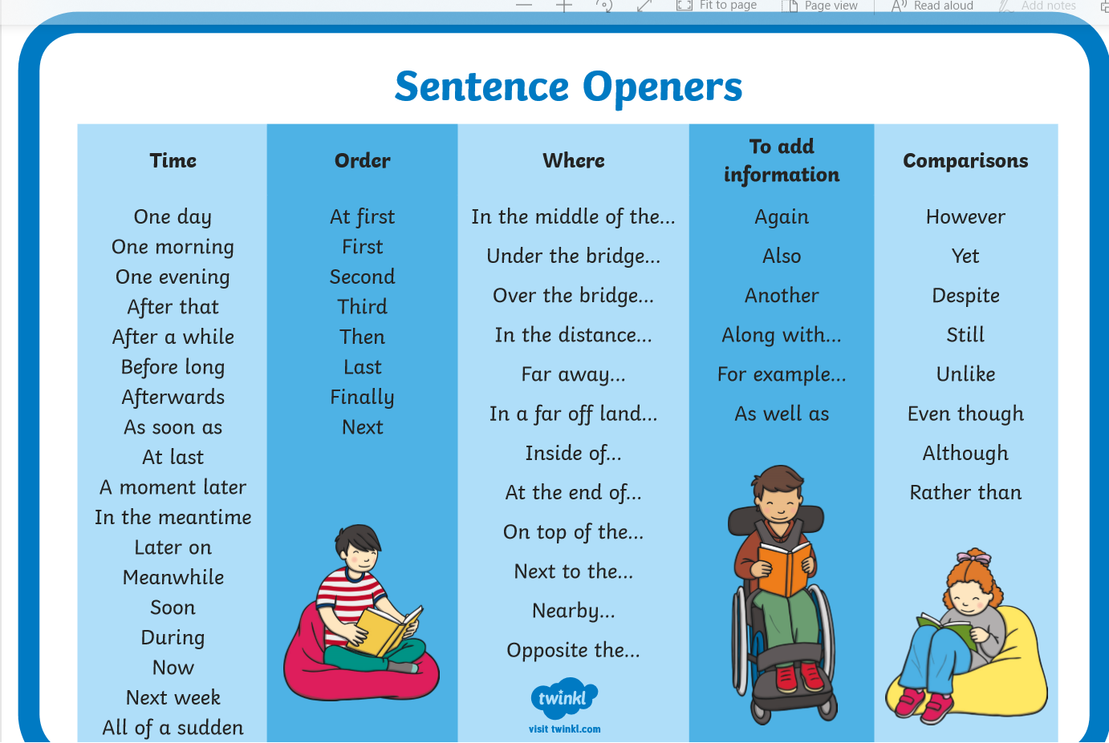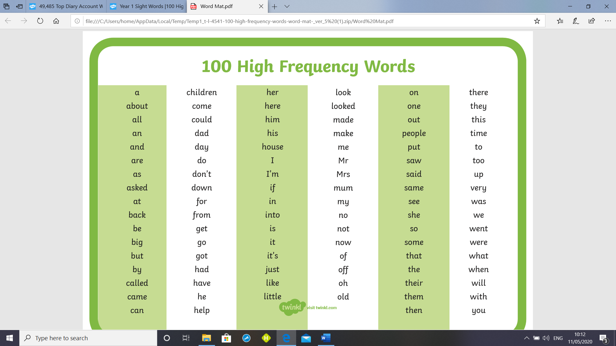
Notes for Parents
In school I would show the children a video of a boat/lighthouse on a stormy night. We would talk about what they can see to ensure that we include these details into our animation. I would model this to the children by creating my own animation talking them through the process. Maybe you could do an animation together with your child or if they have an older sibling this would be a good way to model it. Possibly look at the different backgrounds that they could use and experiment with the tools on the page before creating a final animation.

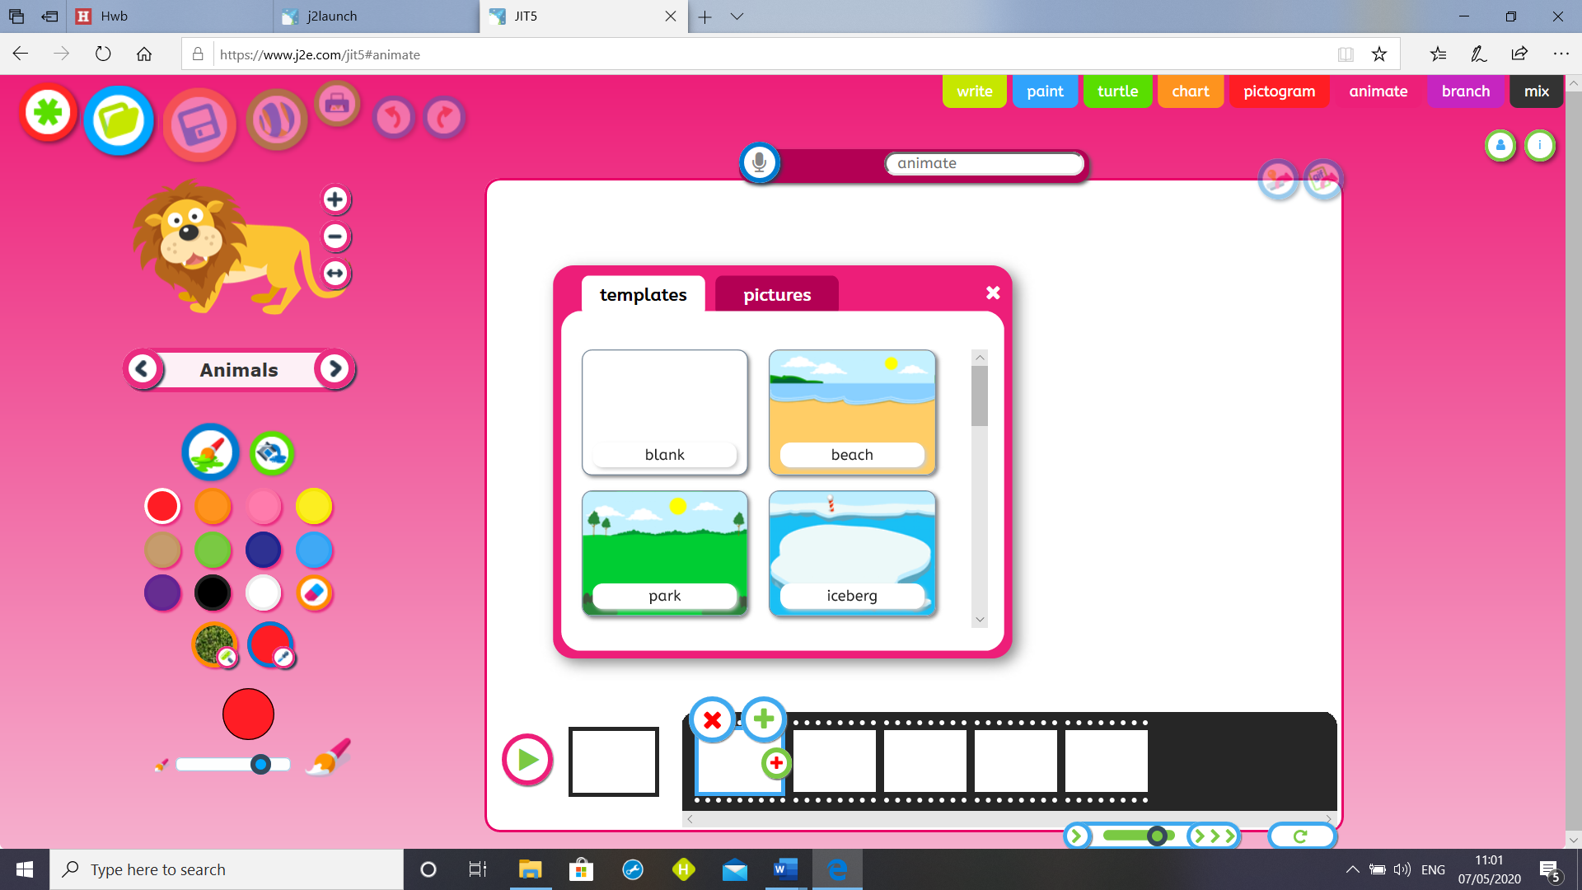

NOTES FOR PARENTS
In school we would look at a selection of her work. The children would talk about what they can see in the paintings, colour, objects etc. They would talk about what they like and dislike about the painting, how the paintings make them feel? do the paintings remind them of any experiences they have had? They would then chooses their favourite painting to recreate.
Pamela Jones
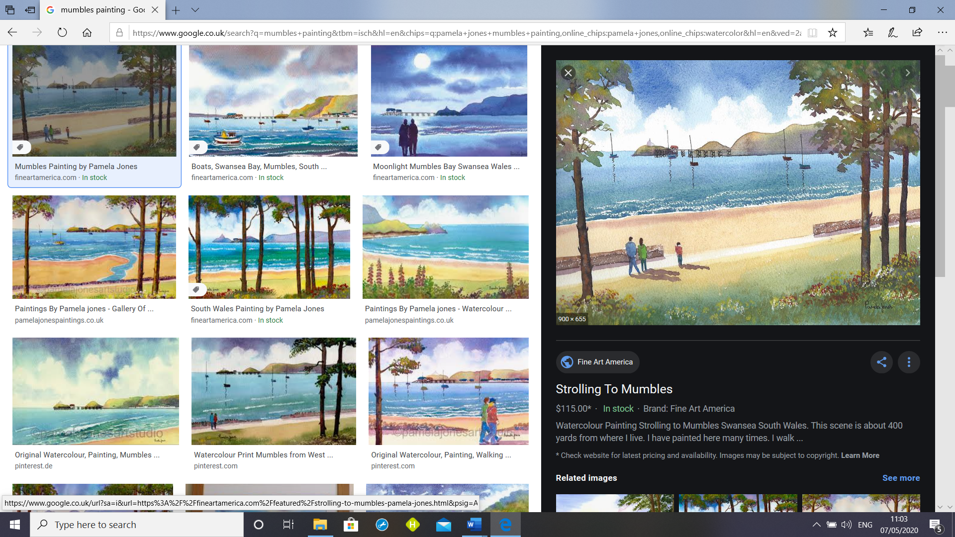

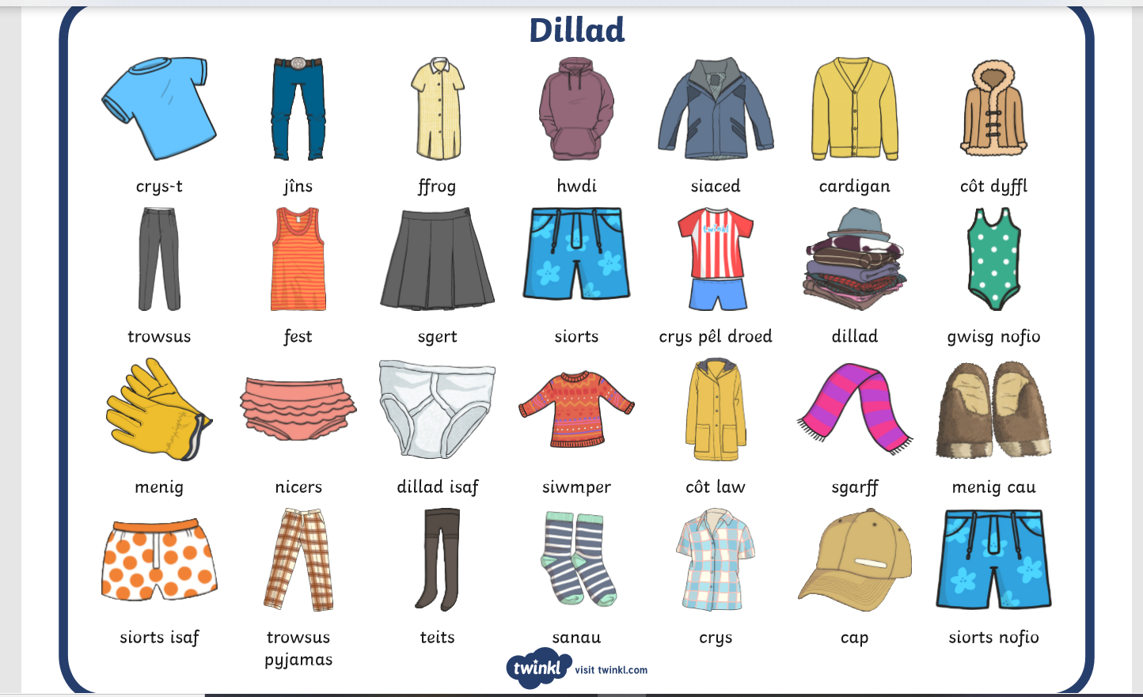

Pack Mr Grinlings Suitcase for a summer holiday.
NOTES FOR PARENTS
In school I would start by using flashcards to practice the welsh words for different types of clothes. I would then do a clothes sort and ask the children how could we sort the clothes. I f you grab a pile of clothes and ask the children to sort them, they may sort in colour, type etc, leave them experiment. I would then suggest sorting into summer and winter to help Mr Grinling prepare for his holidays. As we sort we would be labelling the clothes in Welsh.
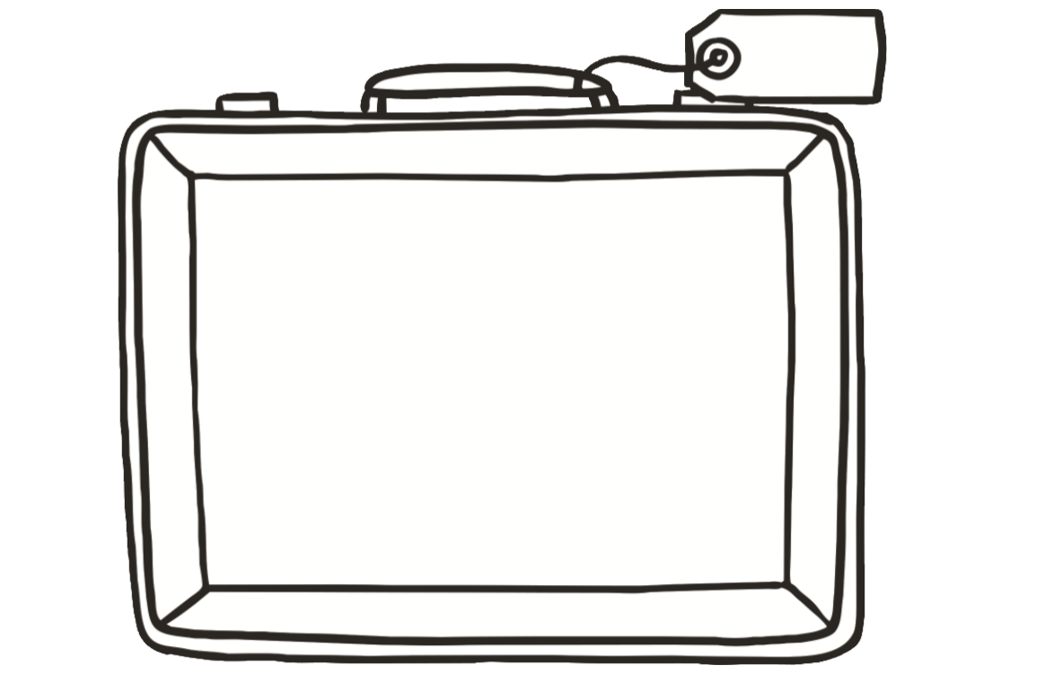

Pack Mr Grinlings Suitcase for a winter holiday

Welsh Sentence Patterns – Colours

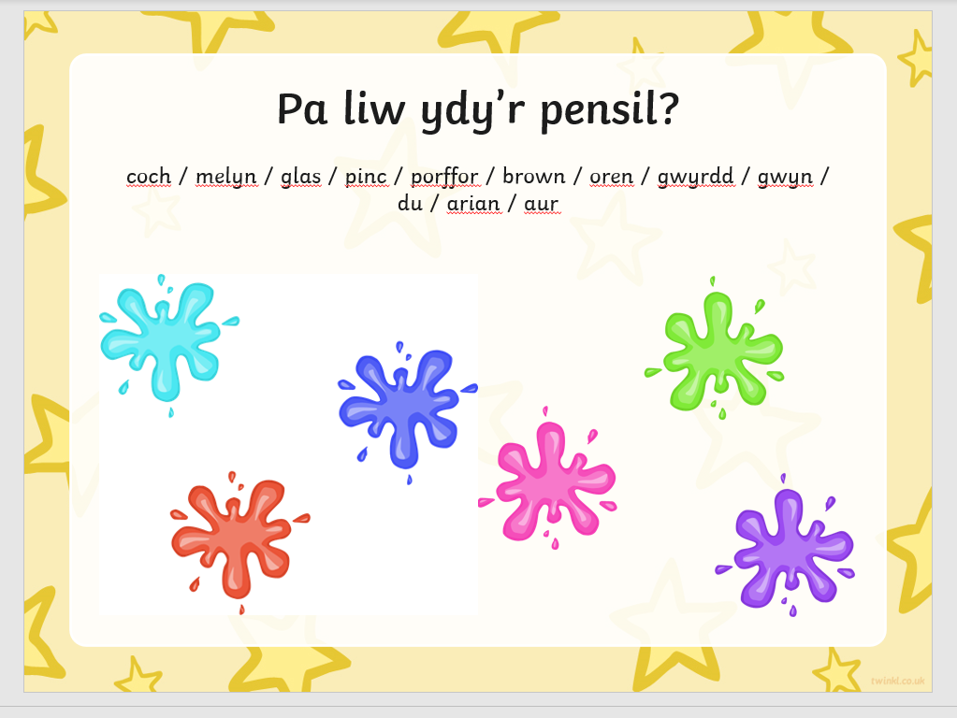

CAPACITY
This week the children will be working on a measurement booklet. I would like to focus on capacity in more detail.
Collect a various bottles, containers, allow the children to fill and empty them. Allow them to decide on a way they can measure how much water they are putting in.
For example and egg cup/cup ask them to estimate how many are needed to fill a jug, bottle, saucepan.
You could find some bottles of different shapes but of the same capacity.
Do they all hold the same amount of liquid? Which do you think holds the most? How can we find out?
The children can then complete the grid below.
Just a fun idea – the children could make a fruit cocktail type drink. They could write out a list of ingredients and amounts, using a non standard unit.
(4 egg cups of orange juice etc)
To extend the task –
In school I would show examples of recipes and how they are written. Ask your child to write out a set of instructions.
Include a title, a list of ingredients and a picture.
Or, a simpler task would be to design a label for your drink and present it on a bottle. In school we would look at lots of examples of labels.

Object | Estimate | Measurement
Jug | 4 cups | 7 cups

