  Date: 06/07/2020 |  |  |  | Theme: The Lightbulb/Who lives in a rockpool  Year group: STF1
Literacy      This Photo by Unknown Author is licensed under CC BY-NC-ND   | Numeracy     | Creative     | Thinking     |  | Healthy me    
The sound of the week is u.  We enjoy these two videos in class for the sound of the week - https://www.youtube.com/watch?v=yWiRgOuaS84 and https://www.youtube.com/watch?v=fi-sX67q9HY Level 1 - Please can your child either practise identifying/saying/signing and forming this letter.  Level 2 – As we are now learning a new topic, I thought it would be nice if your child could start to make a topic dictionary so each time we look at a new sound please can they think of beach themed words for it and write them down. It would be lovely if they could have a blank notebook so each letter has a page. For example this week is u so they could list – umbrella, umbrella shell (a sea slug!) and unicorn fish (a fish with a horn – like protrusion on its forehead!).  If practising forming the letter you can do it in fun ways – writing in/with sand/foam/flour/mud/printing with food etc for multi-sensory fun! Also Ruth Miskin is doing daily RWI sound sessions live on youtube each day – https://m.youtube.com/channel/UCo7fbLgY2oA_cFCIg9GdxtQ Read Write Inc have now announced that their resources are free! To recap learnt sounds so far – m, a, s, d, t, i, n, p, g, o, c, k and u to practise forming this week’s sound (u) please follow – https://home.oxfordowl.co.uk/reading/reading-schemes-oxford-levels/read-write-inc-phonics-guide/ scroll down and click on speed sounds practice sheets.  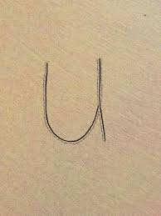   | Level 1 – We are back to 3 this week (if your child is confident identifying/writing/saying/signing you can move on to or recap other numbers 1-5 that they need more support with). We enjoy reading the story of one -http://resources.hwb.wales.gov.uk/VTC/story_of_3/eng/Introduction/default.htm  and completing the activities. Please practise recognising the number/saying/signing/writing and linking to objects eg show three cars/shoes/gloves and write the number next to it. You can also enjoy multisensory activities to write 3. Please also recap basic 2d shapes using songs and mat below.  Level 2 – This week we will again be focussing on 2d shape. We enjoy these two songs as a class - https://www.youtube.com/watch?v=pfRuLS-Vnjs and https://www.youtube.com/watch?v=WTeqUejf3D0. The videos are handy for recapping names and properties of 2d shapes. To help recap names please use the shape mat below -  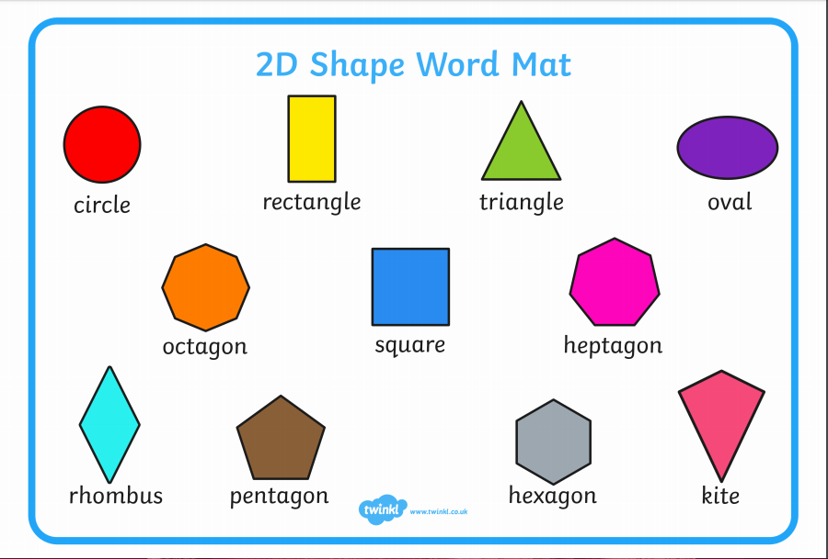  Please could you work on properties of shape. Last week we started to look at this by talking about corners (in the introduction video). This week I would like you to discuss corners and sides. (Enlarged below. I can print out if you would like to collect from school or you could draw out).  If you have access to a printer there is a lovely 2d shape beach themed picture pack here. We used the boat picture in check in sessions and plan to do the fish this week. - https://www.twinkl.co.uk/resource/beach-themed-2d-shapes-activity-pack-t-n-2546888  You will also find a wealth of resources to help with 2d shape on topmarks - http://www.primaryresources.co.uk/maths/mathsE3.htm | Please see Science and Technology column first and then recreate the ‘glowing plankton’ picture from the Gower with your child. They can either use a computer software programme such as J2e paint which will help with the glowing effect or they can use paints and maybe glitter!  Enlarged below. | I found this fascinating article about glowing plankton down the Gower and the beautiful picture in the article - https://www.walesonline.co.uk/news/wales-news/magical-image-captures-blue-glow-16663973  We have been learning about the lightbulb through our beach topic. Do you think the plankton have lightbulbs in them like the lighthouse, beach lighting and boat lighting?  Please help your child research plankton this week and help them fill out a fact file about what they have found out.  https://www.google.co.uk/search?q=plankton+&tbm=isch&ved=2ahUKEwig_Zyvra_qAhWR0-AKHfTSD78Q2-cCegQIABAA&oq=plankton+&gs_lcp=CgNpbWcQAzIECCMQJzIECCMQJzIFCAAQsQMyAggAMgIIADICCAAyAggAMgIIADICCAAyAggAUJkNWNQVYI4ZaABwAHgBgAFmiAHoBJIBAzcuMZgBAKABAaoBC2d3cy13aXotaW1n&sclient=img&ei=czz-XuD3FZGngwf0pb_4Cw&bih=657&biw=1366&safe=strict  https://www.youtube.com/watch?v=lDNsSRhf5Qk  https://www.youtube.com/watch?v=cVRxYEzC6Ng  https://kids.britannica.com/kids/article/plankton/400148 |  | I hope you are still joining me (virtually) for Joe Wicks at 9am Monday, Wednesdays and Saturdays or search for his 5 – 8 minute movers (created for children).  If you would like to try something different we enjoy Cosmic Kids yoga in class found on Youtube.  Also, remember you can always ask your child to move like the sea creatures we have been learning about!

