Literacy Challenge  Mrs Moore has found a strange object in her garden. Record everything you know about this object.  Spelling  Complete a page from the Phase 3 tricky words booklet. (Find on HWB, Class page on website)  Word level  Complete the sentences – First 100 high frequency words activity booklet.  (Find on HWB, Class page on website)    This Photo by Unknown Author is licensed under CC BY-SA-NC | Numeracy Challenge    Play games on the following websites, particularly working in number skills such as place value, addition and subtraction  www.topmarks.co.uk ,  www.snappymaths.com  https://www.bbc.co.uk/bitesize/subjects/z826n39 | Reading Challenge  Read the story ‘The light house keepers’ lunch with an adult’. Draw a picture of your favourite part.  (You can access the story on You tube)    This Photo by Unknown Author is licensed under CC BY-NC-ND
ICT Challenge  Research information on the ‘Lightbulb’.   | Creative Challenge  Mr Grinlings lunch box is very old. Design a snazzy new lunch box for Mr Grinling. You could create a digital one using J2E. Or use paint, crayons/pen or a collage technique.    This Photo by Unknown Author is licensed under CC BY-SA | Welsh Challenge  Mr Grinling has been learning to speak Welsh for when he visits Wales. Write a healthy shopping list for Mr Grinling in Welsh.    This Photo by Unknown Author is licensed under CC BY-SA
PSD Challenge  Sort Mr Grinlings snacks into Healthy and Unhealthy. You could draw the snacks and use a venn diagram.  Complete an activity from this amazing Food website.  https://www.foodafactoflife.org.uk/    This Photo by Unknown Author is licensed under CC BY-NC | P.E. Challenge:  Join in with Joe Wicks PE 30 min a day via YouTube live every morning at 9am (Mon-Fri).   | Science Challenge  Look at the power point all about the famous inventor Thomas Edison.  https://www.twinkl.co.uk/resource/t-t-14318-thomas-edison-powerpoint-presentation - (Find on Class page on website)  If you were a famous inventor what would you invent. Draw a picture and talk about your invention.
Year 1-2 Home Learning Planning Mrs Moore
Week Beginning: 20-4-2020

Daily Tasks

- Daily reading of school reading book. (15 mins)

- Welsh sentence patterns. (10 mins)

- Times tables 2, 5, 10. (10 mins) – Lovely songs on you tube that we use in school.

- Joe Wicks daily home led indoor exercise workouts via you tube channel The Body Coach TV (9am he is live but his videos will also be available after this time)

- If you have access to a garden make sure you have at least 1 hr of outdoor play every day whenever possible football, throwing and catching, hide and seek, den building...

- Sum dog Challenges. (Passwords sent Via Class dojo) (15minutes)

- Just keep moving as much as you can daily dancing to your favourite songs in your bedroom or living room.

Venn Diagram

Healthy Unhealthy

Here is a picture of the strange object Mrs Moore found.
(Record what you know around the picture)

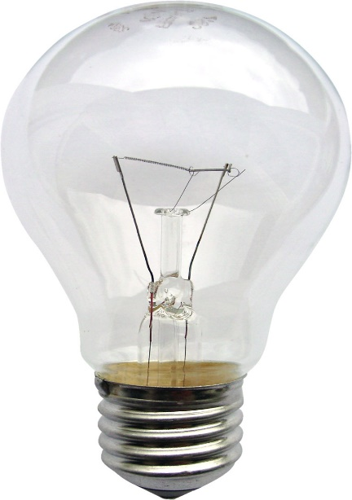

The Light House Keepers Lunch


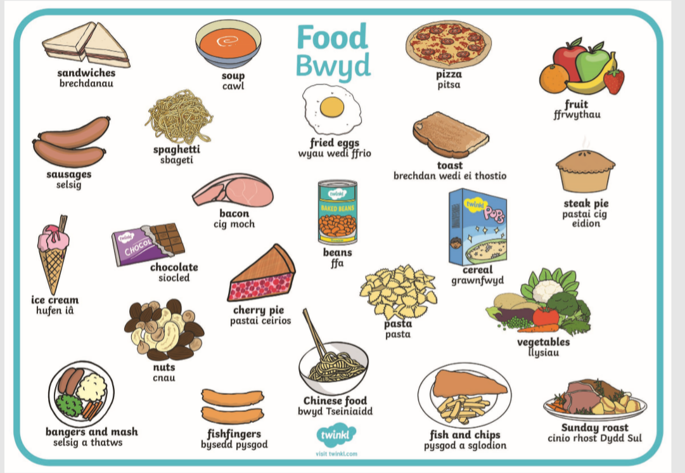
Welsh Sentence Patterns


