Literacy Challenge  Read the VE day information Powerpoint. Imagine you were a child at the time of WW2. Write a diary account of the day you found out the war was over.  Word Level.  Complete phase 4 capital letters and full stops activity. (Find on HWB, Class page on website)  Spelling  Complete Look, cover, write activities. (Find on HWB, Class page on website)    This Photo by Unknown Author is licensed under CC BY-SA-NC | Numeracy Challenge  Work out how much you would spend on a weekly shop for you and your family. Use the rationing sheet to help.  Additional money booklet added to complete.  Play games on the following websites, particularly working in number skills such as place value, addition and subtraction, time, Fractions, multiplication, division.  www.topmarks.co.uk ,    www.snappymaths.com  https://www.bbc.co.uk/bitesize/subjects/z826n39 | Reading Challenge  Read through the power point on ‘VE Day’.  Read a book of your choice every day for 15 minutes.  Reading comprehension activity:  VE Day - https://www.twinkl.co.uk/resource/t-l-53195-ks1-ve-day-differentiated-reading-comprehension-activity    This Photo by Unknown Author is licensed under CC BY-NC-ND
ICT Challenge  Watch videos on you tube of VE Day celebrations.   | Creative Challenge  Design a VE day Cup.    This Photo by Unknown Author is licensed under CC BY-SA | Welsh Challenge  Label the WW2 children. Can you find the welsh words using google for the items.    This Photo by Unknown Author is licensed under CC BY-SA
PSD Challenge  Choose a VE day recipe from the wartime booklet and cook it with an adult.  Plan a VE day party using the party booklet. Design a party invitation.  Complete an activity from this amazing Food website.  https://www.foodafactoflife.org.uk/    This Photo by Unknown Author is licensed under CC BY-NC | P.E. Challenge:  Join in with Joe Wicks PE 30 min a day via YouTube live every morning at 9am (Mon-Fri).  Imagine you are travelling on a stormy sea. Listen to the stormy music and move like waves, sea creatures.   | Morse code Challenge  Write a message to Mrs Moore using the Morse Code Alphabet.
Year 1-2 Home Learning Planning Mrs Moore
Week Beginning: 11-5-2020

Daily Tasks

- Daily reading of school reading book. (15 mins)

- Welsh sentence patterns. (10 mins)

- Times tables 2, 5, 10. (10 mins) – Lovely songs on you tube that we use in school.

- Joe Wicks daily home led indoor exercise workouts via you tube channel The Body Coach TV (9am he is live but his videos will also be available after this time)

- If you have access to a garden make sure you have at least 1 hr of outdoor play every day whenever possible football, throwing and catching, hide and seek, den building...

- Sum dog Challenges. (Passwords sent Via Class dojo) (15minutes)

- Just keep moving as much as you can daily dancing to your favourite songs in your bedroom or living room.

Diary Account
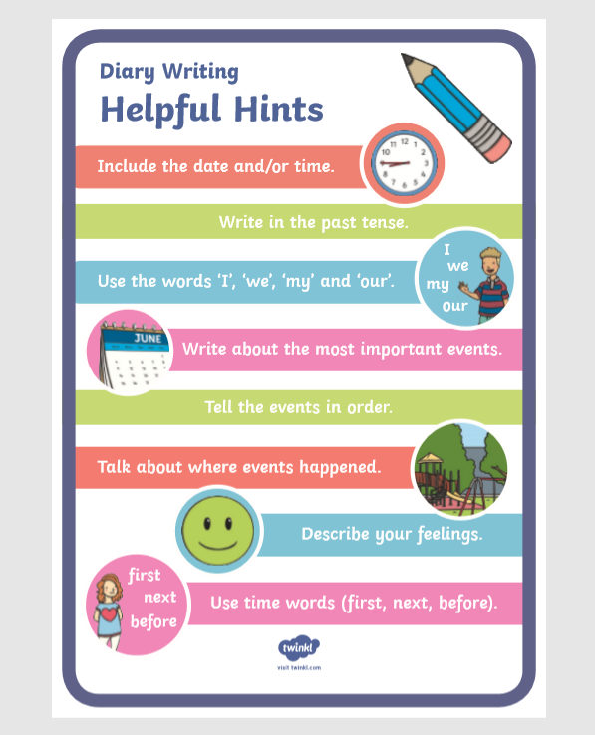

Rationing Numeracy Activity
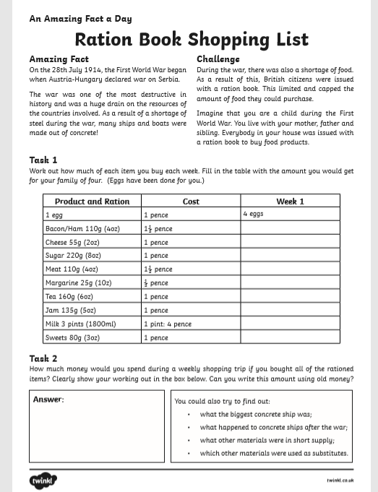

Creative Challenge
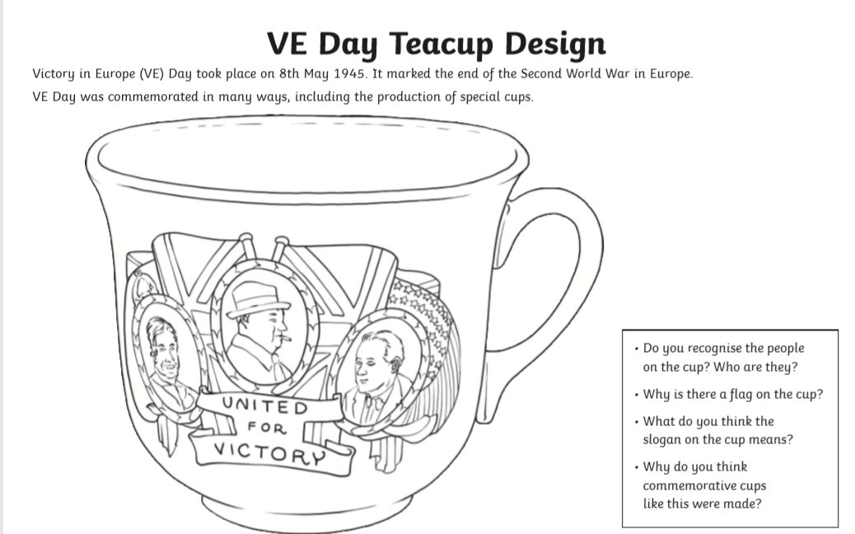

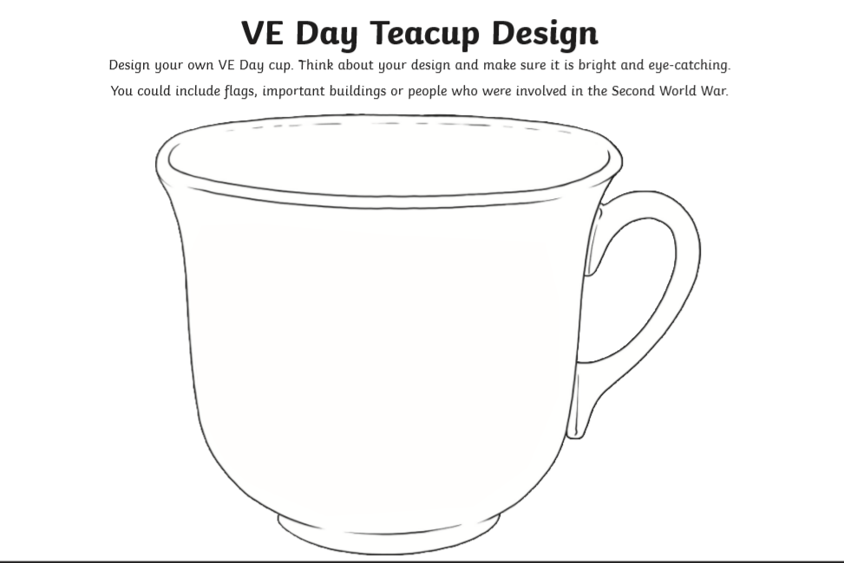

The Morse Code Alphabet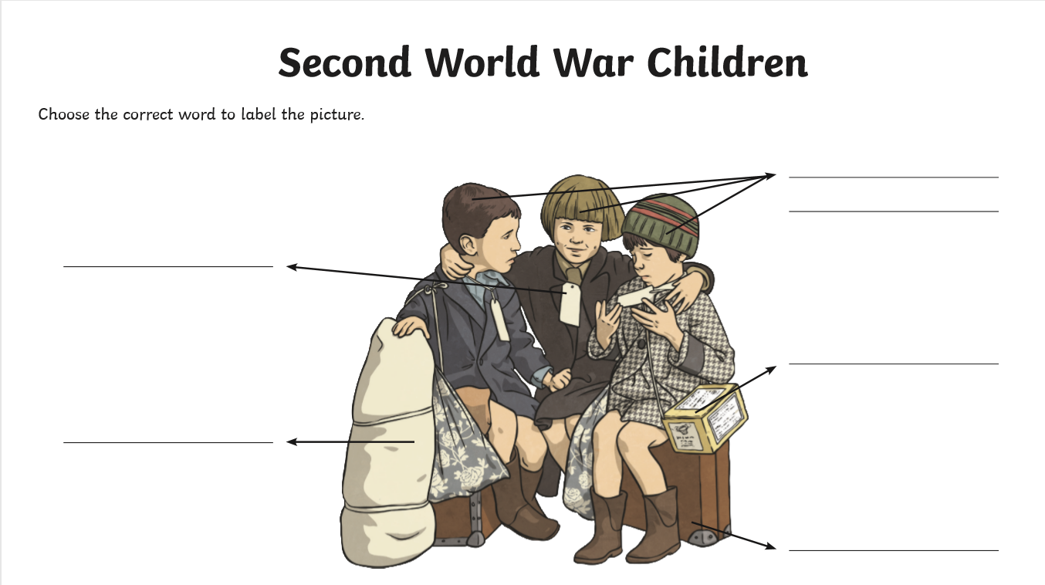

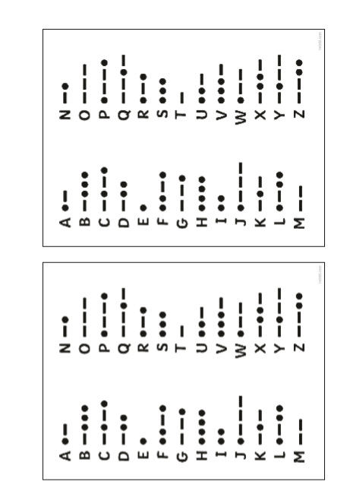

Design a party invitation


