Home Learning challenges – Week 12

Literacy – Sound of the week is k. We enjoy these two videos in class for the sound of the week - https://www.youtube.com/watch?v=j_LNrXd7Jx8 and https://www.youtube.com/watch?v=ZSuDDRG2P-c Level 1 - Please can your child either practise identifying/saying/signing and forming this letter. Level 2 – As we are now learning a new topic, I thought it would be nice if your child could start to make a topic dictionary so each time we look at a new sound please can they think of beach themed words for it and write them down. It would be lovely if they could have a blank notebook so each letter has a page. For example this week is k so they could list – kites, krill, kelp etc. They could even draw pictures next to each. As an extra challenge they can complete learnt sounds so far – m, a, s, d, t, i, n, p, g, o, c and k.
If practising forming the letter you can do it in fun ways – writing in/with sand/foam/flour/mud/printing with food etc for multi-sensory fun! Also Ruth Miskin is doing daily RWI sound sessions live on youtube each day – https://m.youtube.com/channel/UCo7fbLgY2oA_cFCIg9GdxtQ Read Write Inc have now announced that their resources are free! To recap learnt sounds so far – m, a, s, d, t, i, n, p, g, o, c and k to practise forming this week’s sound (k) please follow – https://home.oxfordowl.co.uk/reading/reading-schemes-oxford-levels/read-write-inc-phonics-guide/ scroll down and click on speed sounds practice sheets.

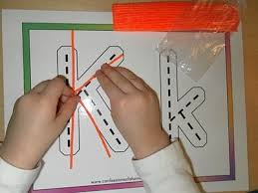 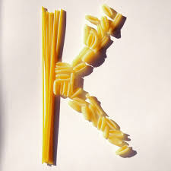 Forming with string and pasta

Numeracy – Two levels – level one – we are back to 2 this week (if your child is confident identifying/writing/saying/signing you can move on to 7 or recap other numbers 1-5 that they need more support with). We enjoy reading the story of one -http://resources.hwb.wales.gov.uk/VTC/story_of_2/eng/Introduction/default.htm
and completing the activities. Please practise recognising the number/saying/signing/writing and linking to objects eg show two cars/shoes/gloves and write the number next to it. You can also enjoy multisensory activities to write 2.
Level two – This week I would like us to take a little break from number and focus on shape. We enjoy these two songs as a class - https://www.youtube.com/watch?v=pfRuLS-Vnjs and https://www.youtube.com/watch?v=WTeqUejf3D0. The videos are handy for recapping names and properties of 2d shapes. To help recap names please use the shape mat below -

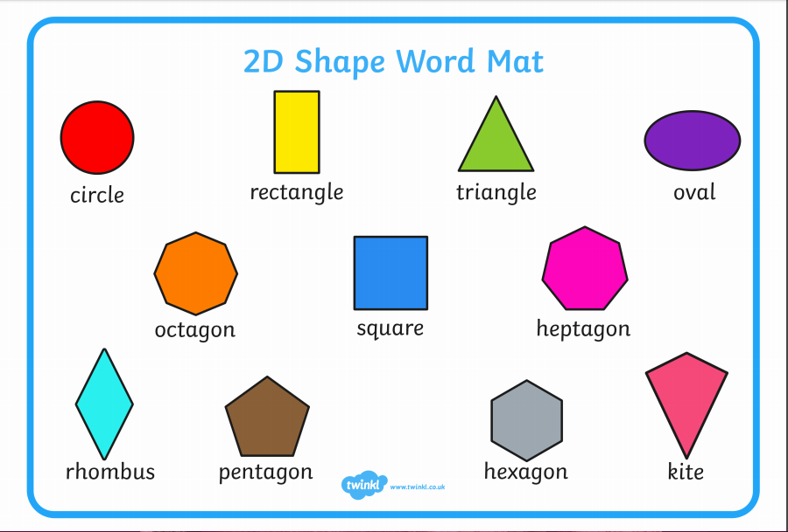
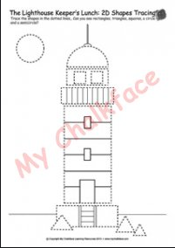
How many shapes can you see in this lighthouse picture? Can you name the shapes? Can you count how many of each shape you can find? Using your lighthouse design from last week can you count how many 2d shapes you used and name them?
If you have access to a printer there is a lovely 2d shape beach themed picture pack here - https://content.twinkl.co.uk/resource/3e/3d/t-n-2546888-beachthemed-2d-shapes-activity-pack-_ver_4.pdf?__token__=exp=1592816844~acl=%2Fresource%2F3e%2F3d%2Ft-n-2546888-beachthemed-2d-shapes-activity-pack-_ver_4.pdf%2A~hmac=426ada842a1c2b0baea1e22ab2c4f840c1619a77589c9e0731f4891c19d82e58.

You will also find a wealth of resources to help with 2d shape on topmarks - http://www.primaryresources.co.uk/maths/mathsE3.htm

Topic – ‘The lightbulb’ – We have looked at the lighthouse and how it keeps boats safe at night, now we are going to look at other elements of the beach and how people keep safe in the dark.
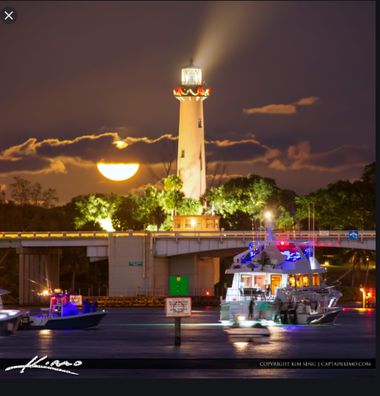

Look at this night scene beach picture – how many sources of light can you see? How many use a lightbulb like the lighthouse? Does the moon have a lightbulb in? List the sources of light that use a lightbulb.

Please enjoy this story with your child - https://www.youtube.com/watch?v=KK7Au1u-_xg
Arts and Craft – As we are looking at boats this week and paying attention to boat lighting. I thought your child may like to create a craft boat/draw/paint/create a boat on an online painting package. As we are looking at boats at night please remind them to include lights – they can be any colour!
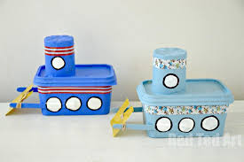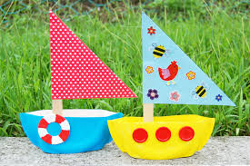
Made from butter tubs!
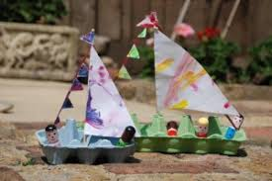
Made from egg boxes

As an extra challenge maybe you would like to see if your boat sinks or floats in water!

PE – I hope you are still joining me (virtually) for Joe Wicks at 9am. If you would like to try something different we enjoy Cosmic Kids yoga in class found on Youtube. Also, remember you can always ask your child to move like the sea creatures we have been learning about!

If you need any help please contact me on dojo or email. Have fun!
Miss Johns

