Literacy Challenge  Write a diary of your seaside visit.  Spelling  Fill in the missing words with the correct spellings.  Word level  Year 1/year 2 spelling packs to complete.  (Find on HWB, Class page on website)    This Photo by Unknown Author is licensed under CC BY-SA-NC | Numeracy Challenge  Position and Direction challenge cards.  Number bonds to 10/20/100.  Play games on the following websites, particularly working in number skills such as place value, addition and subtraction, time, Fractions, multiplication, division.  www.topmarks.co.uk ,    www.snappymaths.com  https://www.bbc.co.uk/bitesize/subjects/z826n39 | Reading Challenge  Read the common exception words and colour them in to create a Rainbow Fish.  Read a book of your choice every day for 15 minutes.  Reading comprehension activity: Four Key words activity.  https://www.twinkl.co.uk/resource/t-s-3381-reading-comprehension-four-key-word-activity-sheets    This Photo by Unknown Author is licensed under CC BY-NC-ND
ICT Challenge  Use the goggle search engine to find out more about the Hermit crab.  Create a leaflet using JIT Mix all about ‘The Hermit Crab’. Adding pictures and interesting facts.   | Creative Challenge  Make a crab using any junk materials you have at home. Give your crab a name. Think about any interesting facts about your crab.    This Photo by Unknown Author is licensed under CC BY-SA | Welsh Challenge  Write an email to a friend asking how they are feeling?    This Photo by Unknown Author is licensed under CC BY-SA
PSD Challenge  Create a safety poster for the seaside.  Complete an activity from this amazing Food website.  https://www.foodafactoflife.org.uk/    This Photo by Unknown Author is licensed under CC BY-NC | P.E. Challenge:  Join in with Joe Wicks PE 30 min a day via YouTube live every morning at 9am (Mon-Fri).  Look at the all about sports day information Power point.  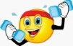  Practice the egg and spoon race. | Science Challenge  Why do boats Float?  Collect a range of objects, identify what they are made of and predict whether they will float or sink. Place objects in a bucket of water one by one and record what happens under floaters and sinkers. How are the objects in their groups similar or different?
Year 1-2 Home Learning Planning - Summer Term Beachcombers. Mrs Moore
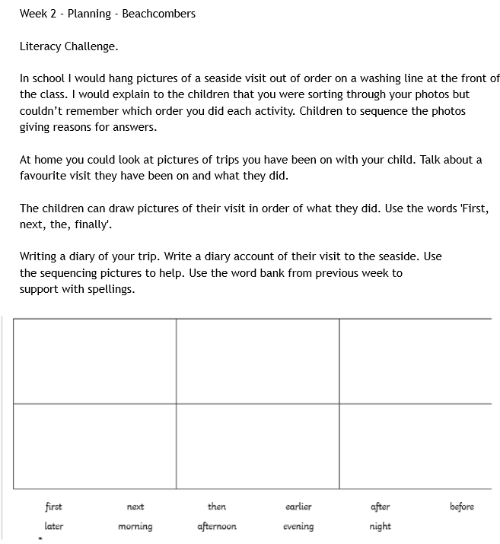
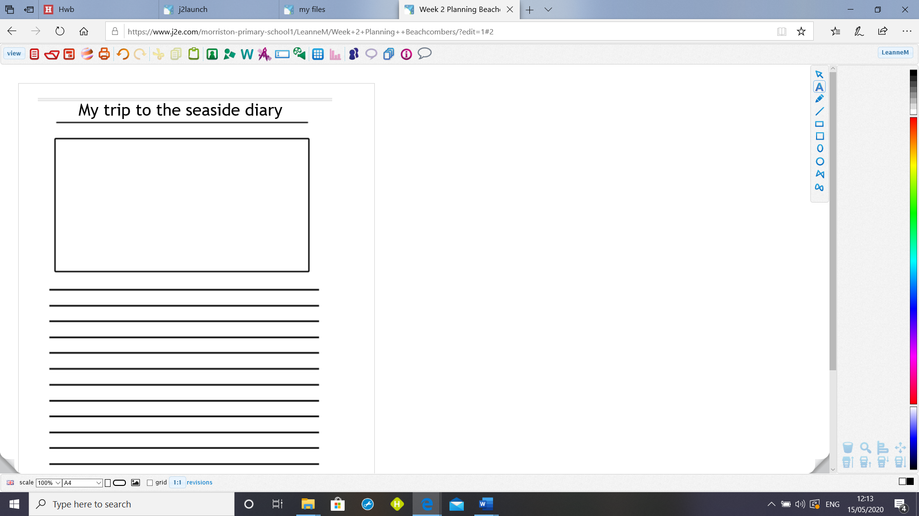
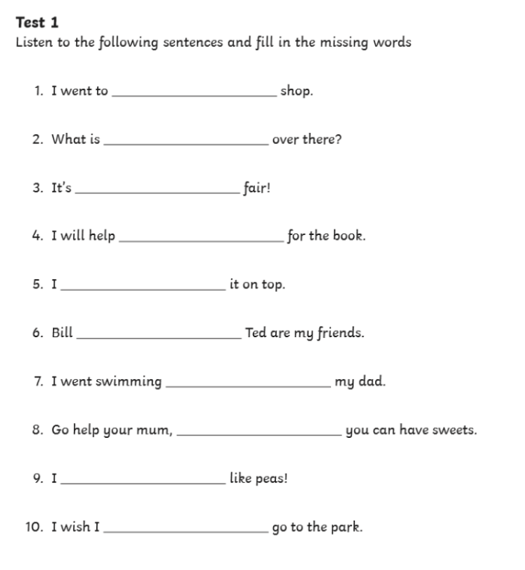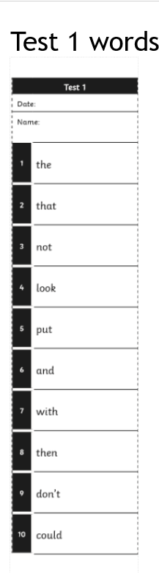
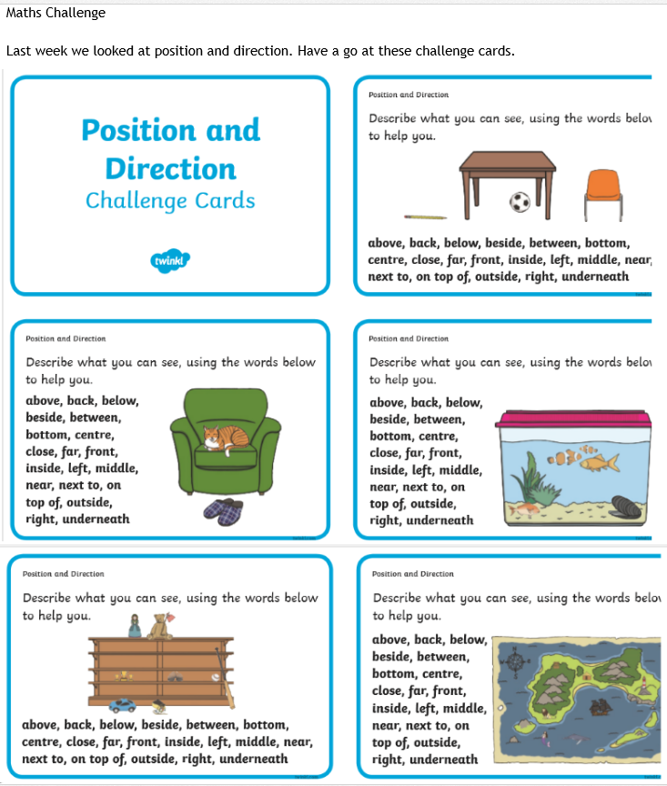

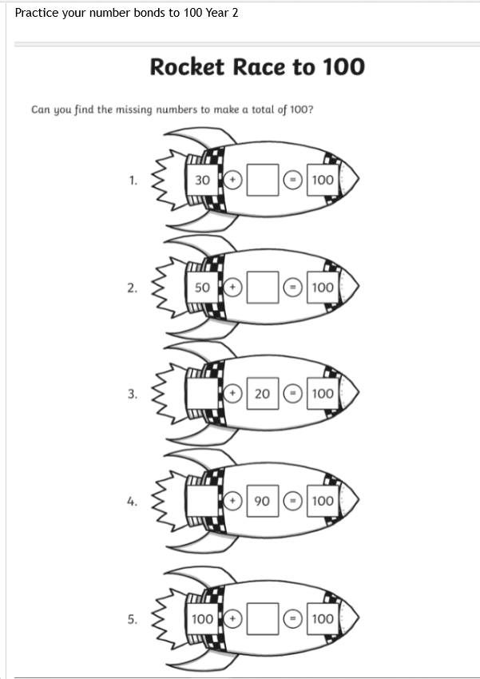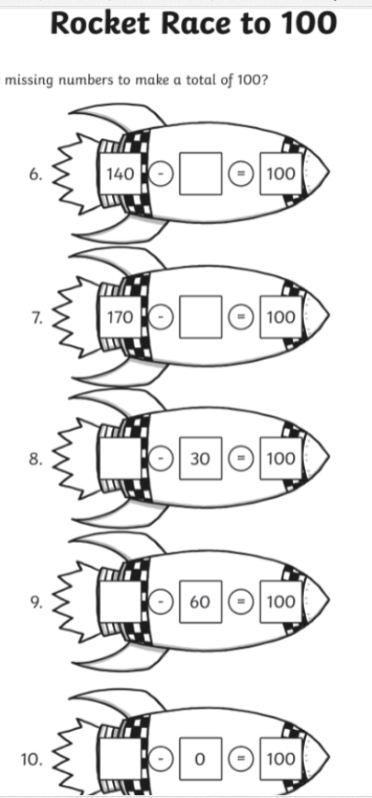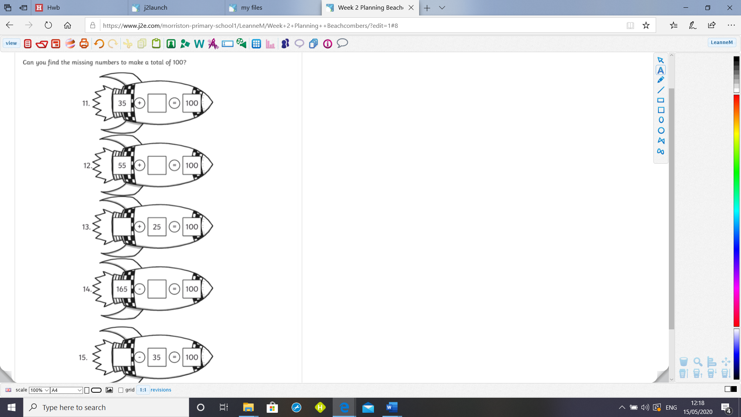

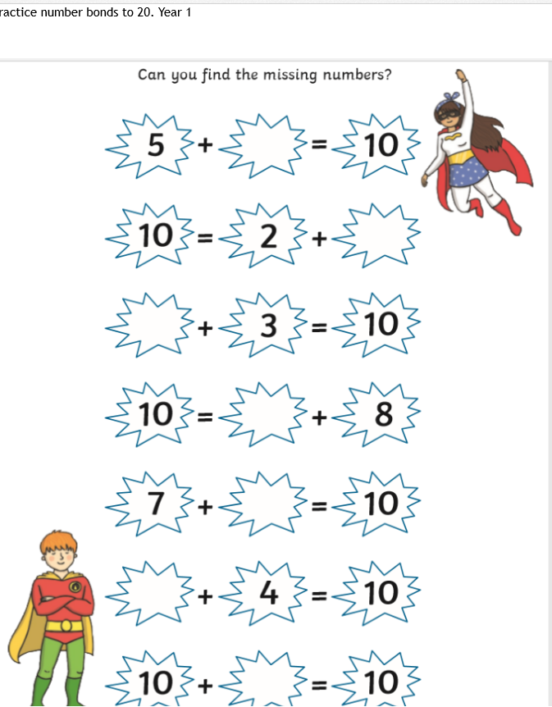 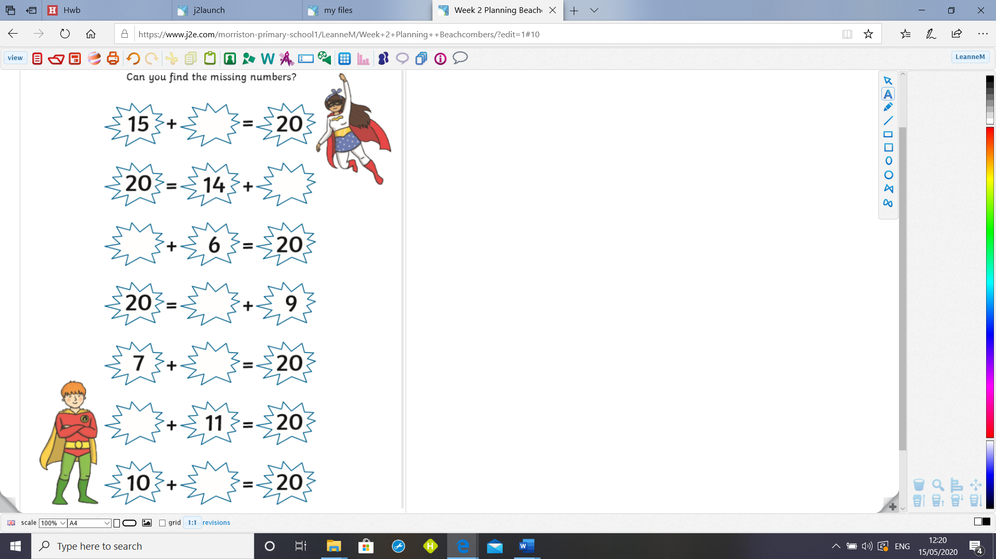4



