Literacy Challenge  Who am I?.  Spelling  Reinforce the formation of capital letters.  Word level  Year 1 and Year 2 activity booklets.  (Find on HWB, Class page on website)    This Photo by Unknown Author is licensed under CC BY-SA-NC | Numeracy Challenge  Patterns – Creating patterns, continuing patterns, describing patterns.  2x tables activity booklet.  Play games on the following websites, particularly working in number skills such as place value, addition and subtraction, time, Fractions, multiplication, division.  www.topmarks.co.uk ,    www.snappymaths.com  https://www.bbc.co.uk/bitesize/subjects/z826n39 | Reading Challenge  Read the tongue twisters and perform them to your family.  Read a book of your choice every day for 15 minutes.  Reading comprehension activity: Four Key words activity.  https://www.twinkl.co.uk/resource/t-s-3381-reading-comprehension-four-key-word-activity-sheets    This Photo by Unknown Author is licensed under CC BY-NC-ND
ICT Challenge  Present your tongue twister using JIT 5.  Use J2 code to make shapes by giving the arrow directions.   | Creative Challenge  Sketch a picture of your favourite type of crab.    This Photo by Unknown Author is licensed under CC BY-SA | Welsh Challenge  Write text message to your friend telling them how you are feeling.    This Photo by Unknown Author is licensed under CC BY-SA
PSD Challenge  I am amazing activity sheet. Positive self image.  Complete an activity from this amazing Food website.  https://www.foodafactoflife.org.uk/    This Photo by Unknown Author is licensed under CC BY-NC | P.E. Challenge:  Join in with Joe Wicks PE 30 min a day via YouTube live every morning at 9am (Mon-Fri).  Sports day board game.    Practice the standing long jump. | Science Challenge  Why do boats Float?  Think about the question How do boats float?
Year 1-2 Home Learning Planning - Summer Term Beachcombers. Mrs Moore

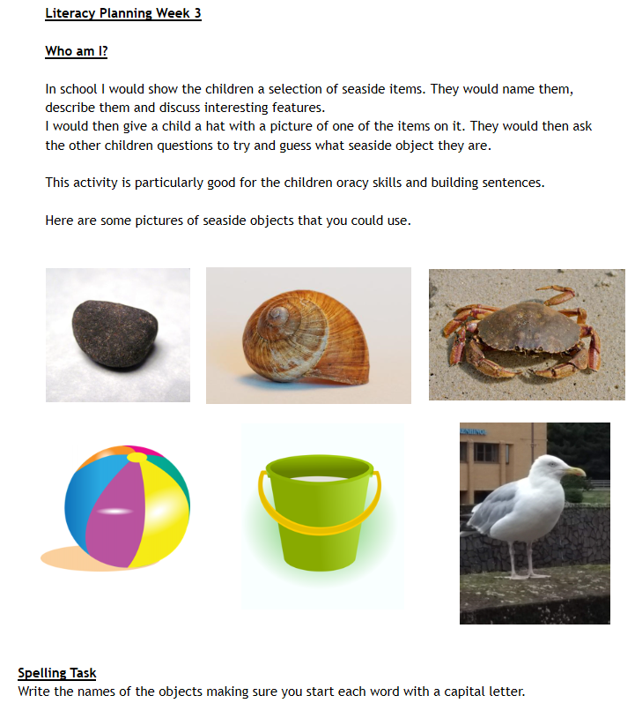
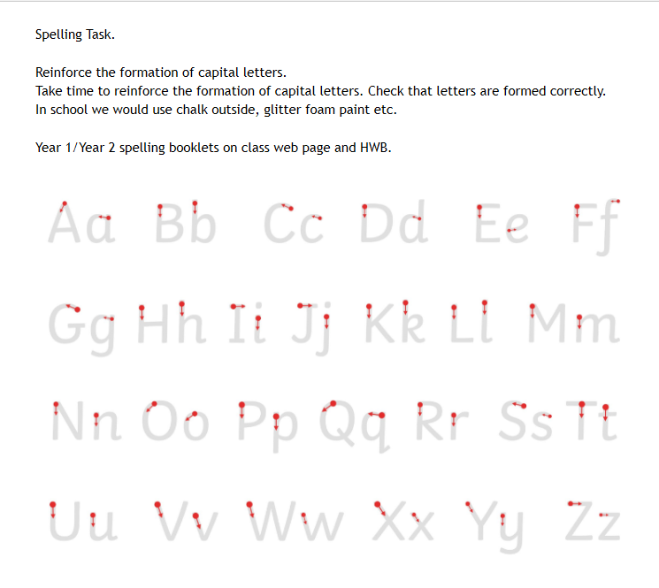

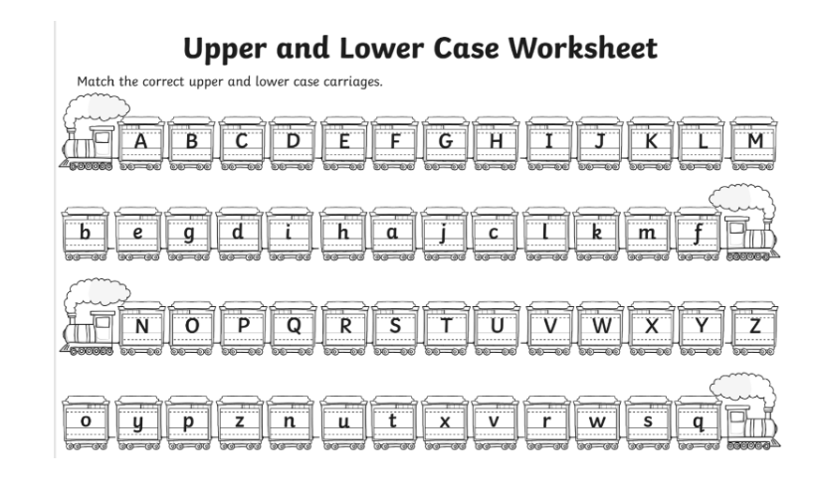

Numeracy planning Week 3
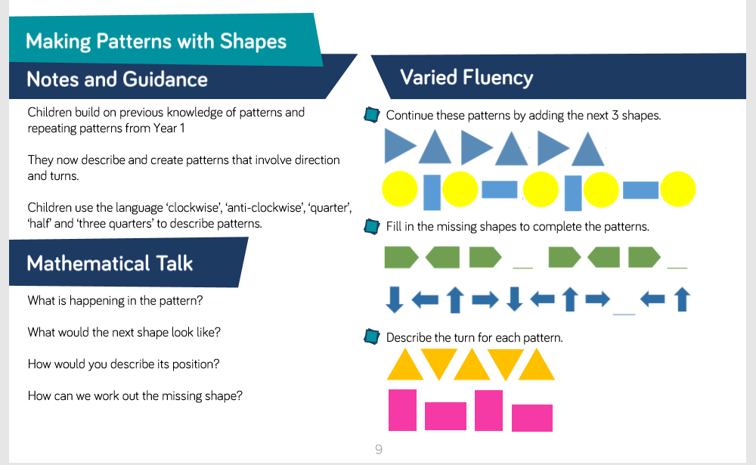
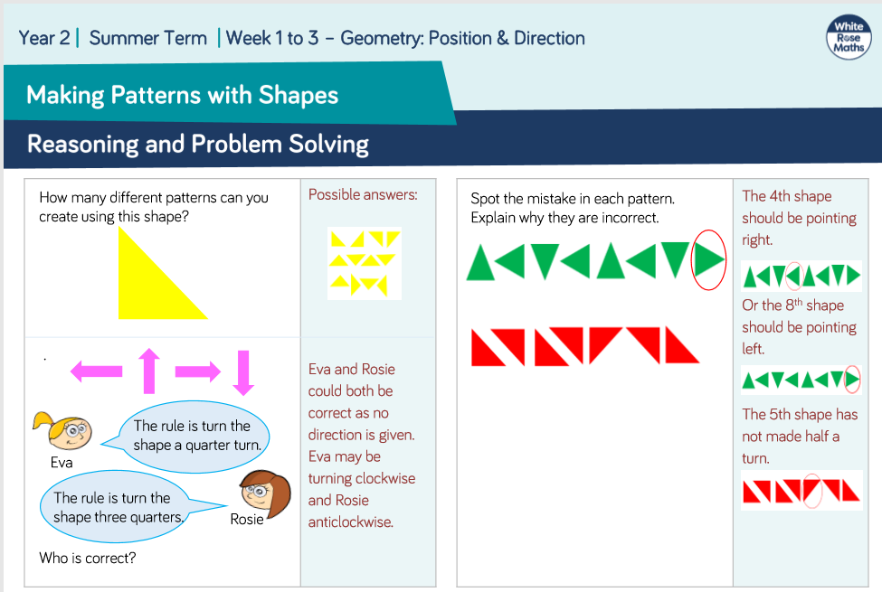
Delete to reveal answers.
Delete to reveal answers.



