Home Learning challenges – Week 9

Literacy – Sound of the week is g. We enjoy these two videos in class for the sound of the week -https://www.youtube.com/watch?v=ru0KCAS5zuY and http://englishlions.blogspot.com/2014/01/g-song-jolly-phonics-5-years-old.html Level 1 - Please can your child either practise identifying/saying/signing and forming this letter. Level 2 – As we are now learning a new topic, I thought it would be nice if your child could start to make a topic dictionary so each time we look at a new sound please can they think of beach themed words for it and write them down. It would be lovely if they could have a blank notebook so each letter has a page. For example this week is p so they could list – gull (seagull, gang plank, giant squid etc). They could even draw pictures next to each. As an extra challenge they can complete learnt sounds so far – m, a, s, d, t, i, n, p and g.
If practising forming the letter you can do it in fun ways – writing in/with spaghetti/glitter/chalk/icing sugar/driving cars through paint etc for multi-sensory fun! Also Ruth Miskin is doing daily RWI sound sessions live on youtube each day – https://m.youtube.com/channel/UCo7fbLgY2oA_cFCIg9GdxtQ Read Write Inc have now announced that their resources are free! To recap learnt sounds so far – m, a, s, d, t, i, n, p and g to practise forming this week’s sound (p) please follow – https://home.oxfordowl.co.uk/reading/reading-schemes-oxford-levels/read-write-inc-phonics-guide/ scroll down and click on speed sounds practice sheets.

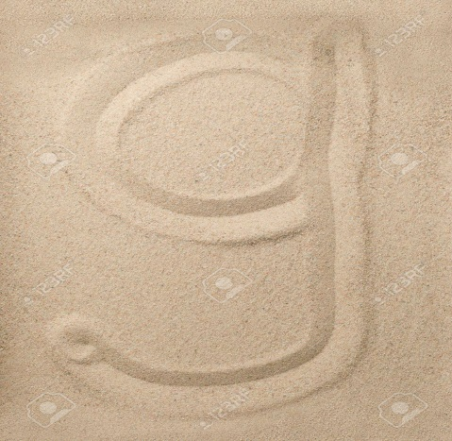 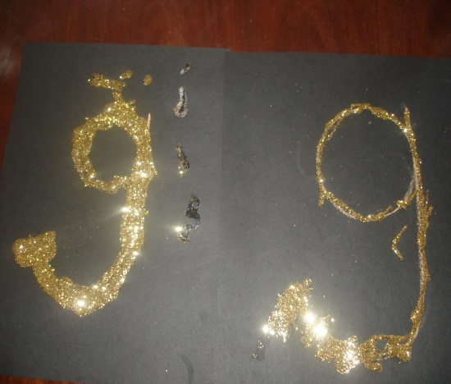 Sand and glitter.

Numeracy – Two levels – level one – we are back to 4 this week (if your child is confident identifying/writing/saying/signing 1 you can move on to 9 or recap other numbers 1-5 that they need more support with). We enjoy reading the story of two -https://resources.hwb.wales.gov.uk/VTC/story_of_4/eng/Introduction/default.htm
and completing the activities. Please practise recognising the number/saying/signing/writing and linking to objects eg show three pencils/cups/stars and write the number next to it. You can also enjoy multisensory activities to write 4.
Level two – I would now like you to move on to looking at and identifying odd numbers. We love the coconut game - https://www.topmarks.co.uk/learning-to-count/coconut-odd-or-even You can ask your child to start off to 20 (only knocking odd numbers down) but there are challenges up to 50, 100 and even 1000! If you would like a different way of finding even numbers maybe you could find a couple of dice in your house (I’m sure 1 dice would be far too easy!) roll 2 or even 3 dice – ask your child what the number is and write the number down – only if it is odd!

Topic – On my daily walk to our local beach I found this building –

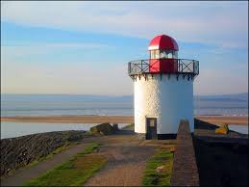

I was wondering if you knew, or if you could find out the following for this week’s topic task -

- What is it called?
- What is it for?
- How does it work?
- What powers it?
- Why are they important?
- Can you think of any others you have seen?

Please enjoy this lovely story with your child - https://www.youtube.com/watch?v=oBmVO-MlVrk

For this weeks craft I would like you to make lighthouses with your children whether they are painted using the image above to help or you can create a junk modelling craft like the ones below –

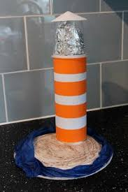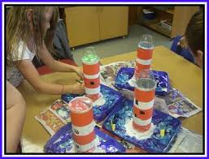
Made from yoghurt pots! Made out of Pringles pots!

Don’t forget the most important feature
To find out how the ‘important feature’ was made please watch this fun video - https://www.youtube.com/watch?v=b1lKwZTtzIY

PE – I hope you are still joining me (virtually) for Joe Wicks at 9am. If you would like to try something different we enjoy Cosmic Kids yoga in class found on Youtube.

If you need any help please contact me on dojo or email. Have fun!
Miss Johns

