Home Learning challenges – Week 10

Literacy – Sound of the week is o. We enjoy these two videos in class for the sound of the week - https://www.youtube.com/watch?v=-EgEt0aru90 and https://www.youtube.com/watch?v=EwycnpTX6BILevel 1 - Please can your child either practise identifying/saying/signing and forming this letter. Level 2 – As we are now learning a new topic, I thought it would be nice if your child could start to make a topic dictionary so each time we look at a new sound please can they think of beach themed words for it and write them down. It would be lovely if they could have a blank notebook so each letter has a page. For example this week is p so they could list – octopus, ocean, oyster etc. They could even draw pictures next to each. As an extra challenge they can complete learnt sounds so far – m, a, s, d, t, i, n, p, g and o.
If practising forming the letter you can do it in fun ways – writing in/with sand/foam/flour/mud/printing with food etc for multi-sensory fun! Also Ruth Miskin is doing daily RWI sound sessions live on youtube each day – https://m.youtube.com/channel/UCo7fbLgY2oA_cFCIg9GdxtQ Read Write Inc have now announced that their resources are free! To recap learnt sounds so far – m, a, s, d, t, i, n, p, g and o to practise forming this week’s sound (o) please follow – https://home.oxfordowl.co.uk/reading/reading-schemes-oxford-levels/read-write-inc-phonics-guide/ scroll down and click on speed sounds practice sheets.

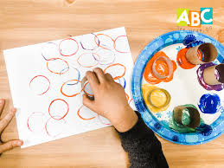  Printing with the base of a toilet roll and formed with spaghetti.

Numeracy – Two levels – level one – we are back to 5 this week (if your child is confident identifying/writing/saying/signing you can move on to 10 or recap other numbers 1-5 that they need more support with). We enjoy reading the story of two -https://resources.hwb.wales.gov.uk/VTC/story_of_5/eng/Introduction/default.htm
and completing the activities. Please practise recognising the number/saying/signing/writing and linking to objects eg show three pencils/cups/stars and write the number next to it. You can also enjoy multisensory activities to write 5.
Level two – This week I would like you to move on to estimation/guessing how many. This can be a difficult concept as children are so used to counting they try to count the objects straight away! Try to keep it fun and a game so say they are only allowed a couple of seconds to look before guessing. Start small to see if your child is able to give a sensible answer and move high eg up to 5 to start then move up to 10 and so on as long as their answers are sensible. You could either find resources around the house, tip them out and guess how many eg pencils/pens/playing cards/counters etc, draw dots/images on paper or you could use sheets like the ones below –

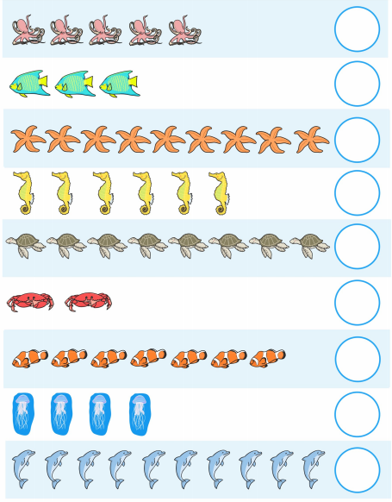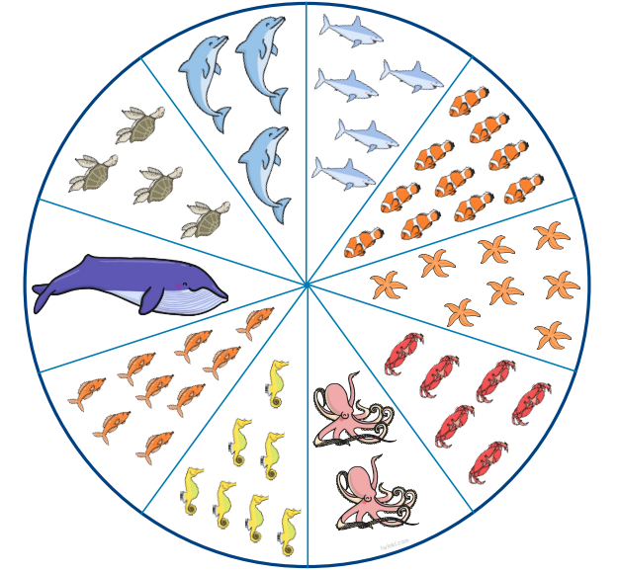

Topic – ‘The lightbulb’ – I hope you enjoyed researching and making Lighthouses last week! We are going to use the lightbulb as a theme for the next couple of weeks, although still linked to the beach as part of a whole school project. For the next part of the project I would like you to choose one local lighthouse, it could be my local one from last week – in Burry Port or maybe Mumbles lighthouse and compare it to an interesting lighthouse in another country. You can help your child Google lighthouses abroad. I though the lighthouse below was interesting! From South Korea.

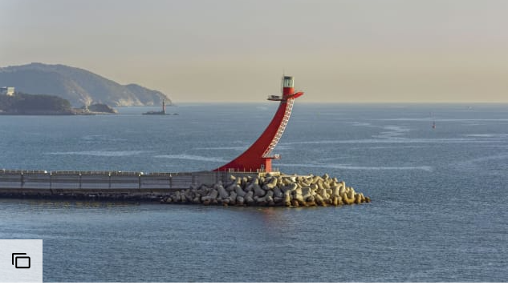

You could ask your child to imagine being there and write a postcard either to Mr Grinling from last week’s story or to myself from the lighthouse they have found. Maybe they could explain a little about the lighthouse? 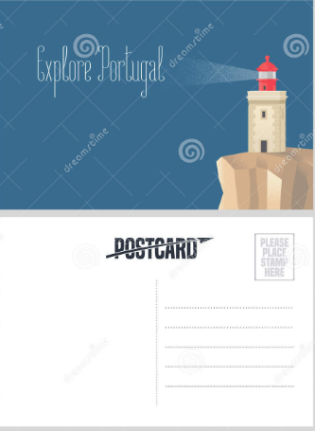
I was wondering if you could then use the facts from last week and comparisons this week to help your child label the lighthouse –

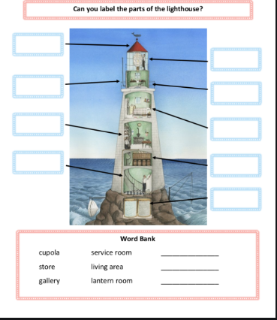

Now that we know what a lighthouse is, what it is for and how it works I have found this lovely story linking our learning back to sea creatures - https://www.youtube.com/watch?v=yo4rD9NvO5M Does the starfish have a lightbulb inside like a lighthouse?!

PE – I hope you are still joining me (virtually) for Joe Wicks at 9am. If you would like to try something different we enjoy Cosmic Kids yoga in class found on Youtube. Also, remember you can always ask your child to move like the sea creatures we have been learning about!

If you need any help please contact me on dojo or email. Have fun!
Miss Johns

