Home Learning challenges – Week 11

Literacy – Sound of the week is c. We enjoy these two videos in class for the sound of the week - https://www.youtube.com/watch?v=ieo0LPYdUfQ and https://www.youtube.com/watch?v=bZNxhoxSAFA (This plays both c and k sounds – the children usually shout stop when the k sound plays!) Level 1 - Please can your child either practise identifying/saying/signing and forming this letter. Level 2 – As we are now learning a new topic, I thought it would be nice if your child could start to make a topic dictionary so each time we look at a new sound please can they think of beach themed words for it and write them down. It would be lovely if they could have a blank notebook so each letter has a page. For example this week is c so they could list – crab, clownfish, cod etc. They could even draw pictures next to each. As an extra challenge they can complete learnt sounds so far – m, a, s, d, t, i, n, p, g, o and c.
If practising forming the letter you can do it in fun ways – writing in/with sand/foam/flour/mud/printing with food etc for multi-sensory fun! Also Ruth Miskin is doing daily RWI sound sessions live on youtube each day – https://m.youtube.com/channel/UCo7fbLgY2oA_cFCIg9GdxtQ Read Write Inc have now announced that their resources are free! To recap learnt sounds so far – m, a, s, d, t, i, n, p, g, o and c to practise forming this week’s sound (c) please follow – https://home.oxfordowl.co.uk/reading/reading-schemes-oxford-levels/read-write-inc-phonics-guide/ scroll down and click on speed sounds practice sheets.

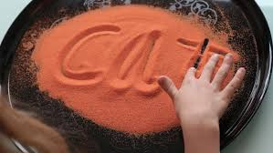 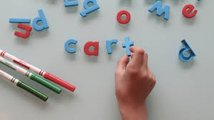 Writing words that start with c in coloured sand and forming words that start with c in magnets.

Numeracy – Two levels – level one – we are back to 1 this week (if your child is confident identifying/writing/saying/signing you can move on to 6 or recap other numbers 1-5 that they need more support with). We enjoy reading the story of one -http://resources.hwb.wales.gov.uk/VTC/story_of_1/eng/Introduction/default.htm
and completing the activities. Please practise recognising the number/saying/signing/writing and linking to objects eg show three pencils/cups/stars and write the number next to it. You can also enjoy multisensory activities to write 1.
Level two – Last week I asked you to have a go at estimation/guessing how many. As this can be quite a difficult concept to understand I would like you to have another week at this just so we know the children are able to say an appropriate number that is within a few numbers from the number of objects. Remind the children that they can’t count the objects but once they have guessed they can count to see how close they were. Try to keep it fun and a game so say they are only allowed a couple of seconds to look before guessing. Start small to see if your child is able to give a sensible answer and move high eg up to 5 to start then move up to 10 and so on as long as their answers are sensible. You could either find resources around the house, tip them out and guess how many eg pencils/pens/playing cards/counters etc, draw dots/images on paper or you could google sea creature pictures like the ones below -

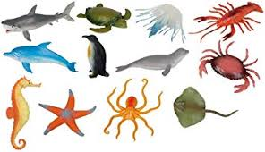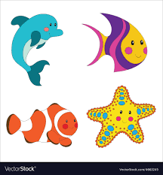

Topic – ‘The lightbulb’ – I hope you enjoyed researching different lighthouses around the world and comparing them to one of our local lighthouses! Before we move on to a different area of ‘The lightbulb.’ I just thought I would share this powerpoint with you as it sums up what we have learnt so far – what they are for, how they work, the parts of a light house and some light houses in other countries - https://www.twinkl.co.uk/resource/t-tp-6412-all-about-lighthouses-powerpoint
In the powerpoint it tells us that the person who works in the light house is the light house keeper. Use the word mat below to decide what clothes he should wear for a stormy night!
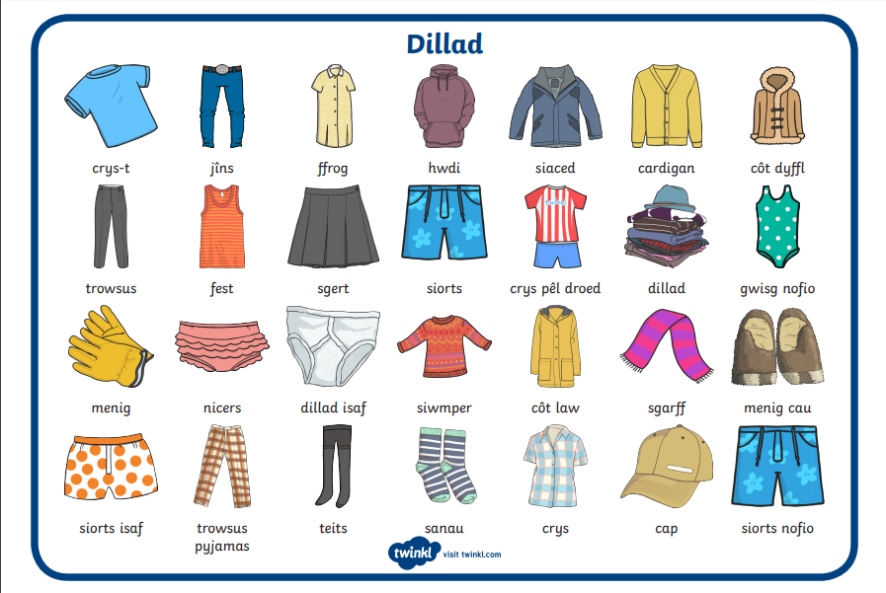

In class every day we record the weather, I would like you and your child to use the word mat below and record the weather for the week while thinking about the light house keeper! Is the light house keeper in for an easy shift or a difficult one?!

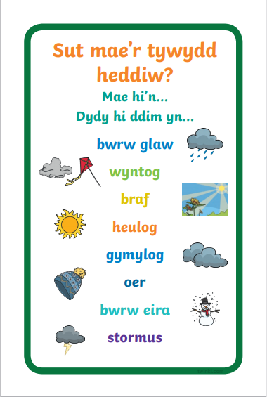

Please enjoy this story with your child - https://www.youtube.com/watch?v=gScnGpAI0N4 Mr and Mrs Grinling went from the lighthouse to their house – did you see another source of light that uses a lightbulb in their house? Look carefully at the pictures! How many sources of light can you find in your house that has a lightbulb? Can you think of a source of light that Mr Grinling could have used while going down the wire to the lighthouse so that he could see in the dark?
Arts and Craft – I hope you enjoyed creating a lighthouse with your child. This week I would like your child to design their own light house – it can be any shape, any colour, the windows/doors can be unusual shapes and the light can be any colour! Lets make them fun!

PE – I hope you are still joining me (virtually) for Joe Wicks at 9am. If you would like to try something different we enjoy Cosmic Kids yoga in class found on Youtube. Also, remember you can always ask your child to move like the sea creatures we have been learning about!

If you need any help please contact me on dojo or email. Have fun!
Miss Johns

