  Date: 6th July 2020 |  |  |  | Theme: Beachcombers  Year group: Mrs Moore YR1/2
Literacy      This Photo by Unknown Author is licensed under CC BY-NC-ND   | Numeracy     | Creative     | Thinking     |  | Healthy me    
Literacy  Now that we have our character think about what might happen to your character. Draw out a simple story plan using pictures, words, short sentences. After creating your story map share it with an adult.  e.g. You may get caught in a fishing net.  Washed away by waves.  Trapped in a plastic bottle.  A large predatory enters your rock pool.  Word Time  High Frequency words – C words. (Send D words home).  Spelling  Correct the punctuation activity sheets.  Catch-up  Read RWI Books with the children depending on which group they are in.  https://www.youtube.com/watch?v=6eh_RQ0Pkhg – Practice set 2 RWI sounds.  Reading  Read a book of your choice for 10-15 minutes a day.  Children to read with their teacher in their session.  Welsh  Welsh  Read the story ‘Tedi Tw tar Lan Y Mor’.  Link to story:  http://adnoddau.cbac.co.uk/Pages/ResourceSingle.aspx?rIid=609  Practice vocabulary used in the story using flashcards.  Practice these sentence patterns.  Cam 4  Beth wyt ti eisiau? What do you want?  Dw i eisiau bwced. I want a bucket.  Dw i ddim eisiau bwced. I don’t want a bucket.  Wyt ti eisiau hufen iâ? Do you want an ice-cream?  Ydw, dw i eisiau hufen iâ. Yes I do want an ice-cream.  Nag ydw, dw i ddim eisiau hufen iâ. No I don’t want an icecream.  Write a postcard to your friend. Tell your friend how you are feeling. Ask them how they are feeling. Tell them what you are wearing. Tell them what you like and what you don’t like. Tell them what the weather is like. There is an example of a postcard on HWB to help. | Maths  Time  White Rose Maths – Telling the time o’clock, half past, quarter past and quarter to.  Reasoning and problem solving  O clock and half past.  My Maths  Telling the Time 1  Year 1  Place value numbers to 100.  Year 2  Place value 2- and 3-digit numbers.  10 x Tables  Practice tables on j2Blast. | Art  Task 1  Make a finger puppet of a seagull.  Task 2  Research the Welsh artist Glenys Cour.  Create a background picture for you Seagull by using one of her paintings. | KUOTW  (Geography)  Research the British Seabird ‘The Puffin’. Find out about what it eats, where it lives (Habitat), how it survives. Use the RSPB website to find information. Create a fact file on the Puffin.  KUOTW  (Science)  Think about some of the non-living items that you may come across on the beach. For example, plastic bottles left, cans, wrappers. Think about how these might be dangerous to the wildlife.  Complete the science investigation saved on HWB to look at these materials.  KUOTW  (R.E)  I am special! Give out mirrors and magnifying glasses and ask the children to look closely at themselves. Focusing in on skin, hair, teeth, eyes and fingerprints. Let the children feedback then explain their eyes will let them see what’s special on the outside but their ears will let them know what makes someone special on the inside. Encourage the children to ask each other questions and listen carefully to the answers. Give the children some picture prompts for this session to help them ask questions. |  | PSD  Look at the pictures of the seaside covered by litter. How does this make you feel? How do you think this effects the wildlife? What could people do to stop this from happening.  Create a poster on keeping our beaches clean.  Remember to add:  Bold title.  Pictures.  Short informative phrases.  P.E.  Joe Wicks  Workout  Movements - Pirates  The children will create different movements for a variety of pirate sayings in an area.  “Walk the Plank!” – One foot in front of the other.  “Cannonballs!” – Jogging and dodging the five cannonballs.  “Man overboard!” – Run to edge of area and shout, “Jim Lad, I’ll save ye!”  “Man the lifeboats!” – In groups or by themselves rowing, turning and walking backwards.  “Scrub the decks!” and “Treasure Hunt” Movement

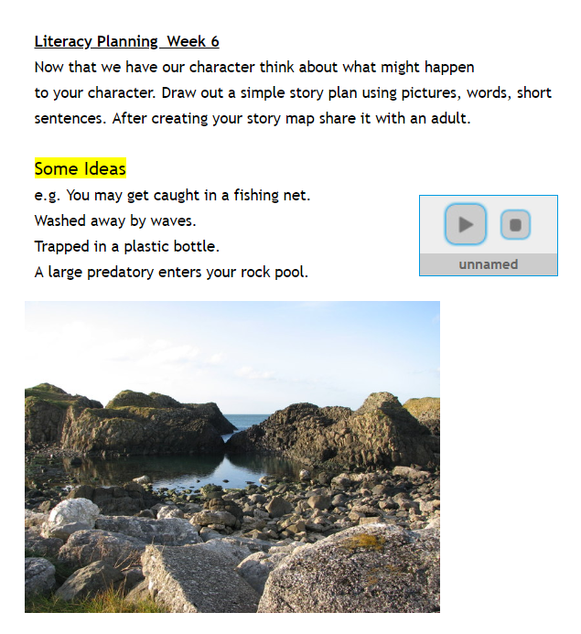

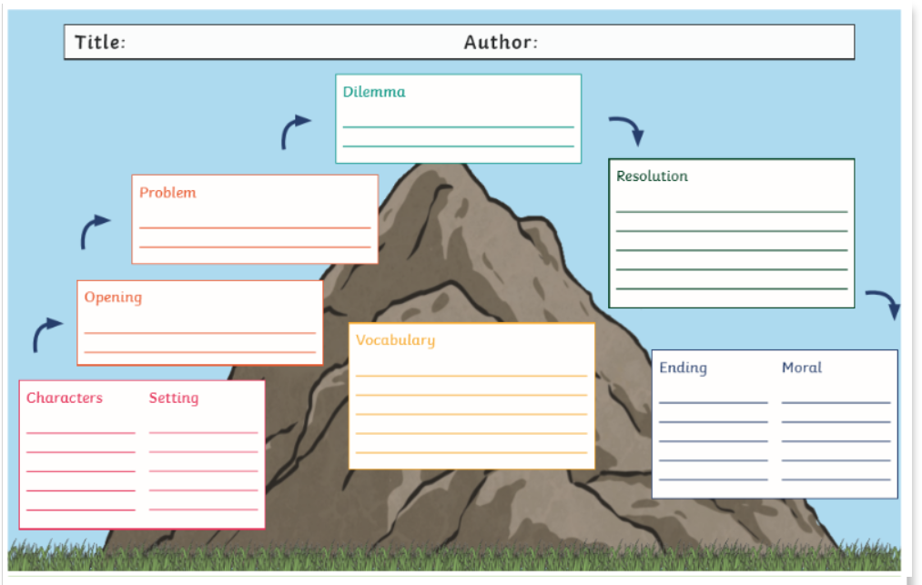

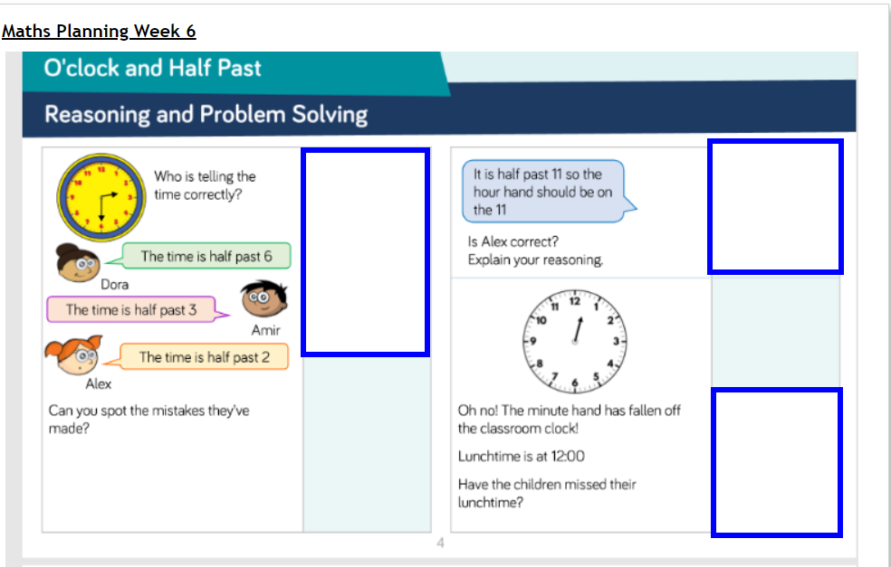

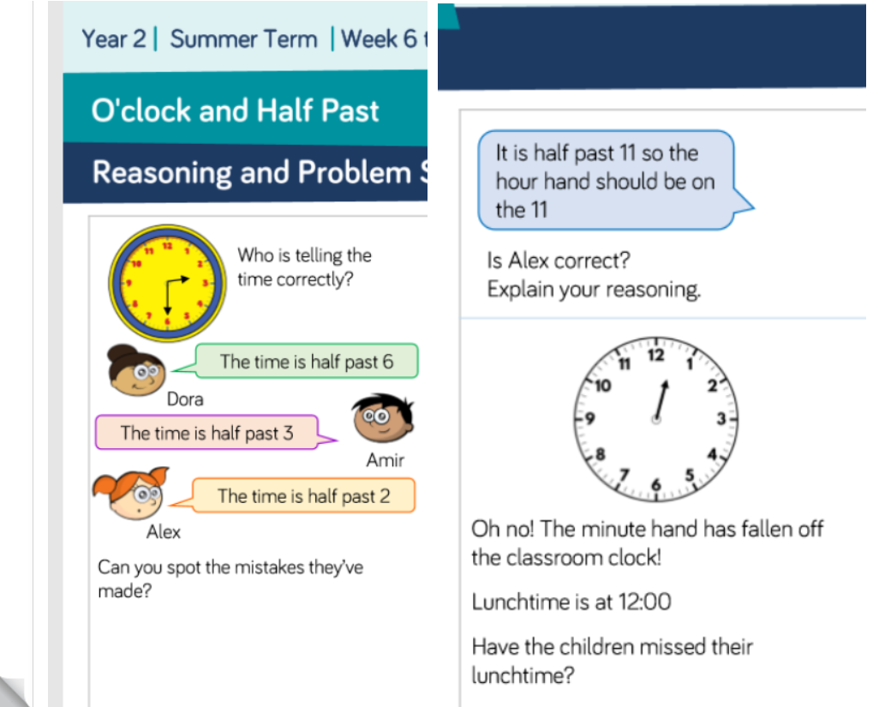
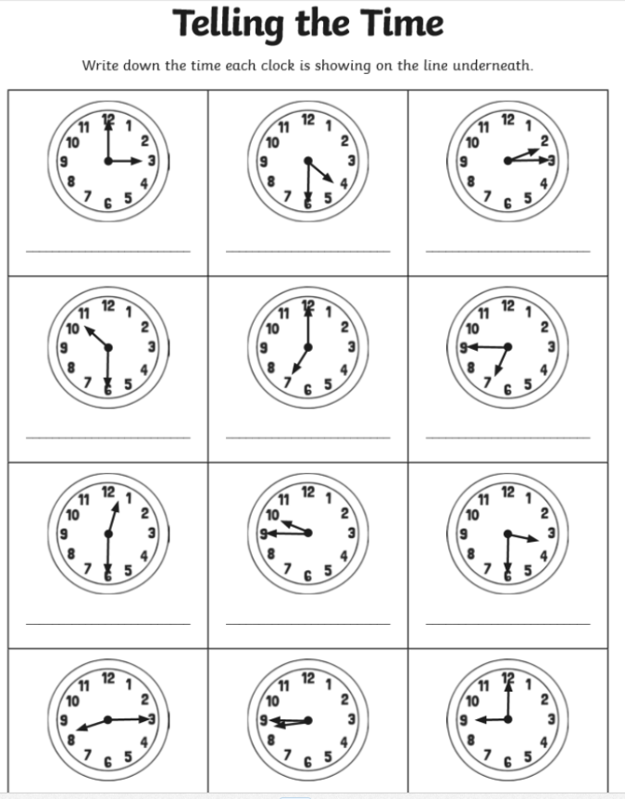
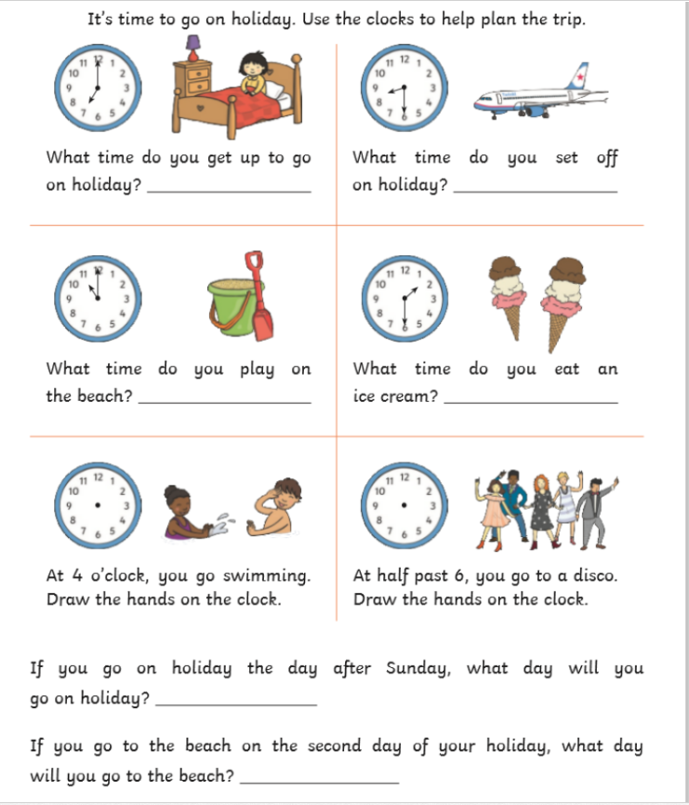
KUOTW
(Science)
Think about some of the non-living items that you may come
across on the beach. For example, plastic bottles left, cans, wrappers. Think
about how these might be dangerous to the wildlife.

Science Investigation
Investigate which materials break up in water by filling 4 bowls/jars with salty water.
- Dissolve a table spoon of salt into 4 jars/bowls.
- Add these materials to a jar/bowl - Plastic, paper, ring pull off a can, food item such as an apple core.
- Cover the bowls/jars with a lid or foil/clingfilm and give them a shake.
- Do this every day over the next week.
- Record what you see every day.

DAY | DAY 1 | DAY 2 | DAY 3 | DAY 4 | DAY 5 | DAY 6 | DAY 7
Metal
Plastic
Paper
Food
Fabric



