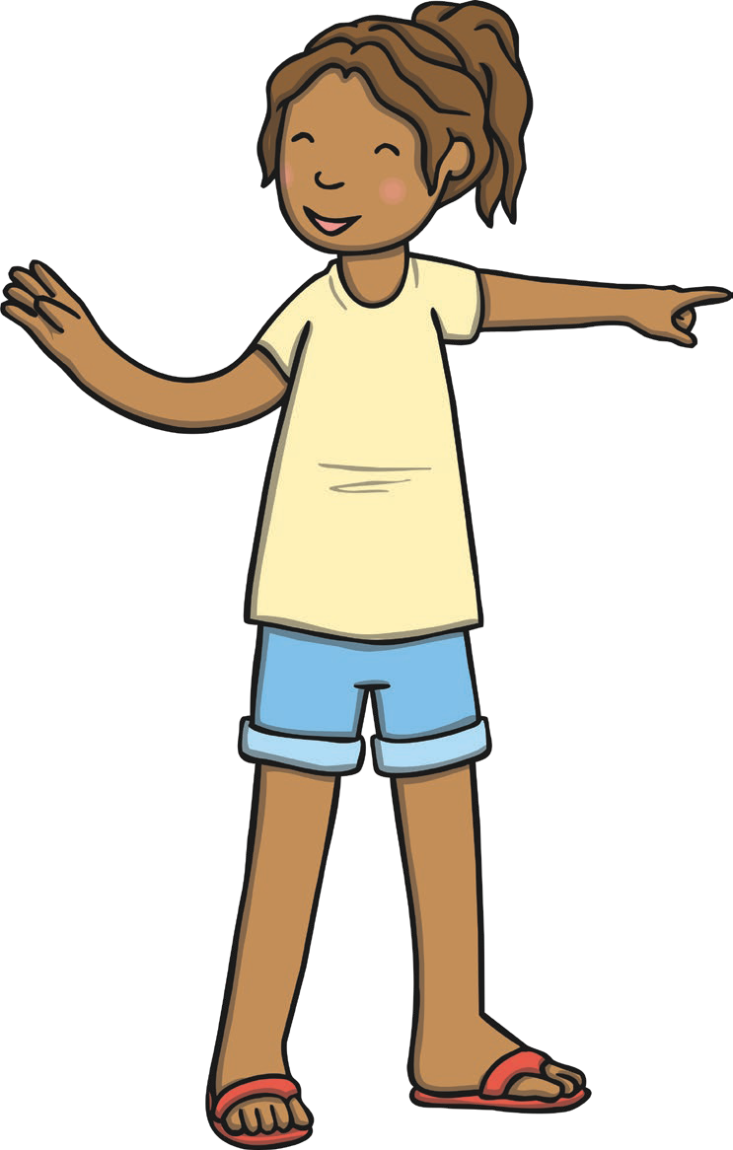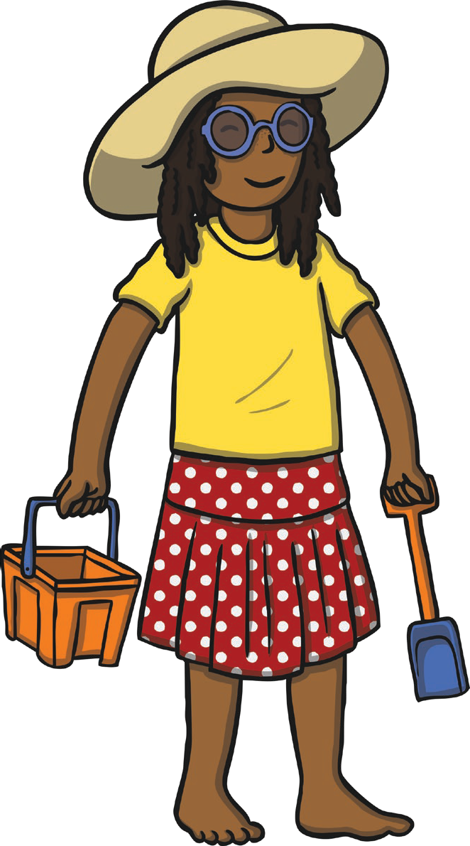
Summer Clothes
Label the items of clothing in this diagram, using the words at the bottom of the page to help.
h
s
s
T
s
s
visit twinkl.com
Page 1 of 2
Word Bank
skirt sunglasses hat T-shirt shorts sandals

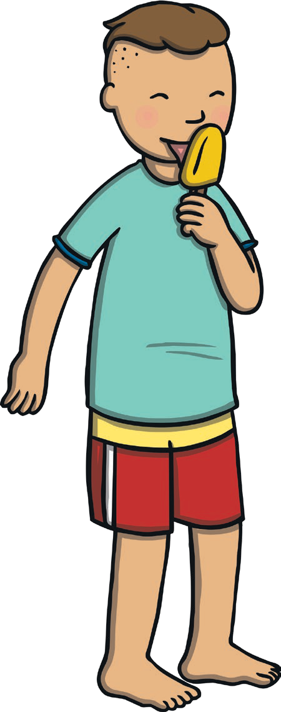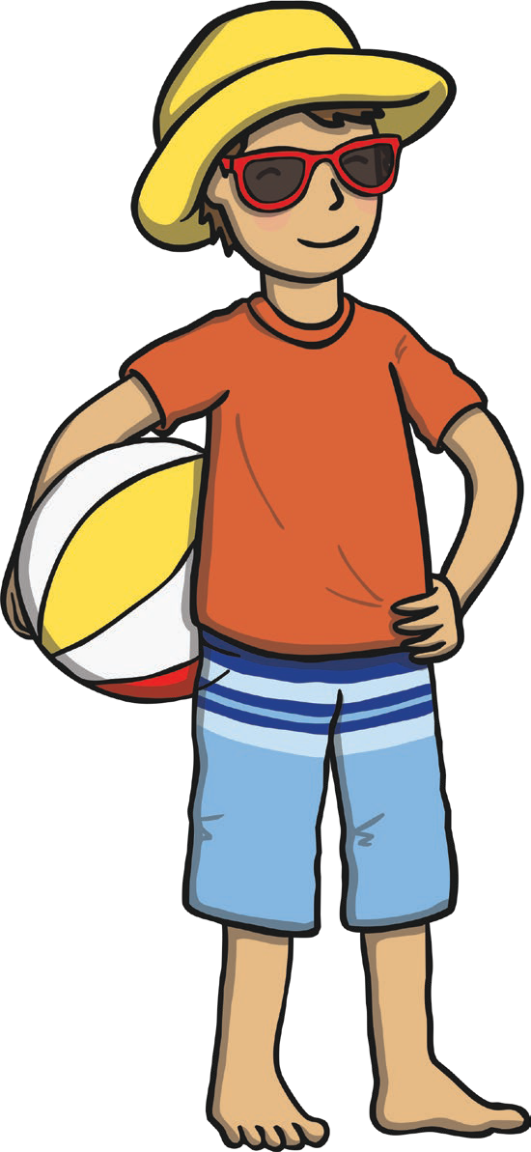
Summer Clothes
Label the items of clothing in this diagram, using the words at the bottom of the page to help.
h
s
T
s
visit twinkl.com
Page 2 of 2
Word Bank
shorts T-shirt sunglasses hat

Summer Clothes
Label the items of clothing in this diagram, using the words at the bottom of the page to help.
visit twinkl.com
Page 1 of 2
Word Bank
skirt sunglasses hat T-shirt shorts sandals

Summer Clothes
Label the items of clothing in this diagram, using the words at the bottom of the page to help.
visit twinkl.com
Page 2 of 2
Word Bank
shorts T-shirt sunglasses hat

Summer Clothes
Label the items of clothing in this diagram.
visit twinkl.com
Page 1 of 2

Summer Clothes
Label the items of clothing in this diagram.
visit twinkl.com
Page 2 of 2

