Home Learning challenges – Week 7
Literacy – Sound of the week is n. We enjoy these two videos in class for the sound of the week -https://www.youtube.com/watch?v=hCxv2ZPU3vg and https://www.youtube.com/watch?v=ShOLkFMTU4s Level 1 - Please can your child either practise identifying/saying/signing and forming this letter. Level 2 – As we are now learning a new topic, I thought it would be nice if your child could start to make a topic dictionary so each time we look at a new sound please can they think of beach themed words for it and write them down. It would be lovely if they could have a blank notebook so each letter has a page. For example this week is i so they could list – net (fishing net), needle fish, nurse shark, etc. They could even draw pictures next to each. As an extra challenge they can complete learnt sounds so far – m, a, s, d, t and i.
If practising forming the letter you can do it in fun ways – writing in rice/foam/soil/sand/driving cars through paint etc for multi-sensory fun! Also Ruth Miskin is doing daily RWI sound sessions live on youtube each day – https://m.youtube.com/channel/UCo7fbLgY2oA_cFCIg9GdxtQ Read Write Inc have now announced that their resources are free! To recap learnt sounds so far – m, a, s, d, t, i and to practise forming this week’s sound (n) please follow – https://home.oxfordowl.co.uk/reading/reading-schemes-oxford-levels/read-write-inc-phonics-guide/ scroll down and click on speed sounds practice sheets.
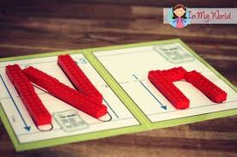 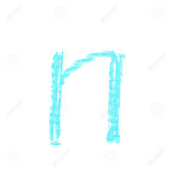 Playdough and chalk

Numeracy – Two levels – level one – we are back to 2 this week (if your child is confident identifying/writing/saying/signing 1 you can move on to 7 or recap other numbers 1-5 that they need more support with). We enjoy reading the story of two - http://resources.hwb.wales.gov.uk/VTC/story_of_2/eng/Introduction/default.htm and completing the activities. Please practise recognising the number/saying/signing/writing and linking to objects eg show two buttons/trains/bowls and write the number next to it. You can also enjoy multisensory activities to write 2.
Level two – The last two weeks we have looked at doubling and halving numbers, this week to keep the children on their toes and check they understand both concepts can you mix them up so you could write out a list double 10, half of 6, half of 12, double 15 etc. You can use the game to help consolidate the learning https://www.topmarks.co.uk/maths-games/hit-the-button There are also sheets on the Twinkl website if you have the free membership.

Topic – Each week I would like you to research one sea creature, write facts about the sea creature, watch videos to see how they move and copy the movements! I would also like you to create a picture/craft/model of the sea creature. I would love to see photos! The text type in English this term is information text so I am hoping each week you could help your child make a mini fact sheet about the sea creature of the week and by the end of the term we can compile them into a sea creature booklet. After finding a large fish (your clue) on the beach last week please could you help your child research – fish! What is their favourite type fish? Discover how many difficult colours and patterns are on different types of fish. See the different sizes of fish! There are lots of stories online about fish if you would like to start off with a story, this is one of my favourites! This site also have other stories listed as you read through - https://www.bedtimeshortstories.com/rainbow-fish-story or read aloud - https://www.youtube.com/watch?v=Z3cmddZh6t8There are lots of websites online with facts about fish for children also there are some lovely youtube videos so the children can see pictures, see how they move and listen to the facts. When creating your fact file you can either make your own template or print out templates such as the one below, I’ve used the clownfish because it is often popular after the film Nemo! – I also like these crafts -
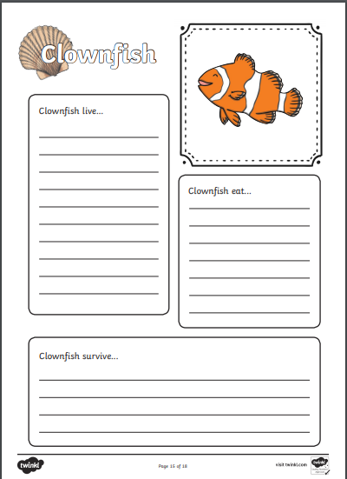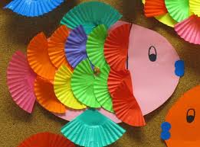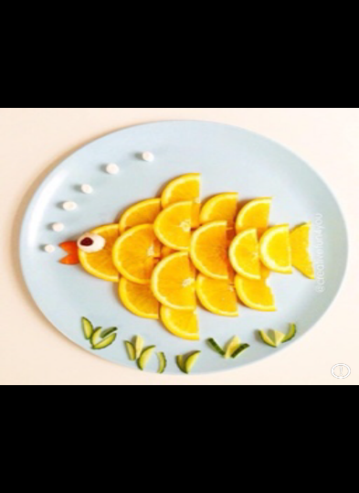
Made from cupcake cases and orange segments!
PE – I hope you are still joining me (virtually) for Joe Wicks at 9am. If you would like to try something different we enjoy Cosmic Kids yoga in class found on Youtube.

If you need any help please contact me on dojo or email. Have fun!
Miss Johns

