Home Learning challenges – Week 5
Literacy – Sound of the week is t. We enjoy these two videos in class for the sound of the week -https://www.youtube.com/watch?v=M5gUg06rock and https://www.youtube.com/watch?v=7r2pT-8cOA0 Level 1 - Please can your child either practise identifying/saying/signing and forming this letter. Level 2 – As we are now learning a new topic, I thought it would be nice if your child could start to make a topic dictionary so each time we look at a new sound please can they think of beach themed words for it and write them down. It would be lovely if they could have a blank notebook so each letter has a page. For example this week is t so they could list – turtle, tide, trunks etc. They could even draw pictures next to each. As an extra challenge they can complete learnt sounds so far – m, a, s and d.
If practising forming the letter you can do it in fun ways – writing in rice/foam/soil/sand/driving cars through paint etc for multi-sensory fun! Also Ruth Miskin is doing daily RWI sound sessions live on youtube each day – https://m.youtube.com/channel/UCo7fbLgY2oA_cFCIg9GdxtQ Read Write Inc have now announced that their resources are free! To recap learnt sounds so far – m, a, s and d to practise forming this week’s sound (t) please follow – https://home.oxfordowl.co.uk/reading/reading-schemes-oxford-levels/read-write-inc-phonics-guide/ scroll down and click on speed sounds practice sheets.
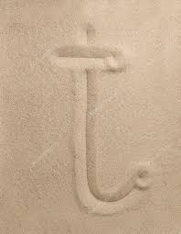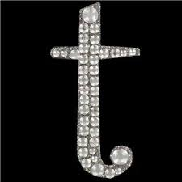

Numeracy – Two levels – level one – the number of the week is 5. We enjoy reading the story of four - https://resources.hwb.wales.gov.uk/VTC/story_of_5/eng/Introduction/default.htm and completing the activities. Please practise recognising the number/saying/signing/writing and linking to objects eg show five cars/stars/pencils and write the number five next to it. You can also enjoy multisensory activities to write 5.
Level two – I hope the children progressed well with 1 more/1 less, 10 more/ 10 less last week, if they need another week to practise please feel free. Otherwise, if your child is ready to move on I would like you to focus on doubles. For example double 1 is 2, double 5 is 10, double 20 is 40. We enjoy the ‘hit the button’ game in class - https://www.topmarks.co.uk/maths-games/hit-the-button If you would like to make a game you could write a number on a piece of card with the answer on the other side, zig zag cut up the middle and the children can check their answer by seeing both sides fit together. The next set of numbers could be cut straight up, the next set could be cut curved and so on so only the matching numbers fit together. There are also sheets on the Twinkl website if you have the free membership.

Topic – Each week I would like you to research one sea creature, write facts about the sea creature, watch videos to see how they move and copy the movements! I would also like you to create a picture/craft/model of the sea creature. I would love to see photos! The text type in English this term is information text so I am hoping each week you could help your child make a mini fact sheet about the sea creature of the week and by the end of the term we can compile them into a sea creature booklet. This week please could you help your child research – star fish! There are lots of stories online about star fish if you would like to start off with a story there is a short one with a lovely meaning- https://www.youtube.com/watch?v=PkV0jvmBLOc There are lots of websites online with facts about star fish for children also there are some lovely youtube videos so the children can see pictures, see how they move and listen to the facts. When creating your fact file you can either make your own template or print out templates such as the one below – I also like these crafts -
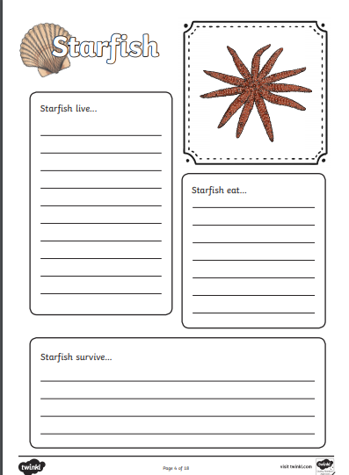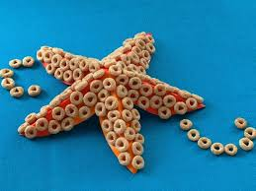
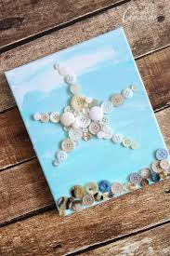First is made with Cheerios and the second using buttons.
PE – I hope you are still joining me (virtually) for Joe Wicks at 9am. If you would like to try something different we enjoy Cosmic Kids yoga in class found on Youtube.

If you need any help please contact me on dojo or email. Have fun!
Miss Johns

