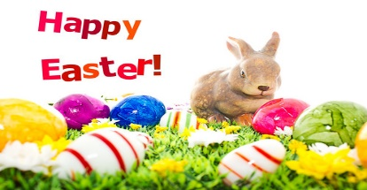
This Photo by Unknown Author is licensed under CC BY-ND
Easter

Dear parents,
I know that I have sent out this weeks’ challenges but just realised, as it is supposed to be the Easter holidays next week, I thought I would send some Easter resources for you to do with your children this week, or next!
The Easter Story – I have found a simple story on powerpoint on Twinkl - https://www.twinkl.co.uk/resource/t-s-3197-the-easter-story-sen-powerpoint they also have more detailed versions if you search. If you do not have the free Twinkl subscription or would prefer an animated story there is a lovely one provided by the BBC - https://www.bbc.co.uk/teach/class-clips-video/religious-studies-ks1-the-christian-story-of-easter/zhgv47h
Usually this time of year we enjoy making our Easter bonnets to show off in our school parade, unfortunately we will not be having our Easter parade but you can still enjoy making them and why not have your own family parade? I would love to see pictures on dojo!
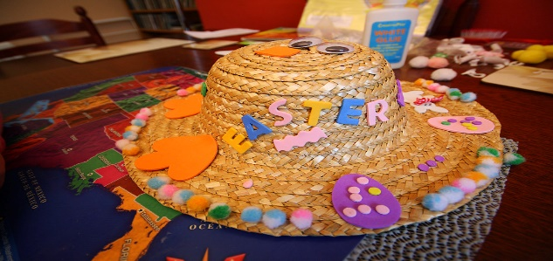
This Photo by Unknown Author is licensed under CC BY-NC-ND
This Easter pack is full of fun activities – dot to dots, puzzles, word searches, colouring sheets https://www.twinkl.co.uk/resource/t-t-10751-easter-activity-booklet
This pack is aimed at developing maths skills – 2d shapes, addition, counting, colour by numbers https://www.twinkl.co.uk/resource/eyfs-easter-maths-games-and-activity-pack-t-tp-6860
This pack has lovely Easter craft ideas which says the resources needed and how to make the crafts - https://www.twinkl.co.uk/resource/t-t-18906-easter-craft-activity-pack
If you do not have a free Twinkl subscription you can find some Easter activities on - http://www.primaryresources.co.uk/seasonal/seasonal1.htm and https://www.activityvillage.co.uk/easter
I printed out a couple of Easter sheets and put them in your child’s home learning pack but here are some fun crafts you could also do to celebrate this lovely time.
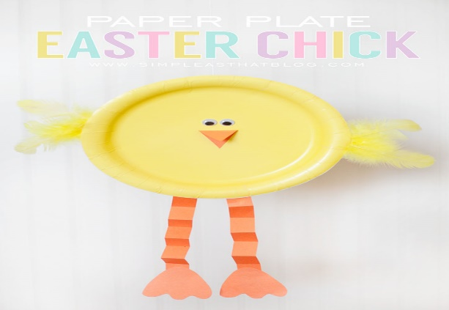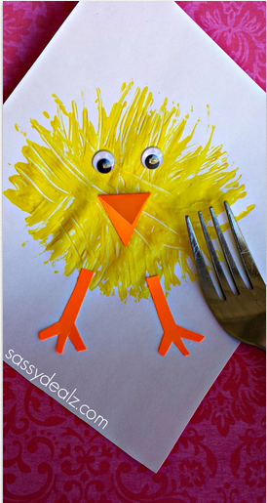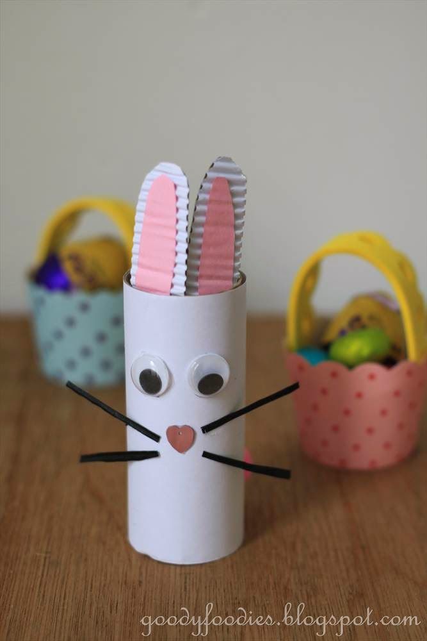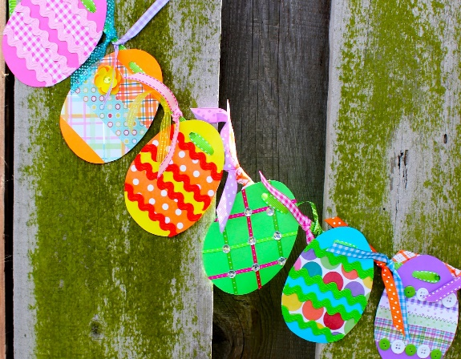
This Photo by Unknown Author is licensed under CC BY-NC-ND
This Photo by Unknown Author is licensed under CC BY-NC-ND
This Photo by Unknown Author is licensed under CC BY-NC
This Photo by Unknown Author is licensed under CC BY
Have a wonderful Easter.
Miss Johns

