  Date: 24th – 28th January 2022 |  |  |  | Theme: The Scented Garden  Year group: 1/2
Literacy      This Photo by Unknown Author is licensed under CC BY-NC-ND   | Numeracy     | Creative     | Thinking     |  | Healthy me    
Handwriting Practice  Handwriting/spelling book – A/B.  Grammar/Punctuation  Adding ed – Past tense.  Literacy Focus Task  Read the story Jack and The Beanstalk. Write in the speech bubbles what each character might be saying.  Story Time  Spend 10 minutes reading a story with your child.  Welsh  Match the sentences to the pictures. . | Maths Attack  Practice your 5x tables.  Maths Number  Colour in a 50 square by counting in fives.  Maths – Shape/Space and Measure  Look for objects around your home.  - Estimate which objects are longer than 1 metre and which are shorter than 1 metre. b) Draw each object in the correct part of the table.  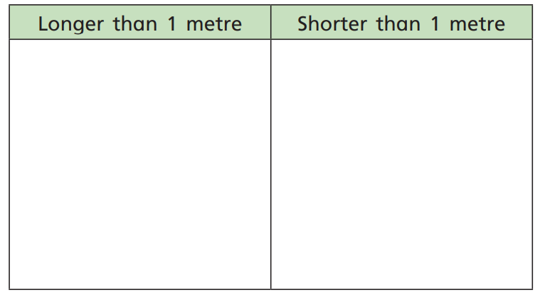 | Expressive Arts  Create model of a flower using materials or junk found around your home. | Humanities  Research information on your favourite flower or plant.  Draw a picture of their plant. Write the name, colour and 5 facts about their plant.  ICT  Using Jit 5 turtle. Move the butterfly around the flowers to create an algorithm. |  | Outdoor P.E.  Find 5 outdoor objects to compare which is the shortest to tallest. How could you measure your objects?

Continuous Provision highlighted in RED italics.

