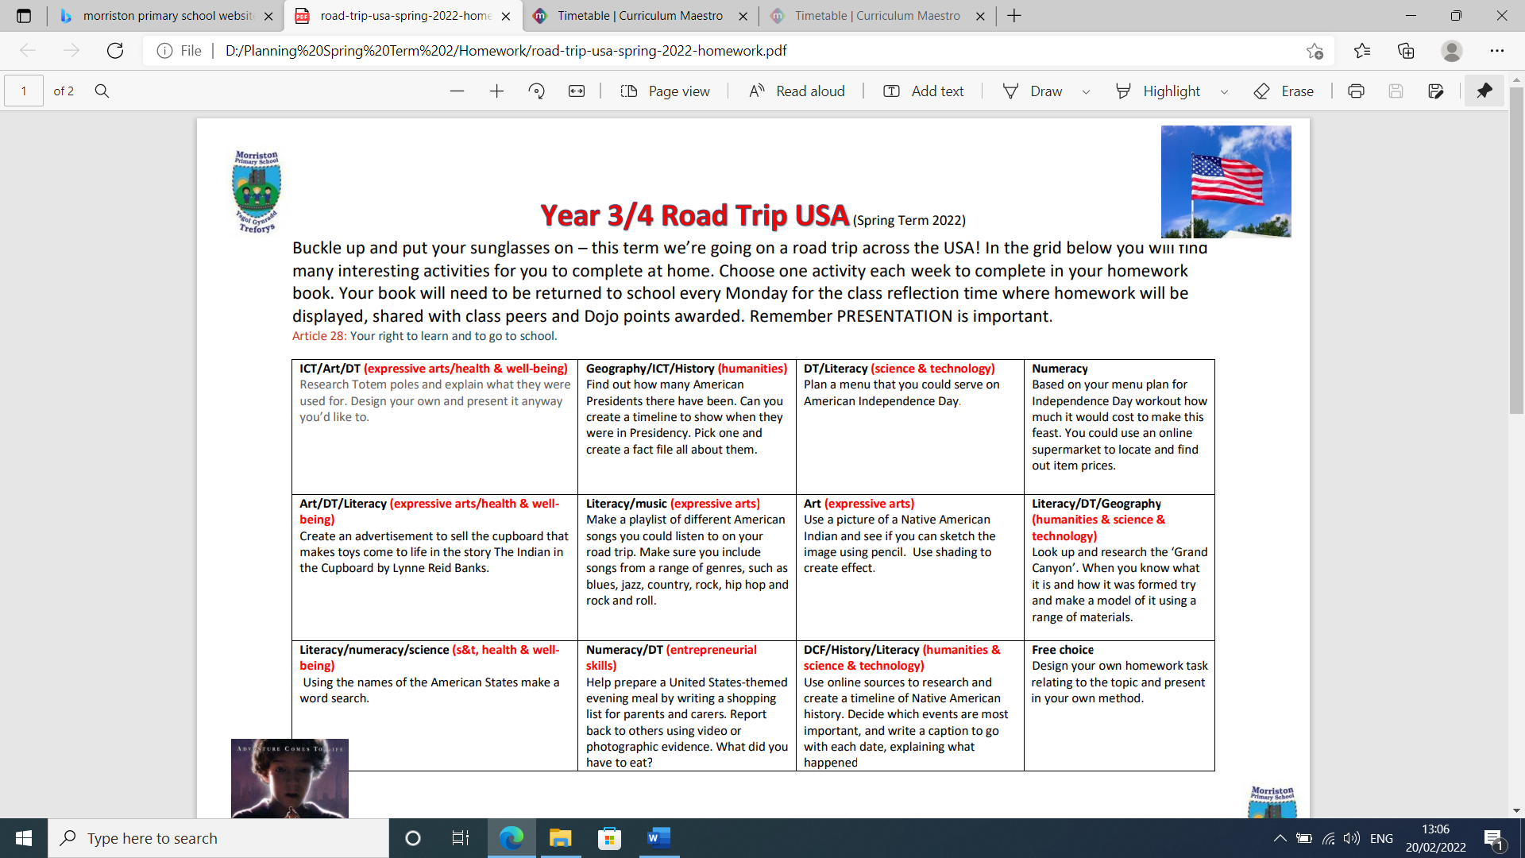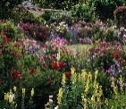
Year 1-2 Beachcombers
This Photo by Unknown Author is licensed under CC BY-NC-ND
Oh, I do like to be beside the seaside. Do you? That’s good, because this term we are going to become an expert beachcomber. Head to your nearest beach to look for interesting and unusual objects, using your senses to spot, sniff and seek them out. Have you seen the rock pools yet? We can take a peek into the cool water to learn about the weird and wonderful animals and plants in their microhabitats. Maybe we can kick back in a deckchair and do a little reading. What’s your favourite book about the seashore? Let's invent an amazing rock pool resident. What features will it need to survive happily in its watery habitat? Make a 3-D model of your plant or creature. Got your shorts and sunglasses on? Bucket and spade at the ready? Let’s get beachcombing - In the grid below you will find many interesting activities for you to complete at home. Choose one activity each week to complete in your homework book. Your book will need to be returned to school every Monday for the class reflection time where homework will be displayed, shared with class peers and Dojo points awarded. Remember PRESENTATION is important. Article 28: Your right to learn and to go to school.
Literacy/Languages and Communication.  Visit the library and look at books about the seaside. Write a review of your favourite book. | Mathematics and Numeracy  Make a list of all the activities you could do at the seashore. Survey your friends and family to find out the top 5 favourite activities. Display the results in a pictogram or a bar chart. | Health and Well-being  Create a poster to tell people how they can stay safe at the seaside. | Humanities  Bring pictures from home of yourself at the seaside or on holiday. Show us on a map where your seaside adventure took place.
Science and Technology  Make a miniature seashore garden using natural materials, such as pebbles twigs, sand and shells. | Expressive Arts  Research a famous artist who painted the seaside. Recreate one of their drawings and write a fact file about the artist.

