 | Look    This Photo by Unknown Author is licensed under CC BY | Cover  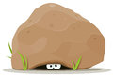 | Write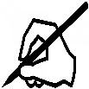 | Check    This Photo by Unknown Author is licensed under CC BY
best
lost
cost
gift
wind
soft
loft
help
children
Its

Learn these spellings. I will post a spelling quiz on Friday on HWB.
Choose 5 of the words and write a sentence using those words.

